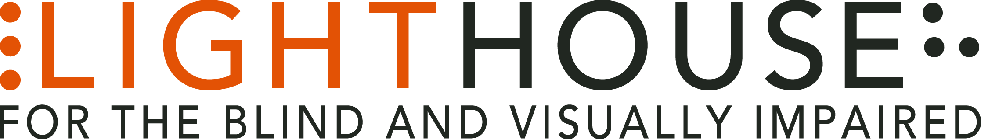

Application for Appointment

LightHouse Board Blind Advisory Committee

Purpose

The LightHouse Board of Directors wishes to formalize an ongoing independent structure through which it can learn from blind people in our community their current needs for programs and services. As these needs change, and as COVID and changing demographics reveal new unmet needs, it’s a best practice to operate an independent ongoing advisory platform from which our Board can learn what LightHouse is doing right, and what it needs to improve upon.

How the Board’s Blind Advisory Committee Operates

The Committee will meet quarterly approximately three weeks before each Board meeting. The Committee is chaired by a LightHouse Board member. The Board member will report on the Committee’s observations, suggestions, and recommendations at each Board meeting.

The Advisory Board will be composed of up to nine individuals, all of them will be blind or have low vision. The Board and CEO will select Advisory Board members from the broadest possible constituency, looking to ensure that the distribution according to age, intersectional disability, gender, and blindness/low vision be representative of the northern California demographics of blindness. At least one-third of the Advisory Board should be composed of people with less than 10 years of personal blindness experience. Both the CCB and NFBC San Francisco chapters will be invited to name their representative for this Committee.

Membership in the Advisory Board is not open to current LightHouse staff or those who have left the LightHouse employ or governing Board in the previous 24 months.

Applications to join the Committee will be reviewed and appointed quarterly by a panel consisting of the LightHouse Board Chair, the LightHouse Blind Advisory Committee Chair, and the CEO. The LightHouse is looking for Committee members who represent a diversity of thought, philosophy, demographics and personal needs. We believe in the capacity of blind people and seek to use our resources in ways that help people become all that they can be. We’re looking for people who are in touch with today’s community needs, as well as those who may have experience with new or different programs and services which might be operated by the LightHouse.

All Advisory Committee members are appointed for a term of two years, after which they may re-apply and serve up to a maximum of three two-year terms. Those who have served a maximum consecutive period of six years will again be eligible to re-apply after a fallow period of two years.

Meeting Procedures

The Board representative will chair the meeting, create the agenda and maintain notes for reporting to the full Board of Directors. As the Board’s Blind Advisory Committee is expected to be an independent voice, the meetings of this body are normally closed to staff and all senior leadership unless the Chair requests staff be present for part of a meeting for informational purposes.

How to Apply

Please fill out the requested questions below and return this form via email to
Board-request@lighthouse-sf.org

Application Form

Name:
Home Address:
City, State and Zip:

Phone:
Phone for texts:
E-mail:

Are you legally blind? Yes or No
Do you have low vision? Yes or No

What interests you in joining LightHouse’s Community Advisory Committee? (200 words or less)

Have you personally participated in LightHouse’s classes, programs or services in the last five years? Yes or No

If so, please list some key LightHouse offerings you have participated in.

If you have participated in blindness or low vision classes, programs or services with another organization or agency over the last five years, please list significant ones. If your experience predates the five years, please write a few sentences about where and how you learned about blindness.

Are you a current member of any blindness consumer group or organization? Yes or No
If so, which?

Are you friends with any current LightHouse staff or Board members? Yes or No
If so, who?

Please list a few of what you think are the LightHouse’s greatest strengths right now?

Conversely, please list a few areas where LightHouse needs to pay more attention.

If appointed, will you be able to commit to serving a full two-year term consisting of eight Committee meetings?

I am requesting to be appointed to the LightHouse Blind Community Advisory Board:

(type your name here)

Please return this form by email to Board-request@lighthouse-sf.org.

