# **­Logo - LightHouse for the Blind and Visually Impaired, San Francisco.**

# **2020 Annual Report** *All data is based on the LightHouse fiscal year: October 1, 2019 – September 30, 2020

Table of Contents for easy reference.

Page 3 – Cover Page with photo

Page 4 – Mission, Vision, Values with photo

Page 5,6 and 7 – Board of Directors, Executive Leadership, Locations

Page 8,9, 10 and 11 – Letter from Board Chair with photo

Page 12, 13 and 14 – Our Programs

Page 15 and 16 – 2020 By the Numbers: Students, Hours, Ages, Program Hours, and Volunteers

Page 17, 18, 19 and 20 – 2020 Outreach: Counties, State and Countries served with State, National, and world map infographics

Page 21, 22, 23 and 24 – EHC By the numbers: Campers, service hours, program

Page 25 and 26 – EHC Camper Profile: Monse

Page 27, 28 and 29 – Holman Prize for Blind Ambition with photos of 2020 winners

Page 30, 31, 32, 33, 34 and 35 – LightHouse Social Enterprises: MADLab, LHI, Adaptations with photos

Page 36, 37, 38 and 39 – Who We Reach: LightHouse in the press, Advocacy groups we worked with, Tech and Accessibility consulting jobs

Page 40 Financial Statements: Assets, Liabilities, Revenue

Page 41 – Photos with captions

Page 42 through 67 – Donor lists

Page 68 – Back Cover with photos and LH contact information.

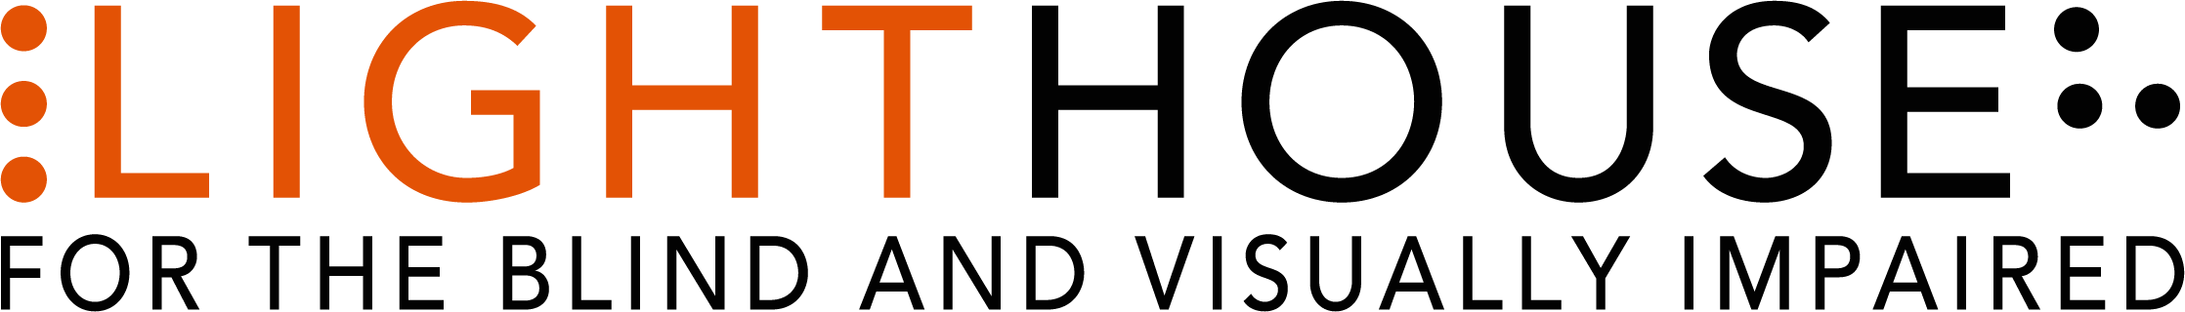

# Serving in unprecedented times; Pivoting during a pandemic

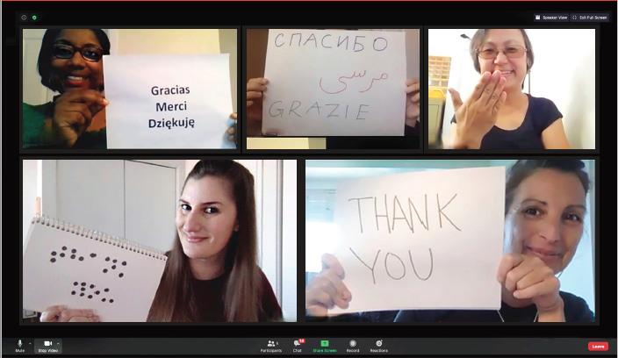

Photo caption: Zoom presentation spelling out “thank you” on cards on a Zoom screen in Spanish, Arabic, French, ASL, braille and English.

# **MISSION**

Founded in 1902, [LightHouse for the Blind and Visually Impaired](https://lighthouse-sf.org/) promotes the independence, equality and self-reliance of people who are blind or have low vision.

# **VISION**

# We offer blindness skills training and relevant services such as access to employment, education, technology, information, recreation, transportation and the environment. We also pursue the development of new technology, encourage innovation, and amplify the voices of blind individuals around the world. **VALUES**

Advocacy, equality, collaboration, employment, literacy, education, innovation, independence, community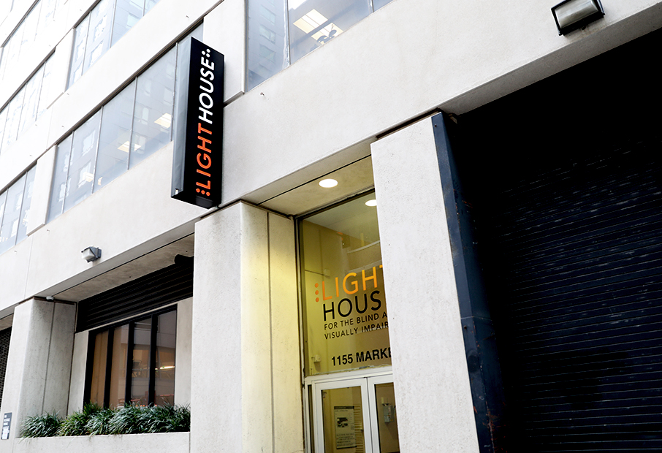

Photo caption: LightHouse building sign with braille “L” and “H”.

# **BOARD OF DIRECTORS**

Sharon Z. Sacks, Ph.D. – Chair

California School for the Blind, Superintendent (retired)

Chris Downey – Immediate Past Chair

Architecture for the Blind, Architect

Luciana Profaca, Ph.D. – First Vice Chair

California Department of Rehabilitation, Chief Deputy (retired)

Joseph Chan – Treasurer, Association of Bay Area Governments, Chief Financial Officer (retired)

Geoffrey Murry – Secretary

Ad Astra – Law Firm, Attorney

Laura Allen – Google, Head of Strategy, Accessibility & Disability Inclusion

Jennison Mark Asuncion – LinkedIn, Head of Accessibility Engineering Evangelism

Janette Barrios – Apple, Accessibility Marketing and Community Manager

Johnny Dadlani – Growing IQ, Managing Partner

Michael Dellar – One Market Restaurant, Co-Founder, Principal

Chancey Fleet – New York Public Library, Assistive Technology Coordinator

Dana Hooper – Life Services Alternatives, Executive Director

Eric Mah – Financial Professional

Michael Nunez, Esq. Rosen Bien Galvan & Grunfeld – LLP, Attorney

Dr. Julius Oatts – UCSF Medical Center, Pediatric Ophthalmologist, Assistant Professor of Ophthalmology

Yue-Ting Siu, TVI/COMS, Ph.D – San Francisco State University,  
Assistant Professor

Ahmet Ustunel – San Francisco Unified School District, Teacher of the Visually Impaired

# **EXECUTIVE LEADERSHIP**

Bryan Bashin

CEO

Scott Blanks

Senior Director, Programs

Brandon Cox

Senior Director, Operations

# **LOCATIONS**

LightHouse for the Blind and

Visually Impaired (Headquarters)

San Francisco, CA

LightHouse East Bay,

Ed Roberts Campus

Berkeley, CA

LightHouse North Coast

Eureka, CA

Enchanted Hills Camp for the Blind

Napa, CA

LightHouse Industries

Sirkin Center

Alameda, CA

# **A letter from our Board Chair Dr. Sharon Sacks**

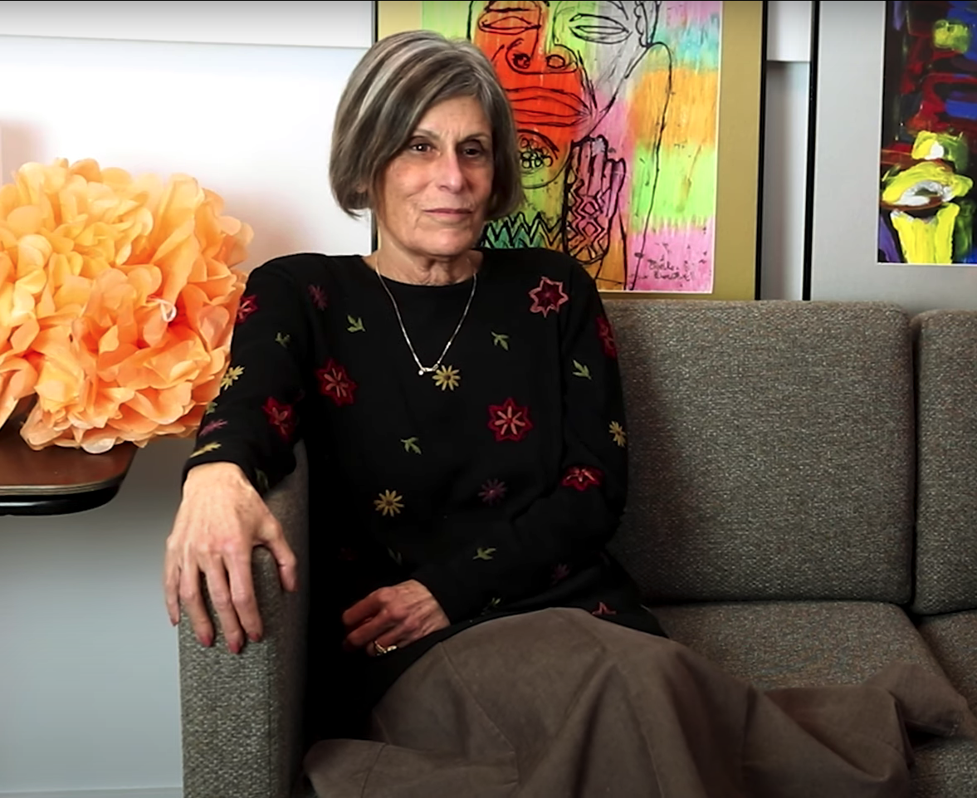

**Photo caption:** Lighthouse Board Chair Sharon Sacks sits on a couch with paintings behind her.

Dear LightHouse Community,

2020 was an unusual year for everyone around the world. March 13th, 2020 was the last day most LightHouse staff went to work in our offices. As the Board Chair, I am proud to share the LightHouse for the Blind 2020 Annual Report, documenting how LightHouse supported the blind community through a global pandemic, with an engaged, tireless and swift-thinking staff, who for the most part pivoted to do their work from the safety of their homes.

We responded to the new reality with Care Calls. LightHouse staff called 1,277 LightHouse students to offer resources, assess their situations and offer support during an incredibly difficult time. As we began offering all of our classes online, we were surprised by the zealous participation. More seniors participated in ”Coffee with Mike Cole” via Zoom and phone, than had taken part in-person. A new program called “Tech Together” became a huge success, allowing the blind community a place to trouble-shoot tech topics with experts and peers. Braille and tech trainers doubled their teaching hours, as students wanted to become tech-savvy and tactile literate. As the year progressed we saw the need to serve the diversity of the blind community, and we now offer more programs in Spanish than ever before in our 118 years. Because people still need to learn the vital independence skill of traveling with a white cane, our Orientation & Mobility staff began to teach community travel skills in-person, with social distance and masks.

Many of you know me as the previous Superintendent of the California School for the Blind. I myself was born with low vision, and have made a career of improving education for blind children. Kids have had a hard time in the pandemic, and distance education is especially difficult for blind youth. Our Youth Programs coursed in with a host of online support, entertainment, and community to help children & youth isolated at home. Monthly Mentor Mondays helped students learn to advocate for their needs and address misconceptions. “Reel Escape”, a weekend movie club, offered popular films shown with audio descriptions followed by lively conversation. The club “College Spaces from Different Places” created a space for older blind students to connect and support each other.

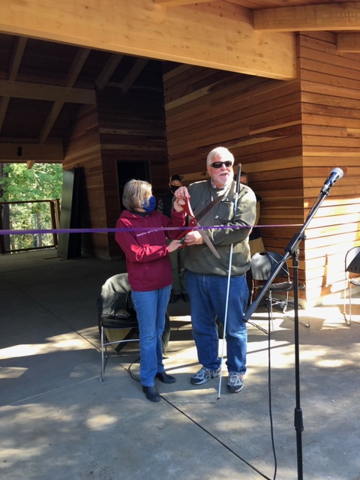

**Photo caption:** CEO Bryan Bashin and Board Chair Sharon Sacks cut the ribbon for our new pool house opening at EHC.

It was [Enchanted Hills Camp](http://enchantedhillscamp.com/)’s 70th Anniversary of providing a community of growth for blind campers. With virtual campfires, a series of Facebook Live concerts and camp sessions held via Zoom, EHC provided a vital connection for blind campers, throughout the year. Meanwhile, the camp renewal continues. The legacy buildings received handsome, fireproof metal roofs and new deep green paint to harmonize with the plush green landscape. The pool has a new fence and pool house, resplendent with a guide dog shade area and clad in redwood salvaged from trees lost in the fires. Meanwhile, in 2020 we planned for a total re-envisioning of [Enchanted Hills](https://lighthouse-sf.org/enchanted-hills/rebuilding/) as a global center for blindness training in the summer and beyond, with construction planned over the coming 24 months.

In 2020, big things happened at the [Sirkin Center](https://lighthouse-sf.org/about/sirkin-center/), LightHouse’s blind labor-force manufacturing plant. We had just recently added a line of cleaners and disinfectants to the production at Sirkin. Then it became clear that our hard surface cleaner was effective at killing the novel coronavirus. Suddenly our burgeoning new business went prime time. We were able to double our staff and hire a blind scientist to oversee the product blends. Our customer base of government agencies and private companies continues to grow, and so do the employment opportunities for people who are blind or have low vision. The BBC covered Sirkin Center’s unprecedented growth in [this video.](https://www.youtube.com/watch?v=yBqA8CVUWk4&feature=youtu.be)

LightHouse’s [Madlab](https://lighthouse-sf.org/braille-and-accessible-design/) creates innovative tactile and accessible materials. They partnered with the New York Library to provide our unique TMAPS for patrons. These tactile maps are empowering library patrons to understand the streetscape in NYC and beyond. TMAPs can be ordered for any location through Adaptations, LightHouse’s store. While our staff miss the hands-on approach in the store, [Adaptations](https://adaptations.org/) is now fully online, serving customers all over the globe.

The three 2019 [Holman prize](http://holmanprize.org/) for blind ambition winners, [Mona Minkara](https://holman.lighthouse-sf.org/2019-mona-minkara/) (created travel documentaries about public transit around the world), [Alieu Jaiteh](https://holman.lighthouse-sf.org/2019-alieu-jaiteh/) (provided training for blind adults in rural Gambia) and [Yuma Decaux](https://holman.lighthouse-sf.org/2019-yuma-decaux/) (created an app for blind citizen scientists to explore space acoustically) completed their Holman year with a bit of an extension due to COVID. Meanwhile [Tyler Merren](https://holman.lighthouse-sf.org/2020-tyler-merren/) (pioneering an app for fitness for people who are blind or have low vision), [Dr. Birendra Raj Sharma Pokharel](https://holman.lighthouse-sf.org/2020-birendra-raj-sharma-pokharel/) (training blind women in Nepal in early detection of breast cancer) and [Tiffany Brar](https://holman.lighthouse-sf.org/2020-tiffany-brar/) (providing blind empowerment and skills to blind youth in South India) began their adventures and projects, all focused on bettering the world.

Looking ahead, I foresee a future of LightHouse programs held in-person with segments taught virtually. Lessons learned during this challenging time will make our programs more effective and accessible to greater numbers of blind students in the years to come.

Thank you for being part of our LightHouse family. In these difficult times, your support is essential to our success.

**Best wishes,**

Sharon Zell Sacks, Ph.D.LightHouse Board Chair

# **OUR PROGRAMS**

**ACCESS TECHNOLOGY** - The Access Technology department facilitates the use of accessible technology among people of all ages and levels of expertise. We also work with companies on design consulting, functional accessibility review and user testing sessions.

**ADAPTATIONS STORE** - Located on the 10th Floor of our San Francisco headquarters, as well as online, Adaptations is the only place in Northern California with a comprehensive offering of tools, technology and other solutions used by

blind people.

**BLIND AND LOW VISION SKILLS** – Training in low vision and blindness skills, including Orientation and Mobility, braille, pre-guide dog skills in partnership with Guide Dogs for the Blind, and independent living skills curriculum like Changing Vision, Changing Life, our flagship introductory program to those with changing vision who want an intensive introduction to the myriad options available at LightHouse.

**COMMUNITY SERVICES** – Blind adults come together in-person and virtually for social events, professional mentoring, accessible movie nights, museum tours, crafting, cooking and fitness programs.

**COUNSELING SERVICES** – Available in individual, couples and  
group settings, LightHouse counseling services support a student’s  
overall well-being.

**DEAF-BLIND SERVICES** – Deaf-blind students benefit from training, resources and free technology. In 2020, LightHouse supplied Deaf-blind students with 450 pieces of equipment valued at $268,008.

**EMPLOYMENT IMMERSION** – Blind and low vision jobseekers receive personalized training to learn how to identify job openings, network, interview and secure competitive employment. More than 100 graduates have secured employment since the program began in 2011.

**ENCHANTED HILLS CAMP AND RETREAT** – The oldest camp for the blind in the American West, hosting campers since 1950. This year we went virtual, hosting four different remote camp sessions and remote campfires to thousands of viewers all over the world.

**LIGHTHOUSE INDUSTRIES SIRKING CENTRE** – Our state-of-the-art manufacturing center produces essential disinfectants and cleaning products in the fight against COVID. Over 80% of employees at LightHouse Sirkin Center are blind or have low vision, working in all aspects of our business from the production line to quality assurance to the new product development laboratory.

**LIGHTHOUSE LABS** – A think-tank for technologists, corporations and designers to meet regularly with blind scientists, engineers and savvy consumers.

**MEDIA AND ACCESSIBLE DESIGN LAB (MAD Lab)** – This team of designers produces tactile graphics, maps, 3D educational objects, ADA signage, braille

and more.

**THE JOSEPH CHAN LOW VISION OPTOMETRY CLINIC** – In partnership with the UC Berkeley School of Optometry and located within LightHouse Headquarters, this is a low vision and primary care eye clinic.

**VOLUNTEER SERVICES** – Throughout the COVID-19 pandemic, volunteers continue to meet with blind community members requesting volunteer matches, students one-on-one, both virtually and through essential in-person visits, as well as providing LightHouse administrative support and maintaining Enchanted Hills Camp.

**YOUTH PROGRAMS** – LightHouse offers activities for blind and low vision youth, including STEM education, outdoor adventures and a monthly YES Academy, a mentor-led employment series that encourages blind teens to prepare for professional success.

# 

**2020 Impact by the Numbers  
  
Blind students served:** 1,624

**Teaching hours:** 24,390

**Care Calls During Covid:** 1,277

**Ages:**

65+: 623

25-64: 794

19-24: 105

13-18: 85

0-12: 12

**Program hours:**

Adults and Seniors: 3,972

Youth: 3,221

Orientation and Mobility: 3,767

Braille: 899

Psychological Services and Counseling: 514

Blind and Low Vision Skills: 875

Employment Immersion: 2,755

Student Support: 1,777

Access Technology: 3,851

Deaf-Blind: 1,581

Grand Total: 24,390 hours

**Volunteer Programs**

Total Volunteer Hours: 8,326

Total Number of Volunteers: 242 people

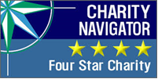 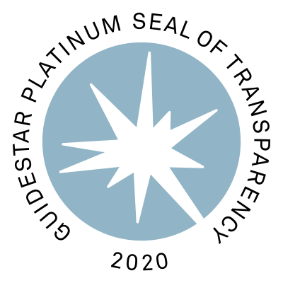

Four-Star Charity Navigator and Platinum GuideStar logos above

# 

# **2020 Outreach California**

LightHouse reaches a robust network of students and organizations at state, national and international levels. In 2020, LightHouse served 45 California Counties.

State of California Infographic

Photo caption: Map of the State of California Infographic

**Counties Served:**

Alameda

Amador

Butte

Calaveras

Contra Costa

Del Norte

El Dorado

Fresno

Glenn

Humboldt

Kern

Kings

Lake

Lassen

Los Angeles

Marin

Mendocino

Merced

Modoc

Monterey

Napa

Nevada

Orange

Placer

Riverside

Sacramento

San Benito

San Bernardino

San Diego

San Francisco

San Joaquin

San Luis Obispo

San Mateo

Santa Barbara

Santa Clara

Santa Cruz

Shasta

Solano

Sonoma

Stanislaus

Tehama

Trinity

Tulare

Tuolumne

Yolo

# **2020 National and International Outreach**

National map infographic

Photo caption: Map of nation infographic

**In 2020, LightHouse served students from 17 states:**

California, District of Colombia, Hawaii, Illinois, Maryland, Massachusetts, Maine, Minnesota, Missouri, New Jersey, New York, Ohio, Oregon, Pennsylvania, Utah, Virginia, and Washington.  
  
  
**Highlights from our Student Surveys**

* 90% students say they would refer someone to LightHouse.
* 88% students say that LightHouse was useful and relevant in meeting their interests and needs.
* 90% students found LightHouse staff to be professional

and knowledgeable.

**World map infographic**

Photo caption: Infographic map of the world

Thanks to our Holman Prize and a large international contingent at camp, our international network continues to expand. In 2020, LightHouse reached these countries.  
  
Albania

Algeria

Armenia

Australia

Bangladesh

Bosnia and Herzegovina

Brazil

Burkina Faso

Canada

China

Estonia

Finland

Gambia

Germany

Ghana

Holland

India

Ireland

Italy

Kazakhstan

Kenya

New Zealand

Malaysia

Nepal

Nigeria

Philippines

Poland

Romania

Russia

Spain

United Kingdom

United States

Zimbabwe

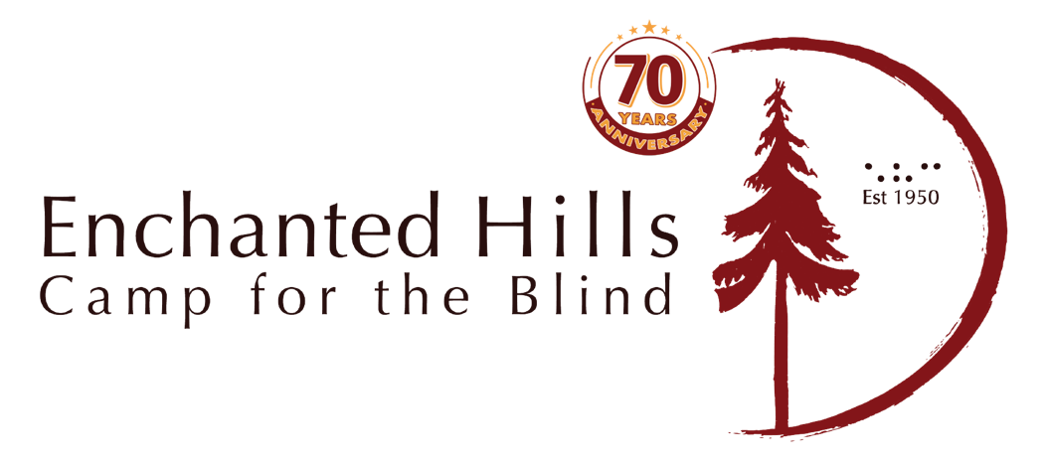

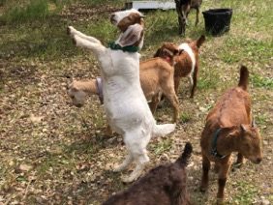

Photo caption: Our new goats! White goat standing on its hind legs.

2020 was our 70th year of EHC, but we were not able to be together in person due to the pandemic. We ran these programs remotely:

* EHC hosted ten different virtual summer sessions in 2020.
* Music Camp rocked the world with a virtual concert finale for several thousand audience members through Facebook Live.
* EHC sponsored a series of ten online music concerts featuring professional musicians, many of whom were previous EHC campers or employees. This event was well attended with over 32,000 reactions from people from all over the world.
* EHC hosted virtual campfire sessions attended by campers from all over the world.
* The new poolhouse is complete, clad in redwood lumber milled from trees damaged in the 2017 fire.
* Two AmeriCorps groups spent six weeks working on a variety of projects: rebuilding bridges and fences, maintaining trails, and helping keep camp in shape.

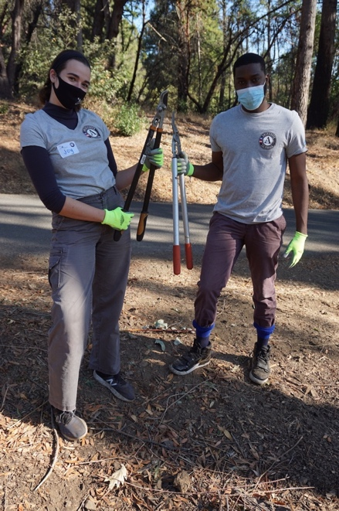

**Photo caption:** Two EHC AmeriCorps volunteers holding clippers.

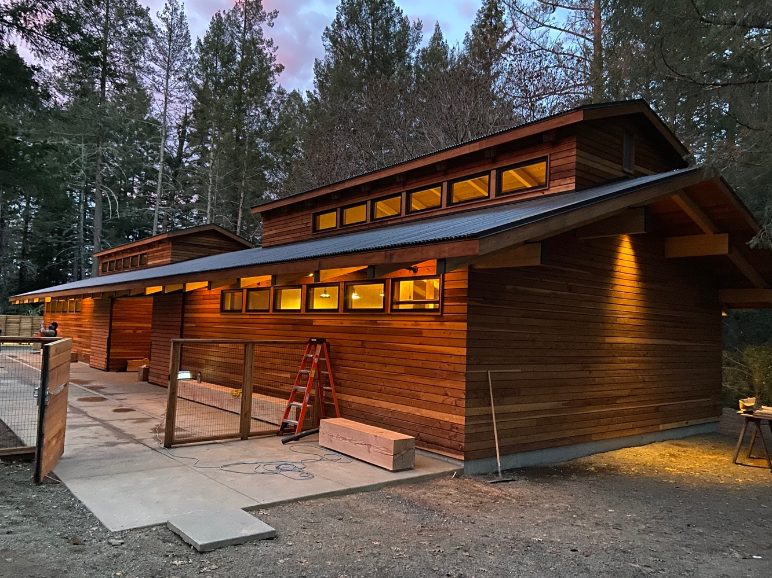

**Photo caption:** New poolhouse at EHC.

**EHC by the Numbers 2020**

Blind Campers: 155

Camper hours: 1,485

EHC Virtual Holiday Concert audience: 2,200

Total reach for EHC concert series on Facebook Live and virtual campfire sessions: 32,000

**EHC 2020 Virtual Programs**

Adult Session

Youth Camp

Teen Camp

Music Camp

Photo caption reading Left to right: Grid of performers’ headshots from the summer “Give Back Concert Series.” Fernando Apan, Mariana Sandoval, Phil Madera, Graham Norwood, Christina Jones, Maceo Williams, Bruce Cockburn, Lawrence Brown and the EHC 70th Anniversary Logo.

# EHC Camper Profile

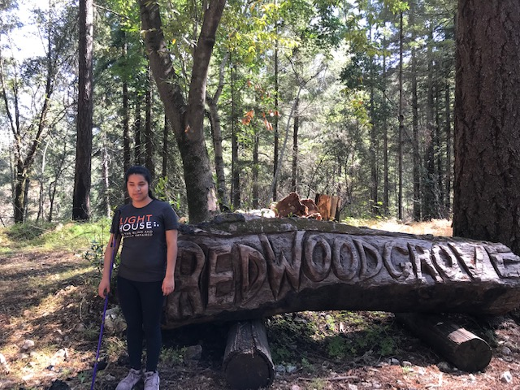

**Photo caption:** EHC camper Monse stands in front of the Redwood Grove sign, carved from a felled redwood tree.

Meet Monse, a blind 16-year-old student, currently in her junior year of high school in California. A few years ago, Monse attended Enchanted Hills Camp for the Blind with her family. Like many parents, Monse’s were hesitant about sending their blind kid away from home. At Family Camp they witnessed how their daughter thrived in an environment where being blind was just another part of her life.

The following July, Monse returned on her own for the Youth Session, and ever since, Enchanted Hills had become her eagerly awaited summer experience.

Until the pandemic scotched our summer 2020 sessions, Monse was planning on attending the two-week session for teens and looked forward to the special formal dinner and dance, the kayaking field trip and the karate workshop.

When the 2020 camp session was cancelled, Monse was sad, but she discovered that all was not lost. Monse was able to join her friends online for the virtual Teen Session. There were games and sing-alongs at the campfire, but what has really stayed with Monse are the profound conversations.

She told us, “We had deep discussions on blindness, the challenges of transitioning from high school to college and how to advocate for ourselves. We also covered strategies for overcoming the isolation and loneliness of the pandemic.” These are conversations that blind kids just don’t have anywhere else.

In addition to friendship and outdoor exploration, Enchanted Hills provides opportunities for older campers to flex their leadership muscles and gain responsibility. Almost all of our counselors are blind, many of whom have worked their way up from campers, to Counselors in Training (CITs), to paid employees. This summer Monse took part in the CIT program. Camp Director Tony Fletcher enthused, “Monse is a promising up-and-comer at Enchanted Hills. I see a bright future for her on our staff.”

Despite challenges, LightHouse was able to hold 2020 summer camp sessions online, including Music Camp, STEM programs, sessions for blind adults, plus some amazing community concerts and campfires. Enchanted Hills Camp is provided free to blind kids, many of whom are from low-income families.

2020 was the 70th anniversary year of the birth of our beloved camp, a sanctuary and place to learn self-reliance for 30,000 campers and growing. We are now re-imagining Enchanted Hills and will soon build 20 new cabins and program areas.

# **Holman Prize for Blind Ambition**

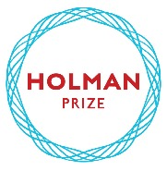

Now in its fifth year, LightHouse’s Holman Prize for Blind Ambition is an international competition with a monetary prize that is awarded annually to three blind individuals who wish to push their limits. It is named for James Holman, a nineteenth-century blind explorer and author, who was the most prolific private traveler before the era of modern transportation.

In 2017, LightHouse for the Blind launched the Holman Prize to support the emerging adventurousness and can-do spirit of blind and low vision people worldwide. This endeavor celebrates people who want to shape their own futures instead of having them laid out for them. Created specifically for legally blind individuals with a penchant for exploration of all types, the annual Holman Prize for Blind Ambition provides financial backing – up to $25,000 – for three individuals to explore the world and push their limits.

The ideal candidate is someone who is willing to probe their environment and eager to savor the richness of a world that is so often thought of as inaccessible to the blind. Prize winners embark on adventures of their choosing, which may involve travel, community organizing, athletics, scientific exploration, art and more. In addition to motivating blind individuals to realize their dreams, the purpose of the Holman Prize is to change the world’s perception of blind ability.

# **2020 Holman Prize Recipients**

**Tiffany Brar, India:**

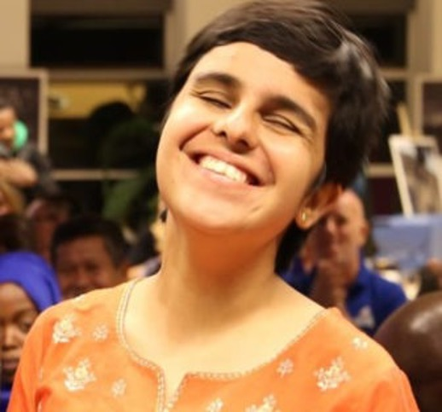

**Photo caption:** Close up of Tiffany Brar smiling.

Brar’s Holman ambition is called “Reaching the Unreached.” With the Holman Prize, Brar will expand services for the blind into rural and tribal south India. Brar’s goal is to train more than 300 blind people across four states: Kerala, Tamil Nadu, Telangana, and Karnataka. She hopes to help teenagers enroll in school and adults participate in residential training centers for the blind or find jobs.

Tyler Merren, USA:

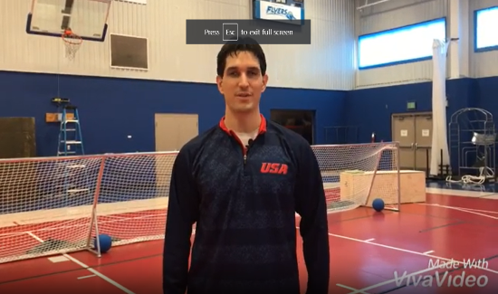

**Photo caption:** Close up of Tyler Merren.

Tyler Merren will develop “ReVision Fitness”, an audio-based fitness mobile application. “While there are many fitness apps out there,” said Merren, “they don’t provide an adequate description of exercises for people who are blind.” The app will include descriptions of equipment, nutrition, heart rate monitoring and journal capabilities, all in an accessible format.

Dr. Raj Sharma Pokharel, Nepal:

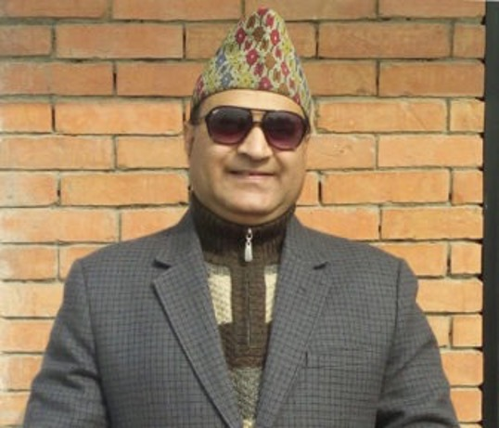

**Photo caption:** Close up of Dr. Sharma Pokharel.

Dr. Pokharel will use his Holman Prize funds to provide training for blind women in Nepal to become Medical Tactile Examiners in the early detection of breast cancer. The new program will provide an employment path for up to 30 blind Nepalese women who traditionally face enormous barriers to employment.

**To learn more about the prize and its winners, view our short video:**<https://www.youtube.com/watch?v=b2ofhVRjzvA&t>

# 

# **LIGHTHOUSE SOCIAL ENTERPRISES**

## **MEDIA AND ACCESSIBLE DESIGN LAB (MAD Lab)**

From printed information to physical space, our [MAD Lab](http://lighthouse-sf.org/braille-and-accessible-design/) specializes in making the visual tactile and turning inaccessible experiences into inclusive ones. Our team of designers and consultants works to enhance understanding of what images and diagrams can do for blind people. We believe that equitable access to information should be an ordinary experience, and that image poverty is avoidable. So we make things that are aesthetically pleasing, legible, relevant and meaningful to blind people. With enough images under our fingertips, image fluency, perceptual and creative abilities around spatial information can flourish.

**MAD Lab 2020 Year in Review**

**Architectural Signage:** The San Francisco Mayor’s Office on Disability and San Francisco Public Works require City projects to obtain a letter from LightHouse certifying that all tactile signs with raised characters and braille comply with building code signage standards. By providing this essential service, MAD Lab allows public housing and other public building projects to go forward.

**TMAP:** During COVID, there has been an exigency among teachers and students around long-term distance learning. In response, MAD Lab and LightHouse’s Orientation and Mobility instructors partnered on a series of webinars that show how indispensable TMAPs are at giving people everyday access to spatial information. As TMAP is incorporated into Orientation and Mobility lessons we’re witnessing a profound change in how practitioners think about and use tactile graphics.

**Interpretive exhibits**: Visitors can run their fingers along MAD Lab designed braille and tactile exhibits at parks and museums including Ala Kahakai National Historic Trail, Asian Art Museum, CIA, de Young Museum, Disney, Exploratorium, Fremont Museum, Golden Gate National Recreation Area, John Dickinson Plantation, National Library Service, Oakland Museum of California, Patterson Great Falls National Historic Park, SOMArts Cultural Center and Utah State Parks.  
  
**Master Plan for Re-imagining of Enchanted Hills Camp:** MAD Lab supplies blind people on the EHC Visioning Committee and our Board of Directors with the accessible materials, maps, and plans for the new EHC.

**MAD Lab by the Numbers**316 different projects for 78 customers in 17 states (CA, DC, HI, IL, MA, MD, ME, MN, MS, NJ, NY, OH, OR, PA, UT, VA, WA). Customers include ACLU, Amazon, Apple, CIA, Disney, Facebook, Federal Reserve, Google, Maximus, NFB, National Library Service for the Blind and Print Disabled at the Library of Congress, National Park Service, Partnership HealthPlan of California, PG&E, Salesforce, Siemens Mobility, Stanford University, Sutter Health, Verizon Media and Volkswagen Group.  
  
**Total Projects by MAD Lab 2020 –** 369 projects broken down into the following categories: **Accessible Design: consulting, tactile maps, graphics, 3D** – 61 projects

**Architectural Signage Inspection and Certification** – 27 approval letters certifying 2,968 signs as 2010 ADA & 2019 CBC compliant

**Braille Translation** – 21,786 pages

**Braille Business Cards** – 5,162 cards

**Audio Recordings** – 20 recordings

**Training, Workshops, Presentations, and Interviews** – 19 with over 1606 attendees and 244 YouTube views

**TMAPs distributed by MAD Lab** – 1,561

**Non-Lighthouse distributed TMAPs (TMAP users and downloads)** – 109 users downloaded 247 maps

**MAD Lab products sold through Adaptations –** With 61 products in the Adaptations store catalog, 569 items made it into 200 customers’ hands

**MAD Lab Map List** – 613 subscribers

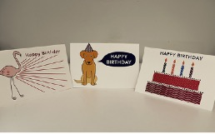   
**Photo caption:** Three birthday cards, one with a flamingo, one with a dog in a birthday hat, and the third showing a birthday cake with Happy Birthday written in text and braille.

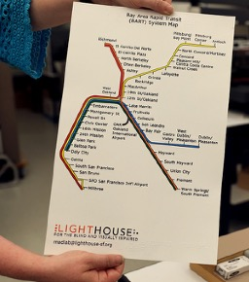   
**Photo caption:** A TMAP showing the Bay Area Rapid Transit (BART) System Map with LightHouse logo on the bottom.

## **ADAPTATIONS BLIND TECHNOLOGY STORE**

[Adaptations](https://adaptations.org/) is the only place in Northern California with a comprehensive offering of tools, technology, and other

solutions for blind and people who have low vision.

**2020 Statistics**

Total number of items sold: 5,257

Total number of transactions: 1,849

Total number of unique customers: 1,235

Number of visitors to Adaptations.org since its launch: 15,185

Total number of online orders: 487

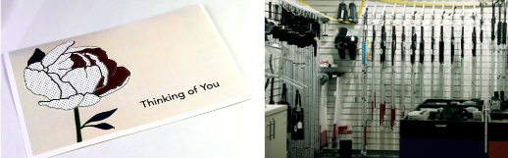

Photo captions:

Image 1 – Card with a flower with “Thinking of You” in text and braille.

Image 2 – White canes hung on the wall in the Adaptations store.

## **THE SIRKIN CENTER**

For decades, The Sirkin Center has provided employment for people who are blind. These jobs include customer service, shipping and receiving, inventory management and light manufacturing – making tissue packets which are included in MREs (Meals Ready to Eat) in emergency rations utilized by soldiers, rescue workers and firefighters in the field.

Recently Sirkin Center expanded the business to include the production of EPA Safer Choice PRIDEClean cleaning and disinfectant products. This is a line of non-toxic, green cleaning products used at private and public facilities around the country. [The products contain no ammonia, phosphates, are biodegradable and contain zero to low VOCs](https://lighthouse-sf.org/sirkin-center-cleaning-products/). **The Sirkin Center also produces**[Skilcraft Glass and All-Purpose Cleaners and Pure Bioscience Hard Surface Disinfectants](https://lighthouse-sf.org/skilcraft-lighthouse-chemicals-sds-and-ingredient-information/)**in partnership with** **National Industries for the Blind and the Ability One Commission.** PURE Hard Surface Cleaner contains no bleach, ammonia, phosphates, phenols or VOC emitting compounds through an odorless formula that is non-caustic and non-irritating. In 2020, PURE was added to the EPA’s List N as a product that is effective against COVID-19.

The Sirkin Center is one of LightHouse’s initiatives dedicated to the employment of people who are blind. By the end of 2021 we expect that 30 blind people will be on payroll at the Sirkin Center. Blind employees hold a variety of positions including a scientist hired in 2020 to oversee our quality control program. In an unprecedented year, Sirkin Center has greatly increased our customer base, productivity and support for LightHouse programs.

Packets of tissue produced in 2020: 51,000,000

Line filled bottling in 2020: 600,000 units

85 percent of the direct labor in our facility comes from blind employees. We doubled our employees from 10 to 21 employees.   
  
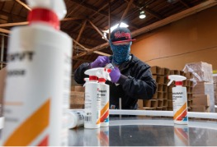 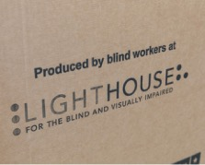  
  
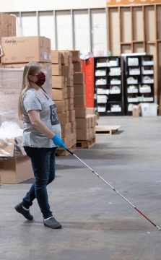 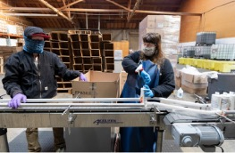



**Photo captions: Image 1** – Masked LightHouse Production Assistant Valentino Benelli bottles cleaning product at Sirkin Center. **Image 2** – A cardboard box used to ship product, labeled with the words “Produced by blind workers at LightHouse for the Blind and Visually Impaired.” **Image 3** – A view of masked Production Assistants Jennifer Holloway with Valentino Benelli bottling cleaning product at Sirkin Center. **Image 4** – One thousand-pound rolls of toilet paper await repackaging at the Sirkin Center in San Leandro. **Image 5** – Masked LightHouse Production Assistant Rebecca Reinier walks across the warehouse floor of Sirkin Center with a white cane.

# **Who We Reach**

Part of LightHouse’s mission is to communicate the truth about blindness to the widest possible audience. These prominent media sources published articles about LightHouse in 2020.

**60 Minutes**  
[Board Member, Chris Downey and LightHouse were featured again on 60 Minutes](https://vimeo.com/312158662)

**BBC Radio In Touch**  
Listen to 2019 Holman Prizewinner: [Mona Minkara On Her Global Public Transport Experiences](https://monaminkara.com/ptc).

**BBC World Service**  
[Watch this BBC World News report about how LightHouse Industries staff who are blind and have low vision are providing essential products to help fight COVID-19 during the pandemic.](https://youtu.be/yBqA8CVUWk4)

**San Francisco Chronicle**  
[LightHouse Industries photo essay.](https://www.fnphoto.com/blind-workers-produce-toilet-paper-for-the-us-military/)[On the bright side: Blind workers on a roll making toilet paper at San Leandro factory](https://www.sfchronicle.com/bayarea/article/On-the-bright-side-Blind-workers-on-a-roll-15227517.php)

**Sight Tech News**  
[Accessibility from the wheels up: the Waymo self driving taxi](https://www.youtube.com/watch?v=xkBIJ8mejDM)

**Vice News**  
[Vital Coronavirus Information Is Failing the Blind and Visually Impaired](https://www.vice.com/en_us/article/4ag9wb/vital-coronavirus-information-is-failing-the-blind-and-visually-impaired)

**The Napa Valley Register**  
[COVID-19 concerns cancel Napa summer camp for blind students](https://napavalleyregister.com/news/local/covid-19-concerns-cancel-napa-summer-camp-for-blind-students/article_fb442bf3-6673-58d1-b811-c8a71b5e84f7.html#tracking-source=home-top-story-1)

**NBC Bay Area**  
[NBC Bay Area Visits 2019 Project Innovation Recipient](https://www.nbcbayarea.com/community/project-innovation/nbc-bay-area-visits-2019-project-innovation-recipient/2229225/)

# **ADVOCACY**

**In 2020 we worked with advocacy groups, companies and organizations from across the nation.**  
AbilityOne

AER

American Camp Association (ACA)

American Foundation for the Blind

American Printing House for the Blind

American Red Cross

Americorps NCCC

Bay Area Arts Access Collective

Better Market Street Coalition

Blindness Support Services in Riverside

Braille Institute of America

CCBVI, Stockton

California Able Act Board

California Blind Advisory Committee

California Council of the Blind

California Department of Rehabilitation

Canadian National Institute of the Blind (CNIB)

Center of Vision Enhancement

City and County of San Francisco

Cruise Automation

Dayle McIntosh Center

Department of Veterans Affairs

Disability Rights Advocates

Earle Baum Center

Foundation for Independent Living Centers

Mid-Market Community Benefit District

Mt. Veeder Fire Safety Council

Napa Open Space District

Napa Resource Conservation District

National Association of Blind Students

National Federation of the Blind

National Federation of the Blind of California

NIB

Nicole Lee Consulting

Northern California Association of Orientation & Mobility Specialists (NCAOMS)

Northern California Deaf-Blind Association

Pride Industries

San Francisco’s Mayor’s Office on Disability

San Francisco State University Teachers of the Visually Impaired and Orientation and Mobility Departments

SF Tech Council

Senior & Disability Action

SF Public Utilities Commission

TRE Legal Services

United States Association of Blind Athletes

VisionServe Alliance

Vision Zero- Safe Streets

Vista Center for the Blind

Waymo

World According to Sound

World Blind Union

World Institute on Disability

## **ACCESSIBILITY** **We consulted and worked on tech and accessibility with companies all over the world, including:**

Amazon

AnswerLab

Automattic Inc.

Blackbird Studios

Google LLC

Level Access

LinkedIn

McGraw-Hill Higher Education

NEST

Volkswagen Group

# **2020 Financials**

## **Support and Revenue:**

Government Contracts and other grants: $1,497,692

Donations and Bequests: $1,484,537

Sales: $4,958,504

Fees for Service: $1,085,849

Interest and Dividends: $2,956,924

Insurance Reimbursements: $593,677

Other Revenue: $385,609

**Total Support and Revenue: $**12,962,792  
  
**Operating Expenses:**

Program Services: $14,064,280

General and Administration: $2,992,180

Fundraising: $1,276,581

Total Expenses: $18,333,041

## **Change in Net Assets from Operations: $5,370,249**

## **Other Gains and Losses:**

Realized and Unrealized Gains (Losses) on Investments, net of fees: $4,677,398

Change in Value of Interest Rate Swap: ($604,376)

**Change in Net Assets: ($1,297,227)**

**Four Photo collage. Alt text left to right:
Image 1 – Former Board member Jerry Kuns holds a white cane and waves to Development Director Jennifer Sachs, who is wearing a mask.
Image 2 – San Francisco Mayor London Breed holds up a TMAP of the Civic Center that she received on White Cane Day, 2019 at the LightHouse.
Image 3 – Kathy Abrahamson, Director of  Rehabilitative Services, stands with Alyah Thomas, Administrative Assistant EHC/Deaf-Blind, in the conference room at LightHouse. Both are wearing masks.
Image 4 – Campers sit in Redwood Amphitheater at EHC, behind two redwood trees in 2019.
**

Photo captions left to right:

Image 1 – Former Board member Jerry Kuns holds a white cane and waves to Development Director Jennifer Sachs, who is wearing a mask.

Image 2 – San Francisco Mayor London Breed holds up a TMAP of the Civic Center that she received on White Cane Day, 2019 at the LightHouse.

Image 3 – Kathy Abrahamson, Director of Rehabilitative Services, stands with Alyah Thomas, Administrative Assistant EHC/Deaf-Blind, in the conference room at LightHouse. Both are wearing masks.

Image 4 – Campers sit in Redwood Amphitheater at EHC, behind two redwood trees in 2019.

# **LIGHTHOUSE DONORS**

LightHouse is grateful to our thousands of donors who, for 118 years, have made it possible to meet our community’s needs.

We couldn’t do our work without you.

Note: Members of our monthly giving program, the Compass Club, are marked by an asterisk.

**$100,000+**

**COMPANIES,**

**CORPORATIONS AND**

**FOUNDATIONS**

North Loop 3, LLC

**$50,000 – 99,999**

**COMPANIES,**

**CORPORATIONS AND**

**FOUNDATIONS**

Consumer Technology Association

Foundation

**$35,000 - $50,000**

**INDIVIDUALS**

Inez E. Martini

**COMPANIES,**

**CORPORATIONS AND**

**FOUNDATIONS**

American Honda Foundation

Comcast

**$25,000 – 34,999**

**COMPANIES,**

**CORPORATIONS AND**

**FOUNDATIONS**

Mr. and Mrs. G. Kirk Swingle Foundation

Schwab Charitable

Uber Technologies

**$10,000 - $24,999**

**INDIVIDUALS**

Ronald and Lois Bloom

Ken and Jennifer Bunt

Nancy Foss

Fred Ruhland

Charles and Elizabeth Travers

John Wilhelm and Tora Isi

**COMPANIES,**

**CORPORATIONS AND**

**FOUNDATIONS**

Charitable Adult Rides & Services,

Inc. (CARs)

Delong-Sweet Family Foundation

Delta Gamma Foundation

Dodge & Cox Investment Managers

Facebook

First Dollar Foundation

Hobson/Lucas Family Foundation

JS & S Michaan Foundation

National Endowment for the Arts

Pacific Gas and Electric Company

Polara Enterprises, LLC

Syar Foundation

The Annunziata Sanguinetti Foundation

The Benevity Community Impact Fund

The Travers Family Foundation

The Walt Disney Company Foundation

**$1,000 - $9,999**

**INDIVIDUALS**

Edward Adams

Ginger and Don Anderson

Sweta Arora

Jennison Asuncion

Judy Barrett

Douglas E. Bergman*

Marilyn Brown

Marie Anne Burkhard

Sandy Cademartori

Lisa Carvalho and David Mager

Joseph Chan*

Horng-Yee Chou

Laura Cinquini

Robert and Pamela Clark

Michael and Leslye Dellar

Kirk and Tamara Dittmar

Joyce M. Dubay

Barbara Eddy

Signe Erickson

Marjorie Follette

Jonathan Funk

Claire Gaudiani and David Burnett

Martha Girdlestone

Candice and Jesse Gomez

Zarah Gulamhusein

Patricia and Greg Gump

Vivian Guze

Gena Harper

Nancy K. Hayes

Eugenia H. Haynie

Mr. and Mrs. Richard Hesse

Judy Howard Giles and Ray Giles

Randolph James

Dwight Johnson

Ronald and Susan Kahn

Mr. and Mrs. Komala Kailash

Andrew Kebbel

Roberta Kehret

Shawn Klein

Nancy Ku and Thomas Wei

Jerry A. Kuns

Elizabeth Laflamme

Barbara J. Lassen

Paul and Jerrie Lore

Peter Lovecchio

Eric and Jacalyn Mah

Michael F. Marmor, M.D.

Karen Meryash

Jane and Robert Micks

Tarak Mody and the Mody Family

Geoffrey Murry

Timothy Ng

Margaret Niland

Bill Norton

Michael Nunez

Paul Park

Rachel Perkins

Luciana Profaca

Sharon and Richard Sacks

Rachel Sanders

Richard and Monica Schoenberger

Seema Shams

Michael and Carole Shebanek

Moira Shek

Diane and Howard Slater

Marc Sola

The Stadlin Family

Richard Stevens and Virginia Behm

Noemi Rebeli Szabo

Timothy Teske

Vrishali Thorat

Patti Birge Tyson

Marco A. Vidal Fund

Carmen Rose Wayson

David and Regula Weill

Daniel Willhite

Henry and Sandra Wong

Bonnie and David Young

Jacqueline Young

**COMPANIES,**

**CORPORATIONS AND**

**FOUNDATIONS**

Alice Phelan Sullivan Corporation

America’s Best Local Charities

Apple, Inc.

Asymmetric Publications

Blaisdell’s Business Products

Bright Funds Foundation

Business Links, Inc.

Charles Schwab Corp

Chateau Montelena Winery

Coach, Inc.

Community Projects, Inc.

Dean & Margaret Lesher Foundation

Ed & Betty Manoyan Foundation

Equinix

Fidelity Charitable Gift Fund

Fitness SF

Goodwin Family Memorial Trust

Handiworks

Herbst Foundation, Inc.

Humboldt Area Foundation

Humboldt Health Foundation

IBM Retiree Charitable Campaign

Iglewski Family Foundation

J.P. Morgan Securities

Kawakami Barron & Lam, LLP

Kurland Family Foundation

Lawrence Livermore National

Laboratory

Marin Community Foundation

Mel & Grace McLean Foundation

N.D.G.W. Childrens Foundation

One Market Restaurant

Perkins & Will, Pfau Long

PG & E Corporation

S.A. Camp Companies

Salesforce Foundation

San Jose East Valley Lions Club

Santen Incorporated

Subaru of America Foundation

Tapestry

Telecare Corporation

The Excel Fund

The Guardsmen

The Henry Luce Foundation, Inc.

The Marmor Foundation

Vanguard Charitable

Volkswagen Group of America, Inc.

Walter E. and Barbara A. Bauke Foundation

Wells Fargo Foundation

**$100 - $999**

**INDIVIDUALS**

Sheri Albers

Peggy Aaron

Judith and Douglas Adams

Yvette Albright

Nancy Allen

Laura and Peter Allen

Jena Allison

Roland M. Andersen

Cynthia and Paul Anderson

Raymond N. Applebaum

Carmelita and John Arburua

Concepcion Arista

Alexia Arriola

Elizabeth L. Ashley

Joseph Ayres

Debbie Bacon

Jim J. Baie

Alan Ball and Sharon Ewing

Peter and Judi Bank

Shirley Banks

Dr. Vishal Banthia

Sylvia Barata

Joan and John Barkan

Dylan Barrell

Dr. and Mrs. Richard B. Barrick, M.D.

Roger Barrow

Olive Bavins

Margaret Bayer

Steven Bayles

Elizabeth and Iraj Behseresht

Dr. Richard Beller

Jane D. Bennett

Lisa Berger

Bryan and Barbara Bergsteinsson

Arlene Bernstein

Charmaine L. Berry

Joshua Bingham

Noel Bishop-Lenci

Bernhard H. Bittner

Patrice Blanchette

Paul Blaney*

Judith Blankman

Brooke Bledsoe

Clemence and Independence Blondo

Lilia Bloom

Valerie Booth

Nora and John Boothby

Brian Borzone

Barry and Adriane Bosworth

William and June Bowen

Adrian Bozzolo

John Brase

Jonathon and Liz Brauer

Maxine Brauer

Michael and Phoebe Bressack

Mary Jo Broderick

Mary and Robert Brown

Michael and Julie Brown

Reg and Jo-Ann Brown

Richard and Alice Brown

The Brown Family Fund

Susan Bullock

Avery Burdette*

Charles Bureker

Ronald and Debra Burgess

Arsella Burton

Charlotte Burton

Natalie Byrne and Michael Schwandt

Anne Cahn

Carl Bunch and Marjorie Caldwell

Lee Canady

Judy Candlish

Joanne Carchiolo

Donna and Oney Carrell

Shari Carter

Charles Casey

Joann Cassidy

Albert Cavazos

Andrew Cedarblade

Shivani Chamakura and

Naresh Kumar

Kancharla

Angela Chan

Buddy Chan

David and Judy Chan

Thomas and Sharon Chan

Cathy Chappuis

Gao Chen

Mindy and Jerry Chen

Sherman Chen

Shumei Chi

Dr. John Chodera

Barry Christian

Eldonna Christie

William and Daisy Chu

Gina Cibuzar

Joyce Cid

Austin Clay

Richard and Marilyn Clothier

Vicki Coe and R. Scott Mitchell

Christie and Stephen Coffin

Janet Cohen

Christine E. Collins

Miguel Contreras

Linda and Craig Corey

Sandra Cornell

Geraldine L. Corvi

Constance and Dave Costa

Kelley Cowan

Brandon Cox

Colleen Crahan McCarthy and

Lawrence McCarthy

Allen Cristofani

Mary Jo Culver

Dianne M. Curtis

Bonne Curtis-Leibee and Henry Leibee

Deborah Danielewicz

Linda Dardarian

William and Jaci Daskarolis

Carol C. Davis

Carol Davis

Lloyd E. Davis

George and Linda Spain de Bruin

Steven Delucchi

Virgil and Ruth Dennis

Shirley Deoliviera

Peggy Deterding

Gina di Grazia

Jane Diamond

Kevin Dieu

Raffaela Dinelli

Loretta Dipboye

Gloria Dobbins

Gene and Denise Dolan

Margaret Mary Dolan

Jerome and Joanne Donovan

Robert Dossee

Brenda Douglas-Lamadrid

Mr. and Mrs. James Downer

Chris and Rosa Downey

Talbert Dsouza

Crystal Dykstra and Tiffany Bush

Toni Eames

N. Jean Edge

Joseph Ehrman III

Daniel Einstein and

Marsha Goodman

Dylan Elissiry

Paul and Elisa Elissiry

Scott and Beverly Erwin

Lewis J. Feldman

Olivia Fiel Peralta and Oscar Peralta

Roberta Flagg

David and Vicki Fleishhacker

Anthony Fletcher and Betty Sapien*

Phillip R. Foster, Jr.

Adam and Krystyna Franczak

Julia S. Frank

Snjezana Frankovic

Erling Fredell

Cathy Freese and D.R. Gillis

Vicki Friedberg

Rhea Friedman

Don and Peggy Fromm

Jim Fruchterman

Phyllis Fullmer

Holly Galbrecht

Catania C. Galvan

Amey Garber and Richard Lesnick

Edward Garcia

Leslie Gardner

Rosemarie Garland-Thomson

Harry Gazarian

Dean M. Genes

Lisa and Jory Gessow

Lisa Giannini

Kathleen Gilbert

Nancy and Stephen Gill

Nicola and Michael Gillespie

Donald Ginn

Margaret E. Ginsburg

Jenny Girard Malley

Diane Goldman and David Singer

Judith and Mark Golod

Maria Gonzalez

Ron Graddy

Linda and Frank Grange

Eva Gregoratos

Lenore M. Griffin

Shaun Griffith*

Roseann Grimm

Janice Grover

Suresh and Usha Gupta

Jean Guttman

Joshua and Kalpana Guttman

Mary Gwynn

Pamela Habek

Dexter and Carol Hake

Sally Hale

Conor Hallinan

Dave and Char Hamilton

Hali Hammer and Margaret Hutchison

Alex Harding

Jonathan Hargest

Anthony Harper

Phillip and Julie Harris

Jeri and Van Hart

Joan M. Harter

Arthur Hartman

Joseph Haubach

Mayela Heacock

Donna Heatherington

Jim and Sharon Heath-Pagliuso

BethAnn Heffner

Alan Hencky

Michael Henderson

Derek and Elizabeth Henninger

Stephen Herman

Mark Herrmann

Steven R. Hibshman

Elaine Hilp

Kit and Linda Hinrichs

Karen Ho

Charles Hoffman

Stephanie W. Holbrook

Jeremiah Holder

Greg and Anita Holquist

Frederic Holub and G. McNally

Mark Hoose

Erin Horne

Joseph and Patricia Howell

Frank Howland

Carolyn and Irvin Howlett

Evan Hughes, Jr. and Linda Craig

Honor and Hillard Huntington

Zoe Hunton

Rachel Inboden

Frederick J. Isaac

Lee Isola

Jack D. Jackson

Ajay and Kalpana Jaggi*

Raymond Jewel

Margaux Joffe

Gil and Becky Johnson

Betty Jones

Kelly Jones

Jerome and Mary Joseph

Stephen Juhasz

Roger Kallen

Evelyn and Peter Kamas

Barry and Shirley Kaminsky

Gay and Harvey Kaplan

Rosemary and Daniel Kaplan

Gaylon Kastner

Robert Katz

Susan R. Katz-Snyder

Julie Kaufman

David and Judith Keyes

Toni Kiernan

Stephanie Kincaid

Joel King

John and Mary Kirlin

Jeanne Kirsch

Elizabeth Kneer

Diane Ko

Thomas and Dorothy Komnick

Martin Krasney

Matthew Kroh

Dean Krutty

Ralph and Carol Kuiper

Tracy Kwok

Marc Lambert

Scott Landry

Susan Lapin and Kenneth Ward

Mr. and Mrs. James LaPlante, Jr.

Chris Lawyer

Gabriel Ledger

Grace and Don Lee

Kim Han Lee

Nancy D. Lee

Wanshu Lee

Anthony Lenzo*

Corey Lesh

Mary Lesh

Wallis and Harry Leslie

Dr. Robert G. Levenson

Dan and Evelyn Levin

Marc Levin, M.D.

Anh-Thu Lewis

Katherine Lewis

Norma and Dennis Libby

Stephen Lindbeck and Martha Ginsburg

Doris Linnenbach

Abe Livchitz

Andres Lopez-Pineda*

Buu Thanh Lu-Hong

Erik and Christina Lunde

Min Ma

David and Mary Maas

Galusina Mageo

Nicole Maher

Sherril Maier

Robert and Patricia Maines

Shawn and Leann Majors

Arun Malhotra

Mary J. Malloy, M.D. and

John P. Kane, M.D.

Robert Manning

Robert and Edna Manzoni

Jean Mar

Velma Markins

Nancy Marshall

Jeffery and Carol Martin

Lisamaria Martinez and Joseph Bakker

Peggy Martinez

Kimberly and Bob Marzullo

Natalie Mauskopf

Michael May

Christine Mayer

Ruth Mayerhofer

Sharon Mayo

Dr. Elliot E. Mazer and Mrs. Trudy Mazer

Lisa McAndrews

David and Rose McCallen

Tony and Linda McClimans

Joyce McCulloch

Cliff McElrea

Sean McGaughey

Cliff and Nancy McGoon

Allene McIntyre

Joan McKenna

Jack and Cindy McMurry

Richard Meggitt

Janet Meiselman

Donna Meixner

Eric Meltzer

Laurell Meredith

Hans and Edith Merten

Spencer and Roberta Michels

Charles and Dorothy Michelsen

Mr. and Mrs. Daniel Miller

Harrell Miller

Patricia Miller

Denise Minaberry

John Moody

Davia Moore

Julia Moore

Beverly and Thomas Morgan

Cynthia J. Morris

Michael D. Morris

Paul V. Morris

Anna M. Morrison

Lisa Morrison

Doris Mullen

Rosemary Murphy

Robert and Lynne Myers

Thomas Myers and Wanda Pansky

Joann Naganuma

Kamna Narain

Terry and Diane Neff

Joseph Nezwek

William and Janet Nicholls

Andrea Nielsen

Tracy Odell

Kelly O’Donnell

Robert E. O’Donnell

Joseph O’Flynn

Valarica Olfers

Joann and John O’Loughlin

Helge and Birgitta Olsen

Carol Olson

Patti and Doug Olson

Michael O’Malior

Janise On

Roger and Teresa On

Vicki and Laurence Oppenheim

Stephen Orndorf

Benjamin Orozco

Kevin Oshiro*

Nora O’Sullivan

Richard Oswald

Abraham Otoupal

Charlene and Leo Ott

Monica Ouellette

Kenneth Pacini

Michael and Kathleen Pack

Stanley and Diane Pamel

Raymond Panattoni

Joan and Jeffrey Panero

David Patten

Thomas Paukert

Karen Pearlman

Eric Peden

Stephen Max Perr and Holly Christman

Alice Peters

Cynthia Peters

Elizabeth Pezone

Michael Pezone

Mary and Edward Phillips

Jennifer Phipps

Louis Piccolo

Michael Plafker

Antonio Plasencia

Elyssa Plasencia

Ted Prim

Alicia and Edward Ramirez

Charles and Patricia Raven

Shahid Rehman

Melanie Reid

Robynn Reilly

Robert and Laura Repke

Russell Rettig

Judith Reynolds

Christopher Ring

R.M. Robelo

Anne Roberts

Bill and Marilyn Robertson

Andrea Robinette

Martha Robinson

Edwin and Elizabeth Roland

Joseph and Donna Rollins

Lyn Romanko

Ruby and Christopher Romano

Dennis and Linda Ronberg

Peter and Beth Rosenthal

Rita Rosenthal

Thomas Ross

Frances Rothenberg

Elizabeth Ruellan

Claudia Rutz

Patrick and Miriam Ryan

Patrick Ryss and Abbey Myszka-Ryss

Mr. and Mrs. Eugene W. Rzym

Jennifer Sachs and William Maggs

Gary Sada

Lola and David Safer

Donna Sanchez

Linda Sanders

Buzz Sapien

Daniel Sapien

Graciela Tiscareno Sato

Carol Saul

Michele Scafani

Dr. Richard Schaar

Wendy Scheffers

Kurt Scheidt

David and Nanka Schneider

Helen Schneider

Jeanne Schoch

James Schwartz and Anneliese Magnelia

Judith Schwedes

Mary Beth Schwehr

Janna A. Scopel

John Scott

Lauren and Mark Scott

Edwin A. Seipp, III

Anita Seipp Marmaduke

Hari Sekhon

Jonathan Sellen

Elisabeth Semel

John Sensenbaugh

Anna and Stanley Shaff

Lucille Shanahan

Susanne Sheeran

Leslie Siegel

Karen and Mike Siladi

Sandra Simon

William E. Simpson, Jr.

Hope Sinclair

Rebecca and Matthew Singer

Chander Singh

Yue-Ting Siu

Igor Skaredoff

Tomasz Skucha

Dr. Howard M. Slyter and Ms. Marjorie E. Ginsburg

Thomas F. Smegal, Jr.

Michael Snow

Amy Sohnen

Susan Sola

Andrew Solari

Jerome Solberg

Alexandre Spehler

Jonathan Spiro

Robert Spotts and Herbert Taxton

Eric Stauffenegger

Kevin Steege and

Camille Peterson-Steege

Lynn Stelmah

Judie and David Stepner

Steve Stewart

Barbara and Warren Stone

Martin Stone

Frank Stuhler

Juliette Surette

Lauren Swanson

Robert and Susan Sweetman

Lucinda Talkington

Robert Talkington

Louise and Jack Tayan

Jack Taylor

Virginia and Robert Temm

Sylvia and Robert Thalman

Mr. and Mrs. Clay Thompson

Dorthy M. Thompson

Clifford Thornell

Richard Tidd

Sameer and Reena Tiwari

Carolyn Tomooka

Karen Torney

Michelle Touw

Jill Townsend

Leslie Trela

Suzanne and Jeff Tremolada

Dr. Mindy D. Trinh, O.D.

Steven Tschacher

Barbara Twedt

Robert Tyson

Jane Unger and Joseph Nezwek

Ahmet Ustunel

Danielle Uttley

Beth Vandiver

Dorothy and Albert Vasquez

Prindle Vaux*

Jeffrey and Lori Veliquette

Alan Venook and Carolyn Small

Martha and Tom Viola

Megara and Marc Vogl

Nhon T. Vuong and Xuan Hieu Thi Phung

Dirk Walvis and Carolyn Dille

Anne Ward

Jeffery and Sabrina Ward

Erik Weihenmayer

Dorothy H. Wesley

Joy and David West

Monique Weston

Roger Wickstrom and Petrina Grube

Sofia Widjaja

Lois Williams

Sandra Williams

Stuart and Donna Wittenstein

Gary Wolff

Rebecca and Peretz Wolf-Prusan

Adrianne and Bruce Wonnacott

Michelle Woodhouse

Judith and Jerold Yecies

Lawrence and Gwendolyn Yee

Chenyu Yen

Julia Young

Ronald and Linda Young

Tiffanie Yu

Patty Yuk

Doug Yule

Michael Zelazek

Gary and Linda Zellerbach

Rebecca and Richard Zeren

Susan Zertuche

Dr. Frank Zisman and Mrs. Katerina Zisman

Mr. and Mrs. Simon Zisman

Roy Zitting

Albert and Teresa Zobrist

**COMPANIES,**

**CORPORATIONS AND**

**FOUNDATIONS**

Alan Shapiro-Elizabeth Shapiro

Charitable Foundation

AmazonSmile Foundation

Anchor Oyster Bar

Apollo Lodge 123 IOOF

Applied Materials Foundation

AT&T Employee Giving Campaign

Body Flows, LLC

California Council of the Blind -

San Francisco Chapter

D.A. Davidson & Co.

Deutsche Bank Americas Foundation

Dodge Stores

Dry Creek-Lokoya Volunteer

Fire Department

Exploratorium

FASTSIGNS of Kirkland

Fontanella Family Winery

Gap Inc. Workplace Giving

Hip Sen Bent Association

IBM Employee Services Center

IDEO San Francisco

International Brotherhood of Electrical Workers/Local Union 6

Invision Optometry

Jewish Community Federation and Endowment Fund

Jewish Family and Children’s Services

Karste Consulting, Inc.

Lions Club of Norfolk Foundation

MOAD

Valley Restorations LLC

Napa Valley Community Foundation

Napa Valley Petroleum, Inc.

Pile Drivers, Divers, Bridge Wharf & Dock Builders

Shamrock Properties

Signs of Our Times, Inc.

Silicon Valley Community Foundation

Target

United Way Monterey County

Viet Huong Fish Sauce Company

Wells Fargo Community Support

**ESTATES**

Lynda H. Altfield

Barbara J. Barr

Horace Crane Day

Emmy Lou Drake

Thomas Dutra

Walter Girdlestone

Catherine Jair

Rolph-Nicol Trust

Annette Schroeder

E.B. Storrow

Emma G. Trebilcot

Dorothy M. Walker

Regina Y. Walker

Lillie Wissman

William W. Witney

**LEGACY SOCIETY**

Hank Boerenko

Lisa Carvalho and David Mager

Joseph Chan

Margie Donovan

Joan M. Dove

Lewis J. Feldman

Robert Ray Foster

Jonathan Funk

Gena Harper

Dolores Ippolito

Ronald and Susan Kahn

Roger Kallen

Justin Kim

Judith Kuhnle

Jerry A. Kuns

Marjorie McWee

Ann Noble and Goran Muhlert

Robert E. O’Donnell

Jill Patton

Robin Schneider

Frederic and Kristine Silva

Richard Stevens and Virginia Behm

David and Regula Weill

Martin and Rosan Weissman

Jennifer Westbrook

Greg Wong

**LONGEVITY SOCIETY**

Anita Shafer Aaron and Robert Scott Aaron

Laura and Peter Allen

Max H. Allen

Italo Amerio

James Arbios

Elizabeth L. Ashley

Jim J. Baie

Peter and Judi Bank

Sylvia Barata

Dr. and Mrs. Richard B. Barrick, M.D.

Jane D. Bennett

Douglas E. Bergman*

Arthur H. Bernstein

Joan Berry

Bernhard H. Bittner

Paul Blaney*

William and June Bowen

Neil H. Brandt

Laura J. Bredemeier

Mary Jo Broderick

Doris B. Brodie

Lonnie M. Brown

Jean Bucaneg

James L. Buhler

John and Gale Bunnell

Anselmo and Alma Caballero

Lisa Carvalho and David Mager

Joseph Chan*

Joyce Cid

Ann Coleman

Barbara Conheim

Geraldine L. Corvi

Bernard Damele

Lance and Billie Darin

Dolores Davi

Carol Davis

Dorothy Dito

Margie Donovan

Leslie K. Doughty

Chris and Rosa Downey

Joyce M. Dubay

Layton M. Duffy

Joseph Ehrman III

Richard T. Ellebrecht

Ursula B. Farfel

Lewis J. Feldman

Olivia Fiel Peralta and Oscar Peralta

Anthony Fletcher and Betty Sapien*

Jennie Fong

Joyce L. Fong

Nancy Foss

Robert Ray Foster

Denise Freinkel

Herbert and Annette Gershen

Walter Howard Girdlestone

Candice and Jesse Gomez

Lenore M. Griffin

Leslie R. Guggenheim

Patricia and Greg Gump

Jean Guttman

June Harman

Gena Harper

Eugenia H. Haynie

Jacqueline M. Hendren

Helen Jean Henke

Wayne and JoAnne Herman

Steven R. Hibshman

Elaine Hilp

Erin Horne

Annette D. Howitt

Carolyn and Irvin Howlett

Frederick J. Isaac

Dwight Johnson

Gil and Becky Johnson

Robert M. Kane

Rosemary and Daniel Kaplan

Ilene and Gary Katz

Susan R. Katz-Snyder

Max C. Kirkeberg

Jerry A. Kuns

Marianne J. Larimore

Lieselotte Le Baron

Norma and Dennis Libby

Cara and John Lisica

Andres Lopez-Pineda*

David and Mary Maas

Lisamaria Martinez and Joseph Bakker

Fredrika D. May

Sharon Mayo

Sean McGee

Hans and Edith Merten

Brian Messina

Mary A. Montgomery

Paul V. Morris

Vivian Mullaney

Carolyn F. Mulliken

Mr. and Mrs. Donald Munakata

James R. Murphy

Robert and Lynne Myers

Diane and Robert Neuhaus

Trang Nguyen

Juan Ocampo Gomez

Robert E. O’Donnell

Helge and Birgitta Olsen

Vicki and Laurence Oppenheim

Florence M. Paraventi

Maja Jean Peters

Ted Prim

Luciana Profaca

Robert Rakshys

Alicia and Edward Ramirez

Joseph and Donna Rollins

Madeleine S. Rose

Rosita Rothschild

Florence M. Rusk

Nancy A. Russ

Jennifer Sachs and William Maggs

Janna A. Scopel

Vartan Shahijanian and Raymond Nolen

Stephen and Joanne Shapiro

Timothy and Mary Sheehy

Gladys Shegoian

Kenneth and Jean Shelley

Leslie Sheppard

Randi Slaughter-Broussal

Henry H. Small

Thomas F. Smegal, Jr.

Gerald G. Stangl

Todd Stevenot and Anne Sandbach

Charles and Matilda Stewart

George and Helene Strauss

Ted Tawshunsky

Patricia Taylor

Clifford Thornell

Robert Tyson

Prindle Vaux*

William H. Vederman

Joseph and Margaret Ward

Sisi Weaver

David and Regula Weill

Gary and Yaffa Weinstein

Betty Jean Weiss

Shelia O. Whittemore

Roy Zitting

Michael Zucksworth

Alice Phelan Sullivan Corporation

America’s Best Local Charities

AT&T Employee Giving Campaign

Bank of America Charitable Foundation

Bellini Foundation

Fidelity Charitable Gift Fund

Jewish Community Federation and Endowment Fund

Mr. and Mrs. G. Kirk Swingle Foundation

PG & E Corporation

Schwab Charitable

SF Park Presidio-Sunset Lions Club, Inc.

The Annunziata Sanguinetti Foundation

The Benevity Community Impact Fund

The San Francisco Foundation

Truist/Frontsream

United Way Monterey County

United Way of the Bay Area

Wells Fargo Community Support

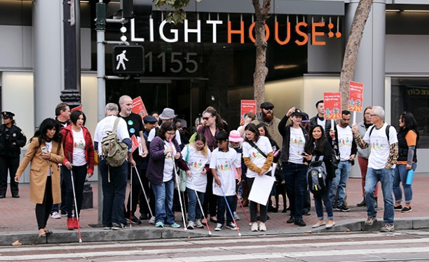

Photo caption: A group of LightHouse staff and supporters gathered outside LightHouse Headquarters in San Francisco on White Cane Day. Photo by Sarika Dagar

With the strength of kind donors and supporters, we are empowering the blind community, designing innovative programs and expanding our reach across California and beyond. Please consider a donation to support LightHouse for the Blind and Enchanted Hills Camp.

To learn more about how you can invest in the LightHouse and Enchanted Hills, please contact our Director of Development Jennifer Sachs at 415.694.7333 or [giving@lighthouse-sf.org.](mailto:giving@lighthouse-sf.org.)



1155 Market Street, Floor 10

San Francisco, CA 94103

Phone: 415-431-1841

VP: 415-255-5906

EIN 94-1415317

Learn more about what we do: [www.lighthouse-sf.org](http://www.lighthouse-sf.org)  
  
© LightHouse for the Blind and Visually Impaired 2021