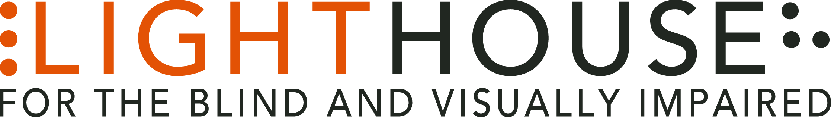

Here is wording to earmark a bequest to the LightHouse for the Blind:

I, ____________ hereby Give, Devise and Bequeath dollar amount ($____________) or percentage (____________%) of the rest, residue and remainder of my estate or specific asset(s) (_______________) to the LightHouse for the Blind and Visually Impaired, located at 1155 Market street, Floor 10 in San Francisco, CA, 94103 to be used for its general purposes (or specific program such as Enchanted Hills Camp for the Blind). If you have questions, or would like to inform us of your intentions, please contact us at (415) 694-7333 or jsachs@lighthouse-sf.org.

