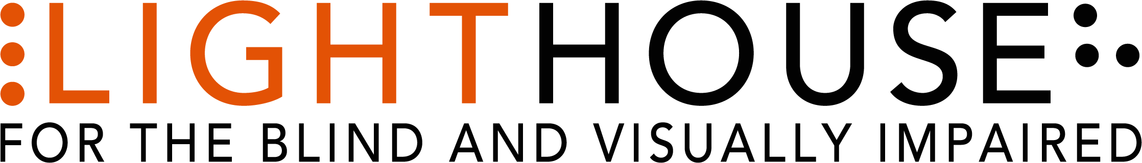

2019 Annual Report
Table of Contents for easy reference.

Page 1 - Cover Page with photo
Page 2 - Mission, Vision, Values with photo
Page 3 - Board of Directors, Executive Leadership, Locations
Page 4 and 5 – Letter from Board Chair with photo
Page 6 and 7– Our Programs
Page 8 – LightHouse Student Profile with photo and bulleted survey results
Page 9 – 2019 By the Numbers: Students, Hours, Ages, Program Hours, and Volunteers
Page 10 and 11 – 2019 Outreach: Counties, State and Countries served with State, National, and world map infographics
Page 12 – The Bunt Family donor profile with photo and three bulleted survey results
Page 13 and 14 – EHC with photos
Page 15 – EHC By the numbers: Campers, service hours, program
Page 16 – Camper Profile: Milo with photos and three bulleted survey results
Page 17 and 18 – Holman Prize for Blind Ambition with photos of 2019 winners
Page 19 – Superfest 2019 with description and photos
Page 20, 21, and 22 – LightHouse Social Enterprises: MADLab, LHI, Adaptations with photos
Page 23 – Who We Reach: LightHouse in the press, Advocacy groups we worked with, Tech and Accessibility consulting jobs
Page 24, 25 Financial Statements: Assets, Liabilities, Revenue
Page 26 – Photos of donors with captions
Page 27, 28, 29, and 30 – Donor lists
Page 31 – Back Cover with photos and LH contact information.

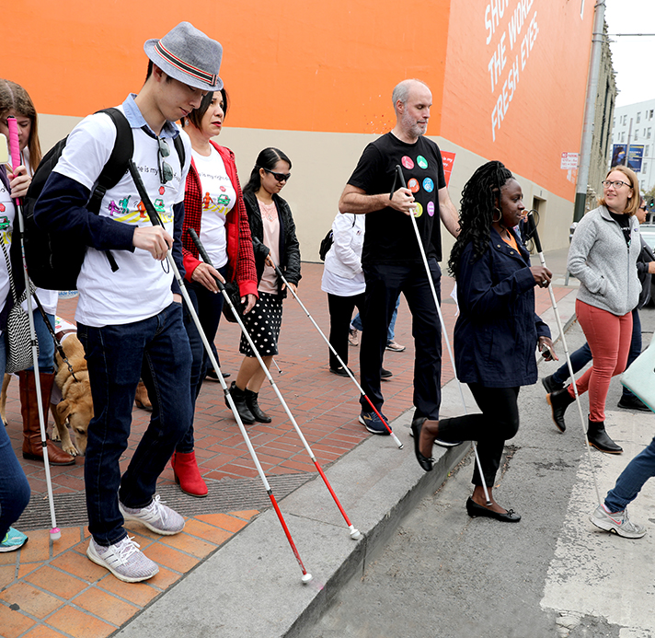
Photo caption: A group of sighted and blind people with outstretched white canes cross Hyde Street in San Francisco en route to City Hall. Photo by Sarika Dagar

MISSION
Founded in 1902, LightHouse for the Blind and Visually Impaired promotes the independence, equality and self-reliance of people who are blind or have low vision.

VISION
We offer blindness skills training and relevant services such as access to employment, education, technology, information, recreation, transportation and the environment. We also pursue the development of new technology, encourage innovation, and amplify the voices of blind individuals around the world.

VALUES
Advocacy, equality, collaboration, employment, literacy, education, innovation, independence, community
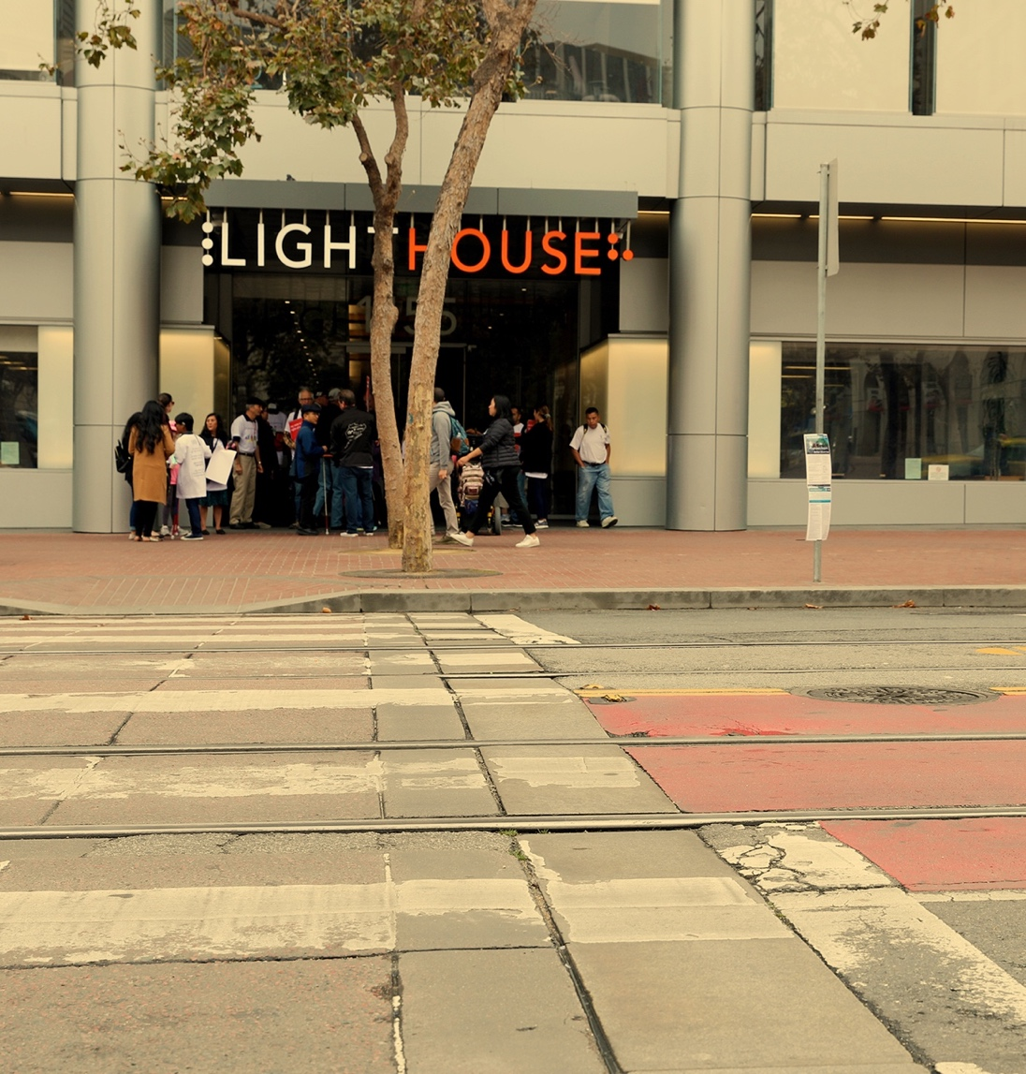
Photo caption: Photo of the LightHouse building and its entrance under a new, illuminated sign that spells LIGHTHOUSE. Students gather underneath. Photo by Sarika Dagar

BOARD OF DIRECTORS
Chris Downey – Chair
Architect, Architecture for the Blind
Lisa Carvalho –Vice Chair
Attorney
Gena Harper – Treasurer
Senior Vice President, Morgan Stanley
Geoffrey Murry - Secretary
Attorney, Ad Astra Law Firm
Laura Allen
Accessibility Program Manager, Google
Jennison Mark Asuncion
Engineering Manager for Accessibility, LinkedIn
Joseph Chan
Chief Financial Officer (retired), Association of Bay Area Governments
Michael Dellar
Co-Founder, President & CEO, One Market Restaurant
Chancey Fleet
Assistive Technology Coordinator, New York Public Library
Eric Mah
Financial Professional
Michael Nuñez
Attorney, Rosen Bien Galvan & Grunfeld, LLP
Luciana Profaca, Ph.D.
Chief Deputy (retired), California Department of Rehabilitation
Sharon Z. Sacks, Ph.D.
Superintendent (retired), California School for the Blind
Michael Shebanek
Head of Accessibility, Facebook
Yue-Ting Siu, TVI, Ph.D.
Professor, San Francisco State University
Ahmet Ustunel
TVI, San Francisco Unified School District

EXECUTIVE LEADERSHIP
Bryan Bashin
CEO

Scott Blanks
Senior Director, Programs

Brandon Cox
Senior Director, Operations

LOCATIONS
LightHouse for the Blind and
Visually Impaired (Headquarters)
San Francisco, CA

LightHouse Marin
San Rafael, CA

LightHouse East Bay,
Ed Roberts Campus
Berkeley, CA

LightHouse North Coast
Eureka, CA

Enchanted Hills Camp for the Blind
Napa, CA

LightHouse Industries
Sirkin Center
San Leandro, CA

A letter from our Board Chair

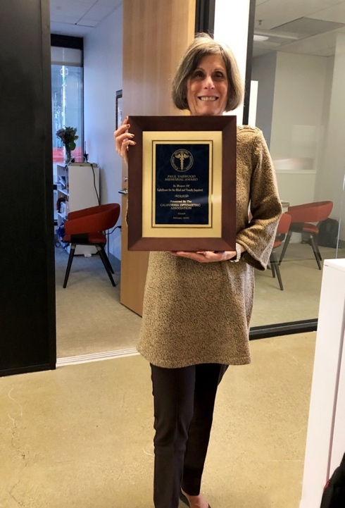
Photo caption: LightHouse Board Chair Sharon Sacks stands holding the Paul Yarwood Memorial Award presented to LightHouse by the California Optometric Association.

Dear LightHouse and Enchanted Hills Camp Community,

I’m pleased to introduce the LightHouse for the Blind 2019 Annual Report, highlighting our accomplishments over a year of substantial growth. As someone who has been on the LightHouse Board for a few years and has had a full career as a blindness educator, and as a woman who has had low vision all my life, I am proud to have recently begun my tenure as the Chair of the Board of Directors. Many of you know me as the previous Superintendent of the California School for the Blind. I know how vital it is for blind people to connect with others and meet mentors. Everything LightHouse does, from cooking classes to braille instruction to providing counseling to offering boot camp for people who are newly blind, is premised on joining a community of support, learning and aspiration.

There was a theme of geographic expansion this year. In response to a need for services where people reside, we opened a new LightHouse East Bay office with more space, additional staff and extended programming. There is a receptionist stationed there too, to help people feel welcome as they take the big step towards gaining blindness and low vision skills.

Our Employment Immersion Program began a series of job training workshops with an option to participate remotely. These students learn critical skills to land jobs in a competitive job market: a crucial program when 56% of working age blind adults are unemployed.
We also expanded our reach by putting our retail store, Adaptations.org, online at adaptations.org. There you’ll find over 800 products, from magnifiers to white canes to individualized tactile maps of any neighborhood.

At Enchanted Hills Camp, we hosted ten sessions for blind campers in the summer of 2019, including the largest teen camp ever. Since the ravages of the 2017 wildfires, our campers are housed in temporary bungalows and use portable restrooms, while we create a master plan, secure building permits, and seek funding to rebuild the entire camp.

National media highlighted our unparalleled programs with a full feature interview on the television show 60 Minutes with legendary host Lesley Stahl and LightHouse’s Immediate Past Board Chair Chris Downey, a blind architect. And we were delighted that San Francisco Mayor London Breed joined us to celebrate White Cane Day on October 15th.

Looking ahead, I’m excited about Access Technology’s work with many of the largest (and innovative) tech companies to ensure that blind people across the globe are able to use the technology of the future. The Holman Prize for Blind Ambition (HolmanPrize.org) is a project I’ve been especially involved with. The Prize continues to encourage blind people from all continents to dream big and live their lives to the fullest, while simultaneously challenging the sighted world to question their assumptions about the capabilities of people who are blind.

Finally, Enchanted Hills will celebrate its 70th Anniversary in 2020. We are seeking leaders in the community to step up and be a part of the campaign.

The transformative programs of the LightHouse and Enchanted Hills are possible because of wide and committed support from the greater community.
Thank you.
Best wishes,

Sharon Zell Sacks, Ph.D.
LightHouse Board Chair, 2020

OUR PROGRAMS

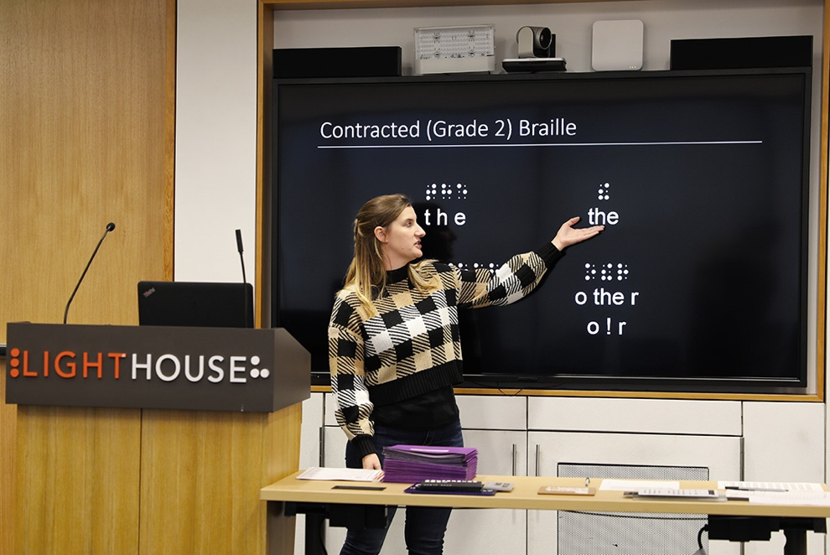
Photo caption: A presenter points at word ‘the’ written in braille on the presentation board for the benefit of sighted students, during an Accessible Signage Training at the LightHouse. Photo by Sarika Dagar

Access Technology - The Access Technology Department facilitates the use of accessible technology among people of all ages and levels of expertise. We work with companies on design consulting, functional accessibility review, and user testing sessions.
Adaptations Store - Located on the 10th Floor of our San Francisco headquarters, as well as online, Adaptations is the only place in Northern California with a comprehensive offering of tools, technology and other solutions for blind people.

COMMUNITY SERVICES – Social outings, professional mentoring, health education, nutrition, yoga, meditation, knitting, rafting, camping, accessible movie nights, arts, crafting, cooking and fitness programs.
PSYCHOLOGICAL COUNSELING SERVICES – Available in individual, couple and group settings, LightHouse counseling services support a student’s overall well-being.
Deaf-Blind Services – Deaf-blind students benefit from training, resources and free technology. In 2019, LightHouse supplied deaf-blind students with 450 pieces of equipment valued at $268,008.
Employment Immersion – Blind and low vision jobseekers receive personalized training to learn how to identify job openings, network, interview and secure meaningful employment. More than 100 graduates have secured employment since the program began in 2011.
Enchanted Hills Camp and Retreat – The oldest camp for the blind in the American West, hosting campers since 1950.
LightHouse Industries Sirkin Center – 75 percent of all direct labor at our light manufacturing plant in San Leandro is provided by workers who are blind or have low vision.
LightHouse Labs – A think-tank for technologists, corporations and designers to meet regularly with blind scientists, engineers and savvy consumers.

The Media And Accessible Design Lab (MAD Lab) – This team of designers produces tactile graphics, maps, 3D educational objects, ADA signage, braille and more. MAD Lab designers interpret museum exhibits, ensure universal access in construction and produce creative signage, maps, recordings or braille to deliver information to all.

THE JOSEPH CHAN LOW VISION OPTOMETRY CLINIC – In partnership with the UC Berkeley School of Optometry and located within LightHouse Headquarters, this is a low vision and primary care eye clinic.

Volunteer Services – Volunteers assist blind people one-on-one with reading mail, grocery shopping, and athletic endeavors; help maintain
Enchanted Hills Camp; and provide administrative support to keep LightHouse running smoothly.
Youth Programs – LightHouse offers activities for blind and low vision youth, including STEM education, outdoor adventures and a monthly, mentor– led employment series that encourages blind teens to prepare for professional success.
Blind and Low Vision Skills – Training in low vision and blindness skills, including orientation and mobility, braille, and independent living skills.

LightHouse Student Profile: Virginia Prince, age 35
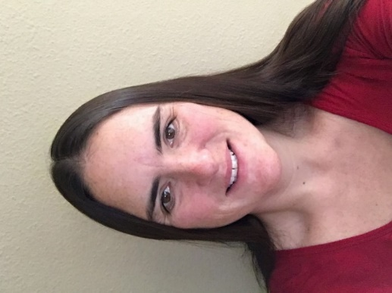
Photo caption: Portrait of Virginia Prince, Employment Immersion student.

“I have a BA in Psychology with honors from Mills College and a certificate in HR from UC Berkeley. I worked in non-profits mostly since college doing disability advocacy, people and leadership development, human resources, and community organizing.
I was connected to the LightHouse Employment Immersion program through the Department of Rehabilitation (DOR). I was fairly confident of my employment goal and my experiences going into the program. I enjoyed the day they had volunteers from Dolby come and do mock interviews. The whole team was helpful in the ways they could be. I benefited from Kate taking me to an HR networking event. Marc was helpful in talking through the blindness related application issues like when to disclose that I am partially blind and need accommodation. Ed helped me learn more about the Access to City Employment (ACE) program that San Francisco offered, which is how I ended up landing the job with the Department of Public Health.
I now work as a Reasonable Accommodation Coordinator for the City of San Francisco. I think my disability has been an asset to my role in assisting others to obtain the accommodations they need because I have had to advocate for myself my whole life! My supervisor, Hallie Albert, has been very supportive
and understanding of blindness related tools like JAWS screen readers and devices like CCTV’s. It feels great to have gotten a position
where my skills and abilities are valued as diversity and not as a strange nuisance.”

Highlights from our Student Surveys
*95% of students say that LightHouse is useful and relevant in meeting their interests and needs.
*84% of our students say that they are successfully using what they learned at LightHouse.
*95% of students found LightHouse staff to be professional and knowledgeable.

2019 Impact by the Numbers
Blind students served: 1,242
Teaching hours: 30,491.95
Ages:
65+: 509
25-64: 614
19-24: 92
13-18: 27
0-12: 2
Program hours
Adults and Seniors: 6,181.90
Youth: 8,969
Orientation and Mobility: 4,552.50
Braille: 765.75
Psychological Services and Counseling: 448.25
Rehabilitation (CVCL, ILS, Low Vision Clinic): 981
Employment Immersion: 897.25
Student Support (Advocacy, Family, Referrals, Transportation): 1,866.05
Access Technology: 3,765.25
Deaf-Blind: 2,065
Grand Total: 30,491.95 hours
Volunteer Programs
Total volunteer Service Hours: 19,386
Volunteer Groups: 28

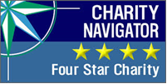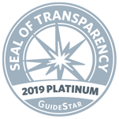
Four star Charity Navigator and Platinum GuideStar logos above

2019 Outreach
LightHouse reaches a robust network of students and organizations at state, national and international levels.
In 2019, LightHouse served 45 California Counties.

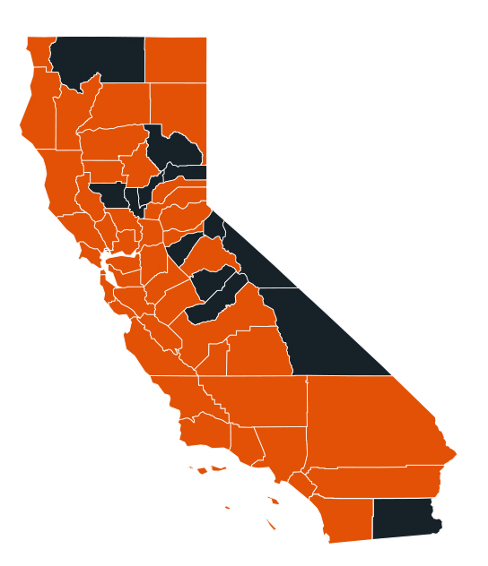
Photo caption: Map of the State of California Infographic

Counties Served:
Alameda
Amador
Butte
Calaveras
Contra Costa
Del Norte
El Dorado
Fresno
Glenn
Humboldt
Kern
Kings
Lake
Lassen
Los Angeles
Marin
Mendocino
Merced
Modoc
Monterey
Napa
Nevada
Orange
Placer
Riverside
Sacramento
San Benito
San Bernardino
San Diego
San Francisco
San Joaquin
San Luis Obispo
San Mateo
Santa Barbara
Santa Clara
Santa Cruz
Shasta
Solano
Sonoma
Stanislaus
Tehama
Trinity
Tulare
Tuolumne
Yolo

2019 Outreach

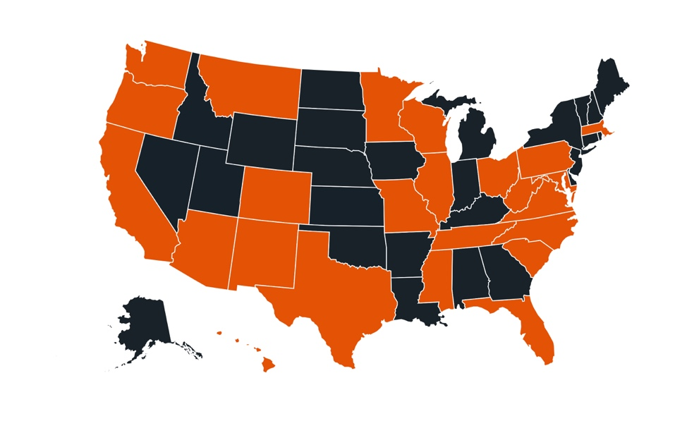
Photo caption: Map of nation infographic

Our national reach grows. In 2019, LightHouse served students from 20 states: Arizona, California, Colorado, Florida, Hawaii, Illinois, Massachusetts, Minnesota, Missouri, Montana, New Mexico, North Carolina, Ohio, Oregon, Pennsylvania, South Carolina, Texas, Virginia, Washington and Wisconsin We need to make it accessible with a list of states highlighted in the graphic

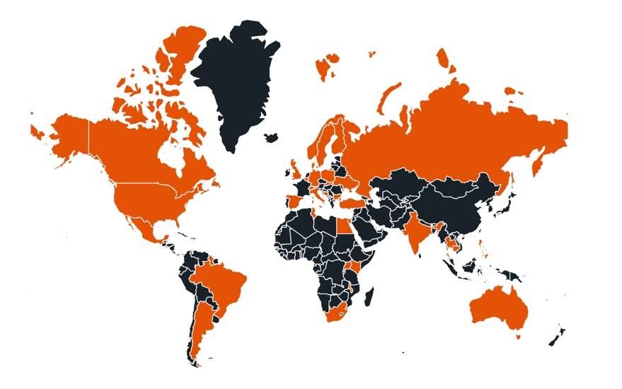
Photo caption: Infographic map of the world
Thanks to our Holman Prize Holman Prize, our international network continues to expand. In 2019, LightHouse reached 46 countries, including Fulbright scholars from Poland and Hungary
Denmark
Finland
France
Germany
Hungary
India
Iran
Ireland
Israel
Italy
Japan
Kazakhstan
Kenya
Lithuania
Malawi
Mexico
Nepal
Netherlands
Nigeria
Philippines
Poland
Russia
Saudi Arabia
Scotland
Serbia
Singapore
Slovenia
South Korea
Spain
Sweden
Switzerland
The Gambia
Turkey
Uganda
United Kingdom
Zimbabwe

Donors: The Bunt Family
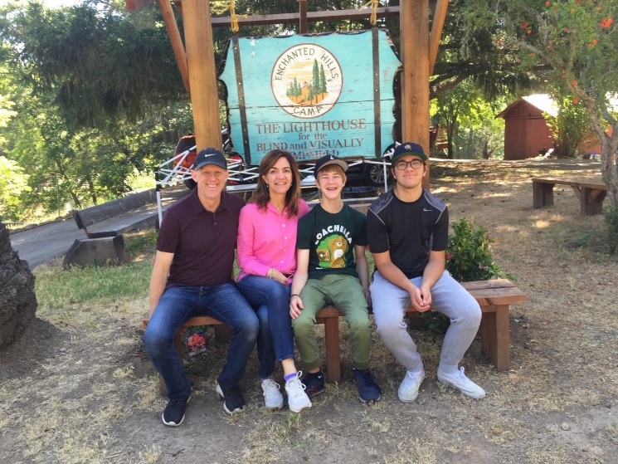

Photo caption: The Bunt Family sits in front of the historic Enchanted Hills Camp sign..

Henry Bunt, age 18, and his parents attended Family Camp at Enchanted Hills, and then he and his mom returned as volunteers. At first, Henry had
apprehensions about going to camp. He wasn’t super outdoorsy and was afraid he wouldn’t like being out in nature. Prior to Enchanted Hills, Henry didn’t know anyone his age with low vision, and he wasn’t sure he wanted to be immersed. But Henry soon grew to love the experiences of Enchanted Hills. He met college-educated, employed blind and low vision counselors who served as examples of what Henry’s future could be like. He learned archery, tried horseback riding and made good friends. And last summer Henry volunteered in the kitchen. He said, “That was a good experience. It was my first step towards having an actual job, and most things I was worried about ended up not being a problem at all.”

Henry’s mom and dad, Jennifer and Ken, said, “When we first went to this beautiful camp, we saw other blind campers achieving, enjoying activities, and navigating their surroundings. It really reduced our feelings of stress. It shifted how we thought about Henry’s vision and his future. We were
heartbroken to hear of the damage from the wildfires and hoped that it wouldn’t be the end. And happily, Enchanted Hills reopened the very next summer even while the majority of rebuilding is still under way. We continue our support every year. Our hope is that the small support we provide will help other campers and their families.”
*82 % of students say that they have more confidence because of their participation in LightHouse programs.
*92% of students say that they are motivated to try new things because of LightHouse.
*84% of students say that they are better able to maintain day-to-day activities and interests because of LightHouse.

Enchanted Hills Camp for the Blind

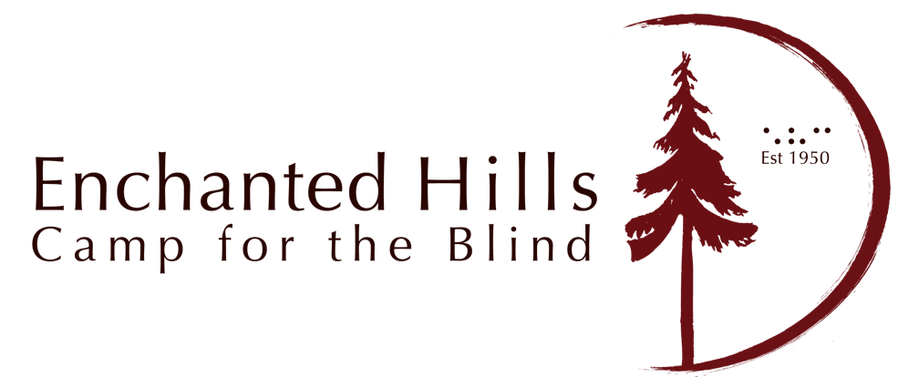

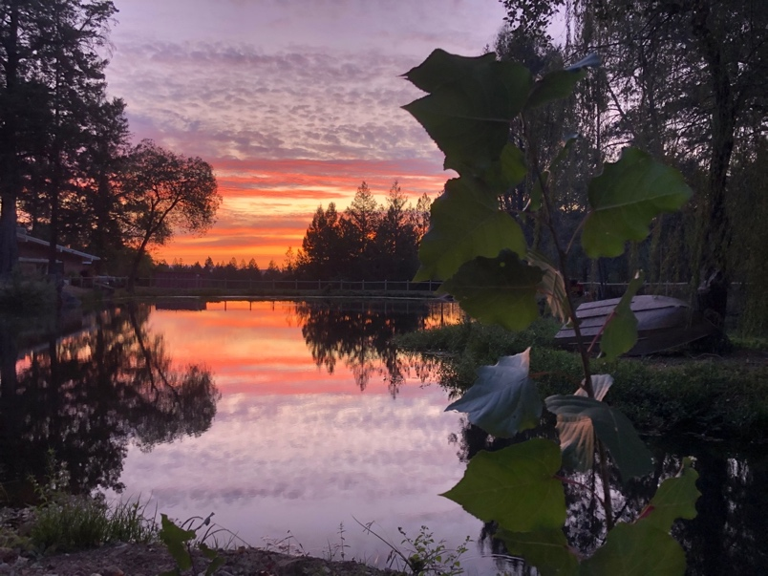

Photo caption: red sunset over Lake Lokoya at Enchanted Hills Camp.

2019 was our 69th year of providing unparalleled programs for blind campers, and we have been busy:
- Enchanted Hills Camp for the Blind hosted ten different summer sessions in 2019.
- We had our largest ever teen camp session.
- Enchanted Hills welcomed campers from Poland, Australia, Puerto Rico and China, Dominican Republic, Japan, Mexico, Philippines, South Korea, Hungary, Turkey, Nicaragua and El Salvador.
- Music Camp rocked the world with a finale concert for several hundred audience members.
- Specialty camps in 2019: STEM Camp and a much-anticipated Facebook Coding Camp.
- We rebuilt the first permanent buildings since the wildfires: a storage barn, maintenance office, pool shade structure and two storage sheds.
- With the help of the Kiwanis Club of Greater Napa we rebuilt the Wing Creek Chapel, and built a new bridge with a Braille Rail to honor donors to the Wing Creek restoration.

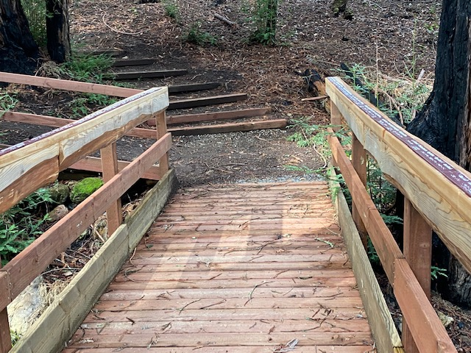

Photo caption: Braille Rail Bridge at EHC.

- Over 25 volunteer groups spent time at EHC in 2019 helping us with fire abatement, overall camp maintenance, fence repair, landscaping and other vital projects.
- Over 25 volunteer groups spent time at EHC in 2019 helping us with fire abatement, overall camp maintenance, fence repair, landscaping and other vital projects.
- Two AmeriCorps groups spent six weeks working on a variety of projects: rebuilding bridges and fences, trail maintenance, building new picnic tables, and painting, painting, painting!
- Enchanted Hills hosted 21 retreat rental groups.
- We dredged and aerated Lokoya Lake to make it cleaner and deeper and stocked it with over 3,000 fish.
- We broke ground on an eco-conscious new Pool Bath House with expanded shade structure built with reclaimed lumber from our own downed trees.

- We hosted the Pacific Division of the National Association of Blind Students’ leadership retreat.

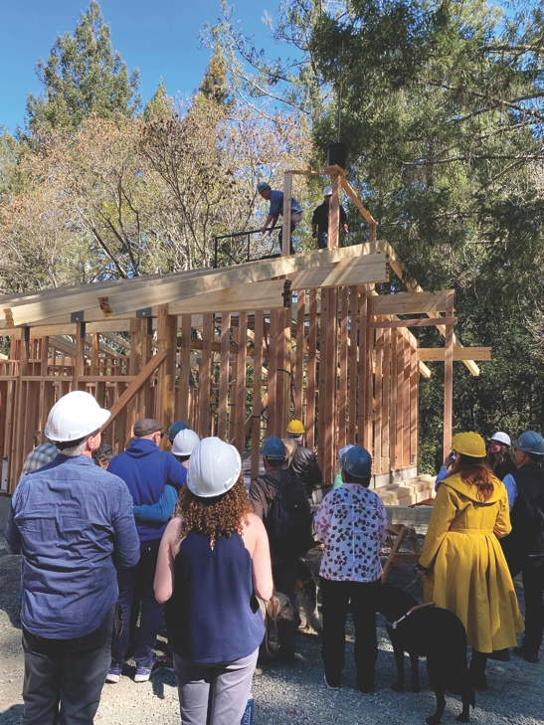

Photo caption: The group watches the beam being placed.

About Enchanted Hills Camp for the Blind

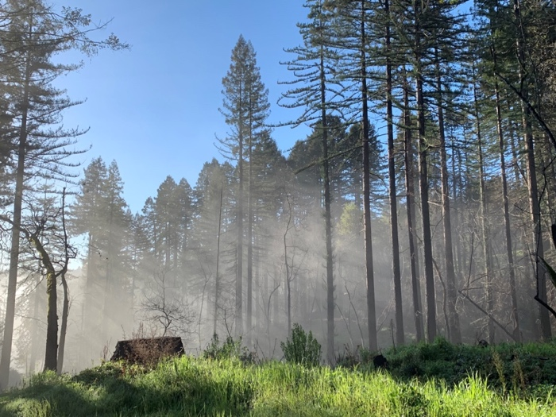

Photo caption: Sun rays spread through a cluster of trees at the Enchanted Hills Camp
In 1950, Rose Resnick, a blind woman who credited her confidence and feelings of self-worth to her time spent at a camp for blind kids in the Adirondacks, founded Enchanted Hills – the first camp for the blind west of the Mississippi.

Located on 311 acres of redwood and mixed forest, Enchanted Hills provides a quintessential camp experience including hiking, horseback riding, archery, and swimming—a place where campers make lifelong friends and meet motivated, blind mentors. Over the years, more than 25,000 blind campers have benefited from Enchanted Hills’ unparalleled programs.

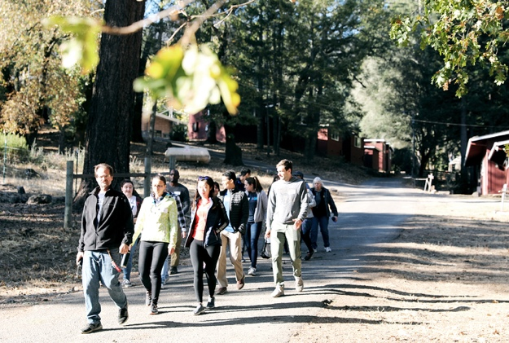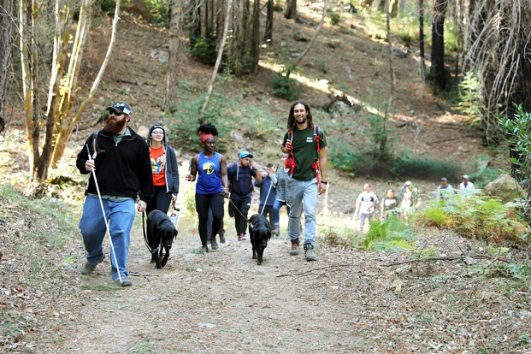
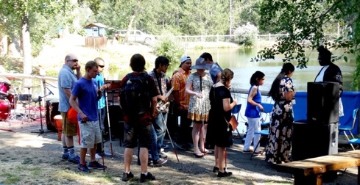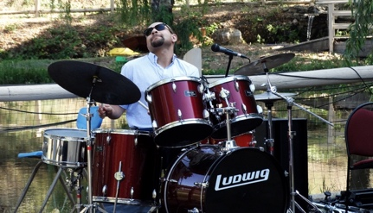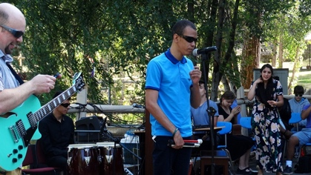

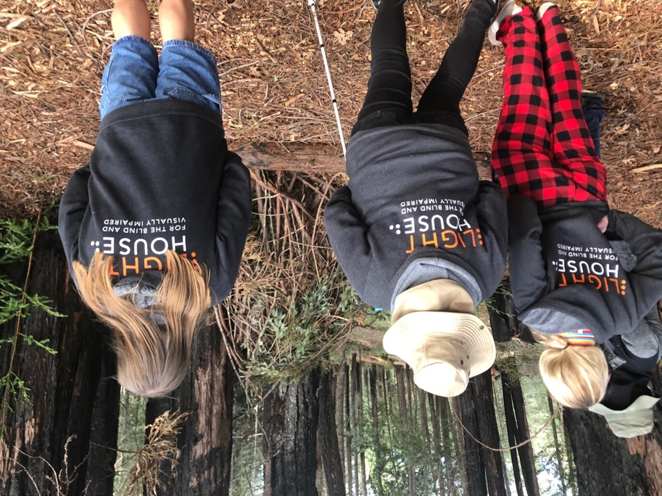

Photo captions:
Image 1 – Group of volunteers at EHC during Volunteer Day walking with Enchanted Hills Director, Tony Fletcher. Photo by Sarika Dagar.
Image 2 – Group of youth campers on a trail at the EHC Health and Wellness event. Photo by Sarika Dagar.
Image 3 – A group of EHC campers getting ready for music camp performances.
Image 4 – A blind singer with his band performs during EHC music camp 2019 while a group of campers cheers him on in the background.
Image 5 – A blind drummer performs near Lake Lokoya during EHC music camp 2019. Image 6 – A group of young campers gaze at redwood trees at EHC, all
wearing their LightHouse sweatshirts for warmth.

EHC by the numbers

Numbers Show the Power of Camp

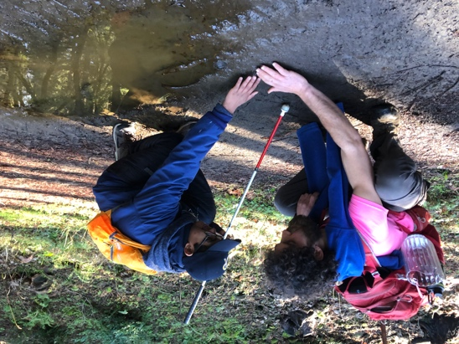
Photo caption: A young, blind camper learning about the nature of mud during EHC summer session 2019.

Blind Campers: 486

Camper hours: 24,076

EHC 2019 Programs
Cycle for Sight
Family Camp I and II
Blind Babies Family Camp
Deaf-Blind Session
Adult Session
Adults with Developmental Disabilities Session
Youth Camp
Teen Camp
Music Camp
Woodworking Camp
STEM Camp
FaceBook Coding Camp

EHC Camper Profile: Milo Kroh

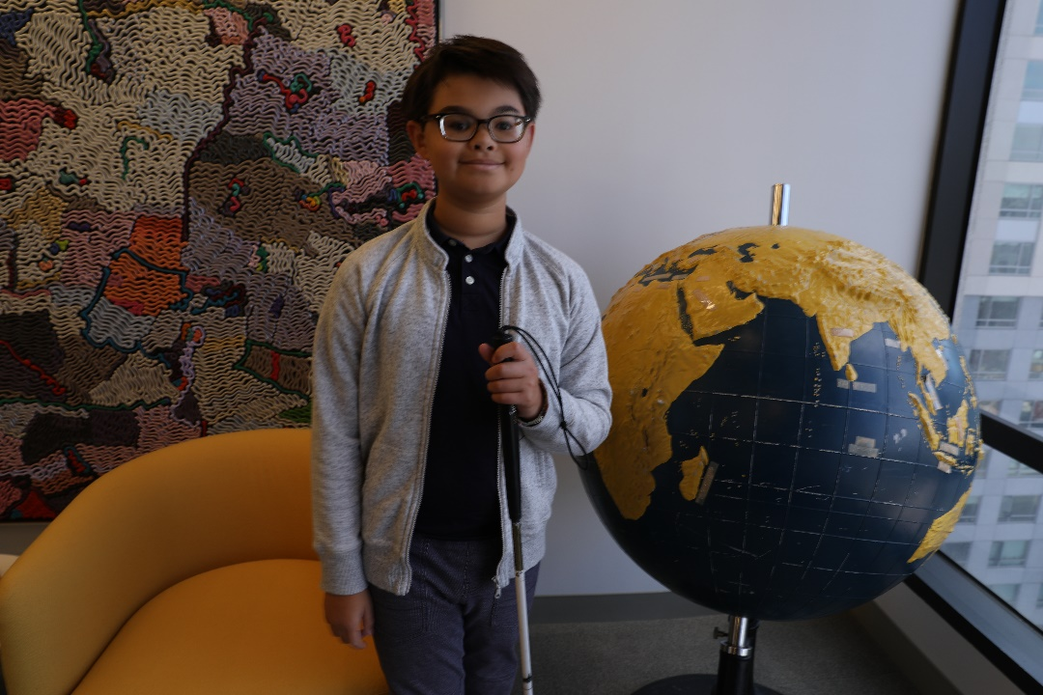
Photo caption: EHC camper Milo Kroh in front of a wall-sized tactile abstract painting by artist Alden Mason, located at LightHouse Headquarters. Photo by Sarika Dagar
Milo swam in the pool as often as he could, kayaked in the lake and enjoyed archery, where he knew his arrow had found its target when he heard the pop of a balloon, placed there for audible confirmation. He told us, “There aren’t too many kids who are visually impaired at my school. At Enchanted Hills I’m just like everyone else.”
“The staff love working with campers that bring enthusiasm, curiosity and playfulness to Enchanted Hills Camp and Milo Kroh is a camper that fits that picture perfectly. I feel strongly that this young man is going to make a difference in this world and we at EHC feel fortunate to be part of his journey towards independence,” said EHC Camp Director, Tony Fletcher.

*76% of students say that they are more satisfied with their quality of life because of LightHouse.
*66% of students say that LightHouse is a place where they extend their community of blind friends, peers and mentors.
*100% of students would refer someone who is blind or who has low vision to the LightHouse

Holman Prize for Blind Ambition
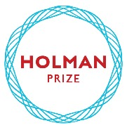

Now in its fourth year, LightHouse’s Holman Prize for Blind Ambition is an international competition that is awarded annually to three blind individuals who wish to push their limits. It is named for James Holman, a nineteenth century blind explorer and author, who was the most prolific private traveler before the era of modern transportation.
In 2017, LightHouse for the Blind in San Francisco launched the Holman Prize to support the emerging adventurousness and can- do spirit of blind and low vision people worldwide. This endeavor celebrates people who want to shape their own future instead of having it laid out for them. Created specifically for legally blind individuals with a penchant for exploration of all types, the annual Holman Prize for Blind Ambition provides financial backing – up to $25,000 – for three individuals to explore the world and push their limits.
The ideal candidate is someone who is willing to probe their environment and eager to savor the richness of a world that is so often thought of as inaccessible to the blind. The Prize Winner embarks on an adventure of their choosing, which may involve travel, community organizing, athletics, scientific exploration, creating art and more. In addition to motivating blind individuals to realize their dreams, the purpose of the Holman Prize is to change the world’s perception of blind ability.

2019 Holman Prize Recipients

Dr. Mona Minkara(United States)
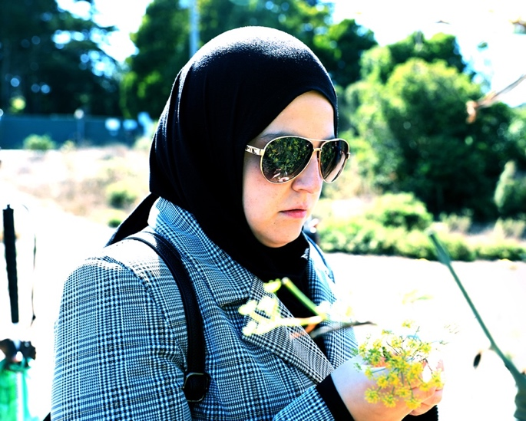
Photo caption: Close up of the United States’ Mona Minkara holding yellow flowers. Photo by Sarika Dagar
Dr. Mona Minkara (United States): Traveled to five international cities, independently navigated their public transit systems and documented this in a YouTube series called Planes Trains and Canes: https://www.youtube.com/channel/UCUAGEcdoYLOD7x5hTDKmVoA

Alieu Jaiteh(Gambia)
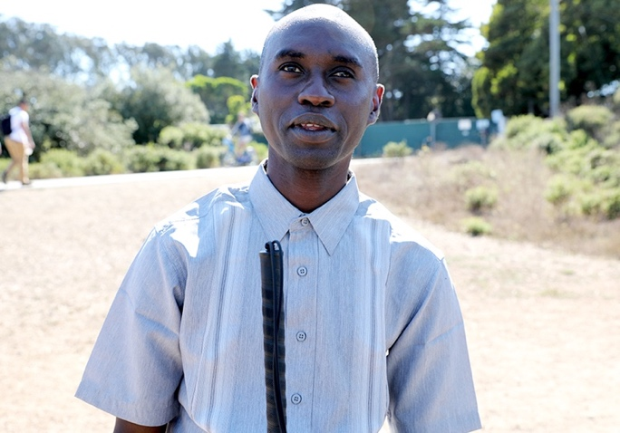
Photo caption: Close up of Gambia’s Alieu Jaiteh in Golden Gate Park. Photo by Sarika Dagar
Alieu Jaiteh (The Gambia): Provided training to eighty blind people in rural Gambia. Yuma Decaux (Australia): Made astronomy more accessible to blind people by visiting scientists around the world and documenting it in the Astrohunters podcast and through a mobile application, Asteros

Yuma Decaux(Australia)
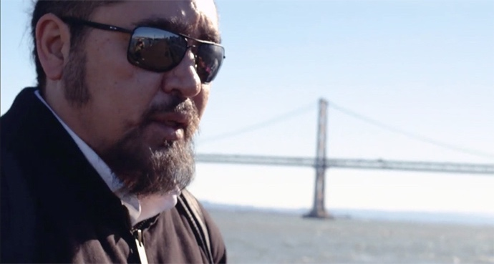
Photo caption: Close up of Australian Yuma Decaux with Bay Bridge in the background.
Yuma Decaux Made astronomy more accessible to blind people by visiting scientists around the world and documenting it in the Astrohunters podcast and through a mobile application, Asteros

2019 Spirit of Holman video link: https://www.youtube.com/watch?v=b2ofhVRjzvA&t

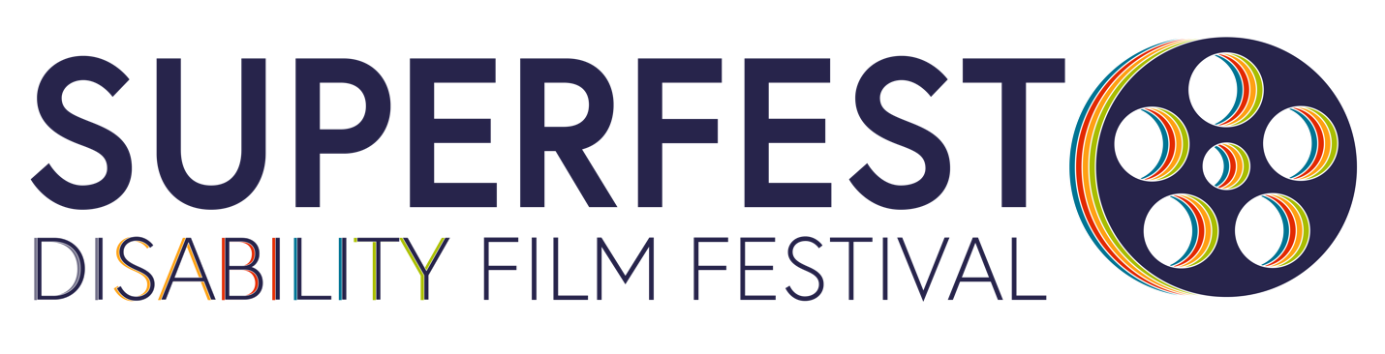

Superfest is the longest running disability film festival in the world.

Superfest Disability Film Festival 2019 was held on October 12 and 13 at the Freight and Salvage in Berkeley and Contemporary Jewish Museum in San Francisco with sold-out crowds and a full roster of films from all around the globe. The festival featured a fantastic blind filmmaker who flew in from Washington D.C, Day Al-Mohamed, the creator of a documentary about the Invalid Corp who served during the Civil War.

Since it first debuted as a small Los Angeles showcase in 1970, it has become an eagerly anticipated international event. For more than 30 years, Superfest has celebrated cutting-edge cinema that portrays disability through a diverse, complex, unabashed and engaging lens. Superfest is one of the few festivals worldwide that is accessible to disabled filmgoers of all kinds, and is an international leader for modeling accessibility, including open audio description, live captions for dialogue, audience-integrated wheelchair seating and chemical free and scent free areas.

Superfest Disability Film Festival continues as an integral program of San Francisco State’s Paul K. Longmore Institute on Disability. For complete information about showcases of films throughout the year and the main festival, visit superfestfilm.com.

Superfest features:
• Open/closed audio description
• Open captions for all live dialogue
• ASL interpretation for all live dialogue
• Audience-integrated wheelchair seating
• Close-up seating for people with low vision
• Seating for people who are Deaf or hard of hearing in close proximity to an ASL interpreter and captioning
• Chemical free / scent free areas
• A quiet space
• Gender neutral restrooms
• Easy access to public transportation, including BART and MUNI
• Ramp access to stage
• Separate screening room without audio description

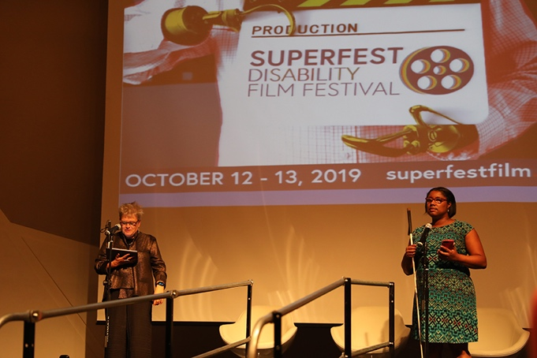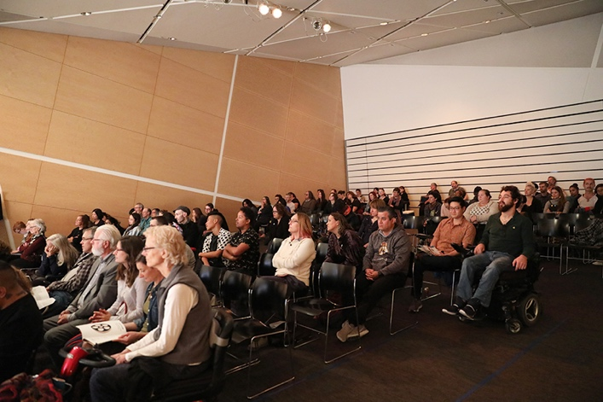

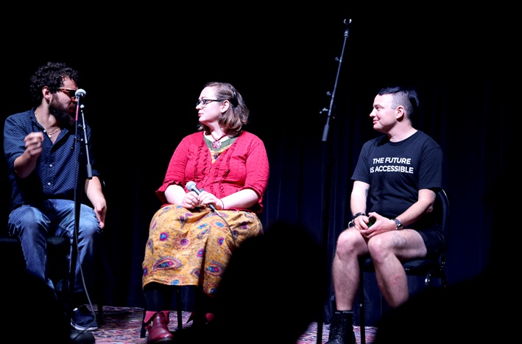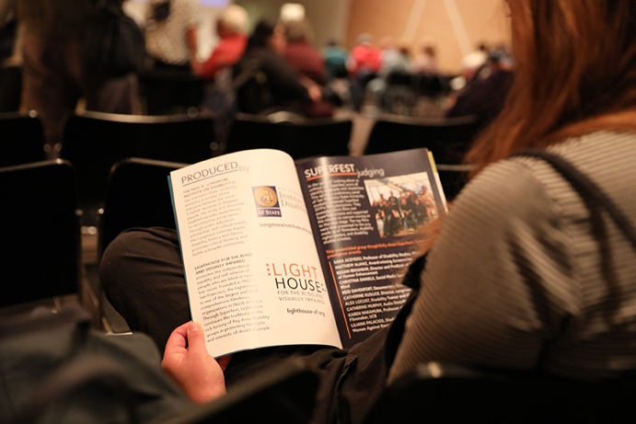

Photo captions left to right:
Image 1 – Cathy Kudlick, Director, Paul K. Longmore Institute on Disability and Christina Daniels, LightHouse Social Media Specialist presenting Superfest 2019 films. Superfest logo is projected onto the screen behind them.
Image 2 – A large group watching a film with various apparent and nonapparent disabilities.
Image 3 – A panel of three Superfes filmmakers on stage.
Image 4 – Someone reading Superfest 2019 schedule with LightHouse logo on the left page.
Photos by Sarika Dagar

LIGHTHOUSE SOCIAL ENTERPRISES

MEDIA AND ACCESSIBLE DESIGN LAB (MAD Lab)

From printed information to physical space, our MAD Lab specializes in making the visual tactile and turning inaccessible experiences into inclusive ones. Our team of designers and consultants specialize in braille, tactile maps, accessible venues and alternative media.
Year in Review:
Design and production of Apple Swift Playgrounds Tactile Puzzle Worlds; Building Graphics Literacy; Library of Congress NLS (in-place indoor floorplan maps), Disney (maps and droid schematics), Microsoft (outdoor wayfinding maps), Maryland Department of Transportation (system strip maps).
Total Projects by MAD Lab 2019
369 projects broken down into the following categories:
Design and Accessibility: consulting, tactile maps, graphics, 3D – 78 projects
Consulting: ADA/CBC Sign Review – Inspection and Approval of 3,207 signs to ensure 2010 ADA & 2013 CBC compliance
Braille Translation – 57,735 pages
Braille Business Cards – 7,743 cards
Audio Recordings – 19 recordings
Trainings, Workshops, and Presentations – 11
TMAPs Distributed (Tactile Maps Automated Production -- 1,284 TMAPs

ADAPTATIONS BLIND TECHNOLOGY STORE

Adaptations is the only place in Northern California with a comprehensive offering of tools, technology, and other solutions for blind and visually impaired people.
2019 Statistics
Total number of items sold: 6,887
Total number of shopping transactions: 2,506
Total number of customers: 2,445
Number of unique customers: 1,376
Product inventory: 1,274
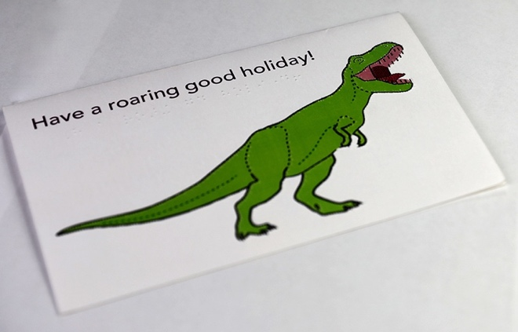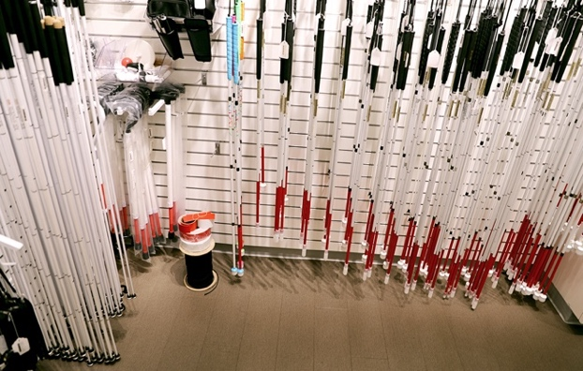
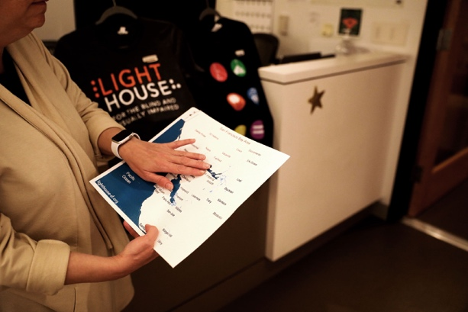
Photo captions:
Image 1 – A braille holiday card depicting a green, tactile printed dinosaur says ‘Have a roaring good holiday!’.
Image 2 - White canes hang on the wall inside the Adaptations Store.
Image 3 – A blind woman holds a TMAP of a San Francisco neighborhood and ex3lores the map with one hand. Photo by Sarika Dagar

THE SIRKIN CENTER
The Sirkin Center provides employment to blind employees in customer service, shipping and receiving, inventory management and light manufacturing. The Sirkin Center is a light-manufacturing plant making the tissue packets which are included in MREs (Meals Ready to Eat) utilized by soldiers, rescue workers, emergency rations and support for firefighters in the field and firefighters in the field. We also sell commercial-size sanitary paper rolls for use at camps, schools and other facilities, and a line of PRIDEClean chemical cleaning products.
In 2019 the Sirkin Center began bottling PRIDEClean products: non-toxic, green cleaning products used at private and public facilities around the country. The products contain no ammonia, phosphates, are biodegradable and contain zero to low VOCs.
The Sirkin Center also produces Skilcraft products with National Industries for the Blind and the Ability One Commission.
Packets of tissue produced in 2019: 52,071,000
Line filled bottling in 2019: 150,000 units
75 percent of the direct labor in our facility comes from blind employees.

Photo caption: One thousand-pound rolls of toilet paper await repackaging at the LightHouse for the Blind plant in San Leandro.

Who we Reach
Part of the LightHouse’s mission is to communicate the truth about blindness to the widest possible audience. In 2019 we had a remarkable year of such communications.
These prominent media sources published articles about LightHouse in 2019:

Chris Downey 60 Minutes Coverage
https://www.cbsnews.com/news/architect-chris-downey-goes-blind-says-hes-actually-gotten-better-at-his-job-60-minutes-2019-08-11/

World According to Sound with Bryan Bashin
https://www.kqed.org/news/11755736/listen-this-is-what-its-like-to-navigate-the-bay-area-while-blind

World According to Sound https://www.kqed.org/news/11754661/california-sounds-touching-the-secret-world-of-mollusk-shells

World According to Sound
https://www.kqed.org/news/tag/california-sounds?mc_cid=ea8bff7238&mc_eid=%5bUNIQID%5d

Chris Downey – Word According to Sound
https://www.kqed.org/news/11771686/california-sounds-an-architect-who-listens-to-buildings

Holman Prize Winner: Ham & Hight
https://www.hamhigh.co.uk/news/red-szell-hampstead-blind-climber-in-daring-ocean-expedition-dedicated-to-lost-mountaineer-martin-moran-1-6161057

UK Climbing Magazine
https://www.ukclimbing.com/news/2019/06/triple_sea_stack_success_for_blind_climber_red_szell-71990

Talking Vision Radio Program
https://talkingvision.podbean.com/e/talking-vision-episode-457-9th-january-2019/

RNIB Connect
https://audioboom.com/posts/7301471-read-on-presenter-red-szell-conquers-am-buachaille

ADVOCACY

In 2019 we worked with advocacy groups and organizations from across the nation.
Napa Resource Conservation District
American Camp Association (ACA)
American Foundation for the Blind
American Printing House for the Blind
Americorps NCCC
Bay Area Arts Access Collective
Better Market Street
Blind Advisory Committee (BAC)
Blind Babies Foundation
California Blind Advisory Committee
California Council of the Blind
Canadian National Institute of the Blind CNIB
California Department of Rehabilitation
Department of Veterans Affairs
Disability rights Advocates
Foundation for Independent Living Centers
I See Music
San Francisco’s Mayor’s Office on Disability
Mt. Veeder Fire Safety Council
Napa Open Space District
National Association of Blind Students
National Federation of the Blind
Northern California Association of Orientation & Mobility Specialists (NCAOMS)
Northern California Deaf-Blind Association
Paul K. Longmore Institute on Disability
San Francisco Safe Streets
San Francisco State University Teachers of the Visually Impaired and Orientation and Mobility Departments
Senior & Disability Action
SF Pride
The City and County of San Francisco
TRE Legal Services
United States Association of Blind Athletes
VisionServe Alliance
World Blind Union
World Institute on Disability

ACCESSIBILITY: We consulted and worked on tech and accessibility with companies all over the world, including:
Adobe
Apple
Airbnb
Amazon
BART
Capital One Services
Clover Network, Inc.
Federal Reserve Bank
Google LLC
Ike Smart City
JP Morgan Chase & Co
Level Access
LinkedIn
McGraw-Hill Higher Education
Microsoft
Netflix
Salesforce
TripIt
Weight Watchers

2019 Financials

Support and Revenue:
Government Contracts and other grants: $1,837,341
Donations and Bequests: $1,879,158
Sales (Net of fees of $87,326): $3,078,213
Fees for Service: $1,491,684
Interest and Dividends: $3,511,893
Insurance Reimbursements: $1,429,373
Other revenue: $279,622
Total Support and Revenue: $13,507,284

Operating Expenses:
Program Services: $11,674,719
General and Administration: $2,485,568
Fundraising: $1,075,502
Total Expenses: $15,235,789

Change in net assets from operations: ($1,728,505)

Other Gains and Losses:
Realized and Unrealized Gains (Losses) on Investments, net of fees: ($867,924)

Change in Net Assets: ($2,596,429)

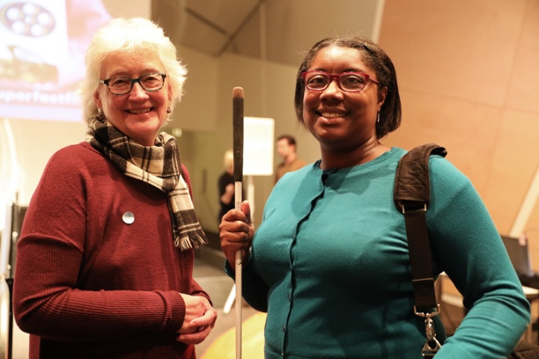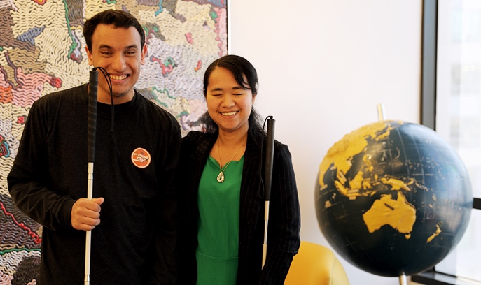

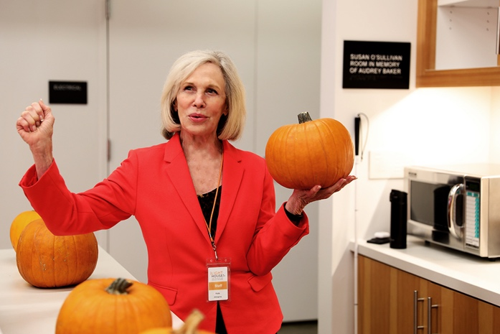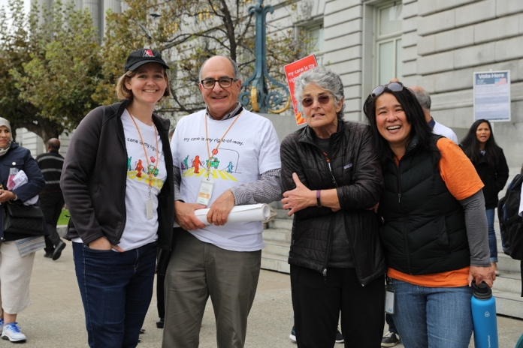

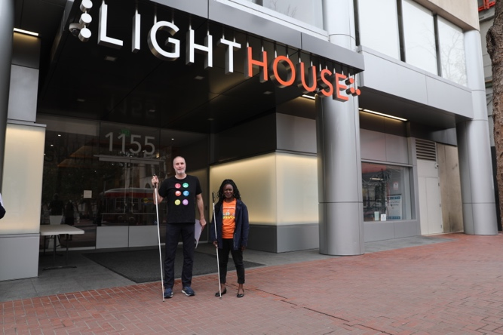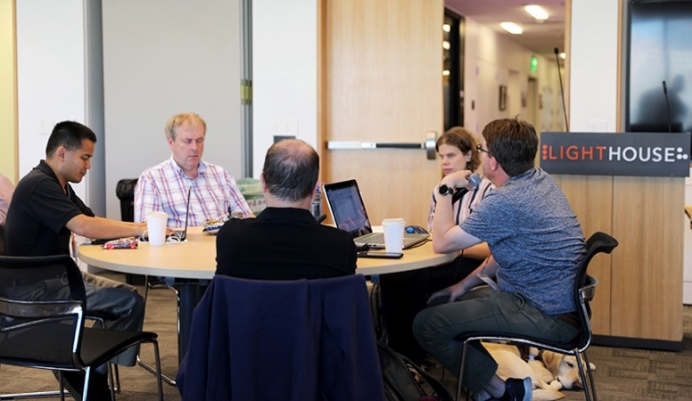
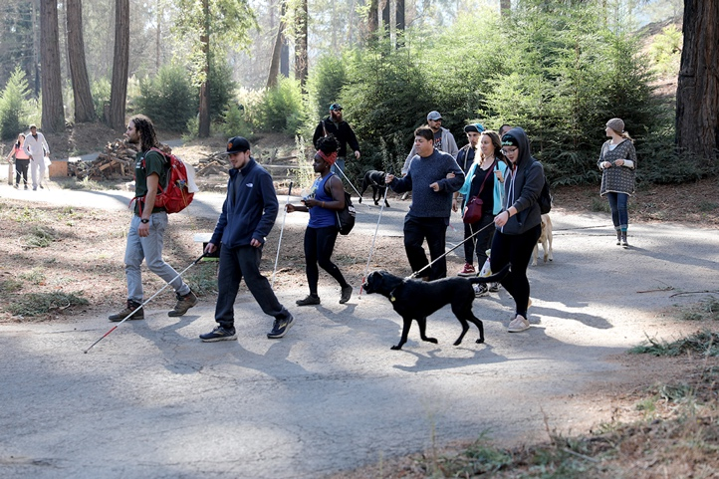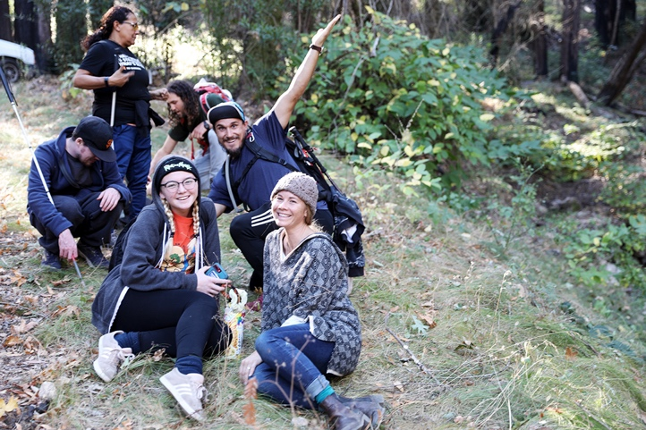
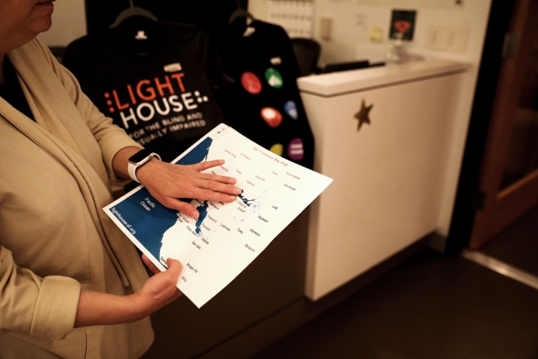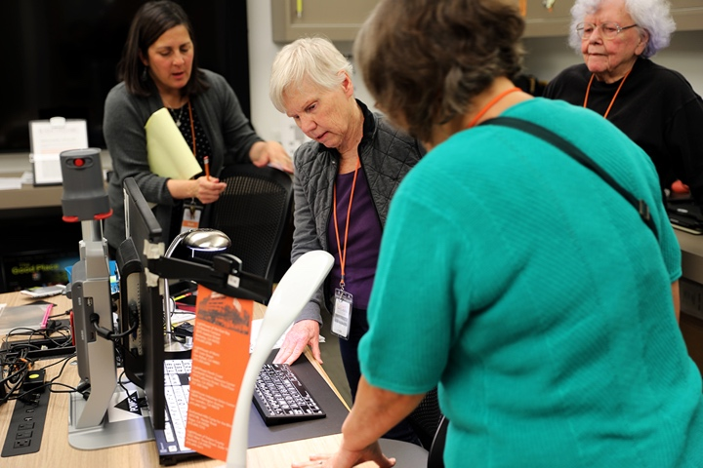

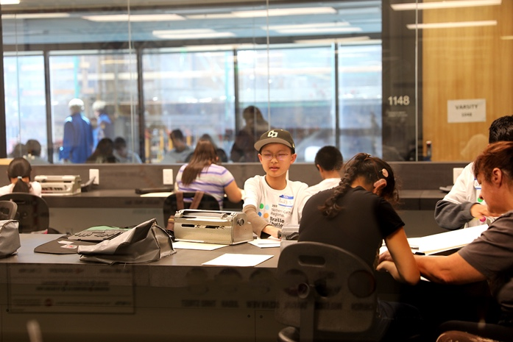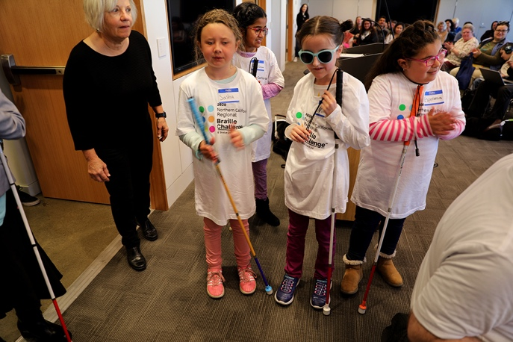
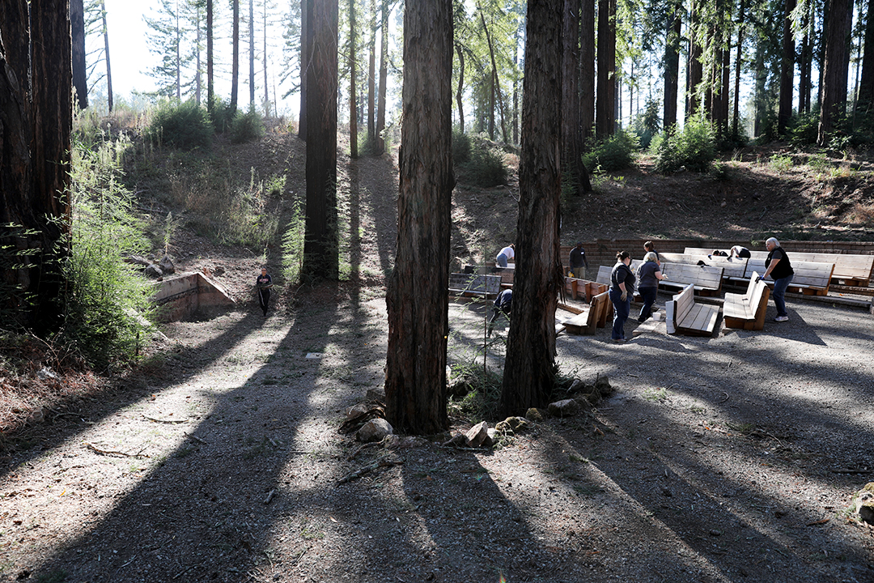
Photo captions:
Image 1 – Two women smile for the camera in front of the Superfest screen.
Image 2 – Young EHC camper Andy Rodriguez and YES program specialist Ann Kwong smiling in front of the camera.
Image 3 – Employment Immersion director Kate Williams holding a pumpkin during
Pumpkin Palooza cooking class.
Image 4 – LightHouse’s Orientation and Mobility instructors outside City Hall during
White Cane day.
Image 5 – Two people with their white canes stand under the LightHouse sign on
Market street.
Image 6 – A group around a table discuss current technology during our Access Tech
Trainer Conference.
Image 7 – Group of blind and low vision campers walking on a path at EHC with their
white canes and guide dogs.
Image 8 – Group photo of smiling blind and low vision campers.
Image 9 – At the Adaptations store, a shopper touches the tactile map of a
San Francisco neighborhood.
Image 10 – Changing Vision, Changing Lives participants learn low vision desk setup
using products from the Adaptations store.
Image 11 – Students take their test during the Northern California Regional Braille
Challenge, held at LightHouse Headquarters.
Image 12 – Students enjoy each other’s company during the Northern California
Regional Braille Challenge, held at LightHouse Headquarters.
Image 13 – Sun rays peaking through redwood trees while EHC volunteers work.
Photos by Sarika Dagar

LIGHTHOUSE DONORS

INDIVIDUALS-ORGANIZATIONS

$100 - $999
Anita Shafer Aaron and
Robert Scott Aaron
Jenny Adam
Judith and Douglas Adams
Louis Adams
John Alexander
Robert and Elaine Allen
Juan Alvarez
Adrian and Laura Amandi
Judi and Thomas Ambrosius
Kate Andersen
Roland M. Andersen
Harry and Judy Andrew
Raymond N. Applebaum
Linda and Anthony Ara
Radhika Arora
Sweta Arora
Elizabeth L. Ashley
Eileen Aste
Lynn Aurelio
Nadine and George Aurelio
Joseph Ayres
Margaret Azcona
Carol Bacchetti
Jim J. Baie
Gay Baldwin
Shirley Banks
Joan and John Barkan
Judy Barrett
Roger Barrow
Linda Barsotti
Ashley Barth
Bryan Bashin
Margaret Bayer
Steven Bayles
Jesse Beach
James and Patricia Beall
Elizabeth and Iraj Behseresht
Barrie Benson
Lisa Berger
Bryan and Barbara Bergsteinsson
Charmaine L. Berry
Joan Berry
Joyce Cid
William and Laura Cinquini
John and Mona Clements
Vicki Coe and R. Scott Mitchell
Christie and Stephen Coffin
Fern Cohn
Debbie Conlon
Patricia Corcoran
Sandra Cornell
Geraldine and Al Corvi
Constance and Dave Costa
Cary Courier
Kelley Cowan
Carla Crahan
Colleen Crahan McCarthy and
Lawrence McCarthy
Antoinette Craig
James Craig
Edward Craine
Elizabeth Cronin
Amy and Jeffrey Crowe
Kevin Cullinane
Dianne M. Curtis
Bonne Curtis-Leibee and Henry Leibee
Linda Dardarian
William and Jaci Daskarolis
Carol Davis
Lloyd E. Davis
Salvatore De Riso
Sarah DeLeon
Jagsimrat Dhillon
Constance Diernisse
BJ Dietz-Epstein
Danny and Ashley Dike
Loretta Dipboye
Elizabeth and Donald Dixon
Jeff Dixon
Robert and Kathryn Dodd
Zhao Dong
Jerome and Joanne Donovan
Greg Doolittle
Suzanne Dougan
Joan M. Dove
David Drinkhouse
David Dryer
Talbert Dsouza
Alma Duran
Kelli Dutto
Crystal Dykstra and Tiffany Bush
Amanda Ebey
Jerry and Laura Edwards
Joseph Ehrman III
Christine England
Shayna Eskew
Randy Evangelista
Carrie Farber
Cindy and Marty Fassler
Rob Feckner and Deborah Jachens
Lewis J. Feldman
Alex Fiannaca
Pamela Fischer
Diana and Drew Fitzpatrick
David and Vicki Fleishhacker
Anthony Fletcher and Elizabeth Sapien
Veronica Fluken
Laura Fogg
Kathleen Folks Martin
Phillip R. Foster, Jr.
Marina Franco
Julia S. Frank
Cathy Freese and D.R. Gillis
Patty Freitas
Vicki Friedberg
Buthina Frikert
Don and Peggy Fromm
Jim Fruchterman
Michael Fucciolo
Phyllis Fullmer
Jonathan Funk
Frank Gaetz
Dominic Gagliano
Holly Galbrecht
Catania C. Galvan
Ernest Galvan
Denise Galway
Jim and Kyra Gammon
Amey Garber and Richard Lesnick
Pam Gardner
Dyke Garrison
Mengisteab Gebrehiwot
Dean M. Genes
William and Ann Gerard
Lisa and Jory Gessow
Lesley Gibbons
Myra and Brent Gifford
Kathleen Gilbert
Margaret E. Ginsburg
Aric Gitomer
Stanton and Marsha Glantz
Frank Golbeck
Rose Golden
Rolando Gomez
Phillip Gordon and Philippa Newfield
Marie Gravelle
Debra Greenstein
Eva Gregoratos
Irene and Barry Grenier
Herbert and Lenore Griffin
Mitchell Grubman
Wendy Grus
Susan and Leonard Gugick
Joan and Joseph Guidetti
Angela and Mark Gundlfinger
Juan Gutierrez
Jean Guttman
Joshua and Kalpana Guttman
Mary Gwynn
Miki and Larry Hakim Tolchin
Mark Hall
Philip and Susan Hammer
William Hammond
Kathleen Hamon-McGee and
Kevin McGee
Pamela Handman
Wendy Hardy
Dorothy Harkavy
Harriet Harris
Phillip and Julie Harris
Arthur Hartman
John Hays
Mayela Heacock
Reiko Healman
David Heglund
Alan Hencky
Michael Henderson
Shawn Henning
Luther and Crystal Hermano
Austin Hertell
Mr. and Mrs. Richard Hesse
Dallas Hickle
Jefferson Hill
Michelle and Kenneth Hill
Paul Hill
Elaine Hilp
Kit and Linda Hinrichs
Karen Ho
Julien Hoffman
Mickey Hoffman
Tim Hohne
Susan Holt
Dana Hooper and Alicia Swanson
Erin Horne
Mona Horst
Amy J. Hosa
Evan Hughes, Jr. and Linda Craig
Kevin Hughes
Harold and Janet Hunt
Nicholas Hurlburt
Jeremy Hwang
Norma Ingalls
Frederick J. Isaac
Jack D. Jackson
Phillip Jai
Randolph James
Kara Janssen
Brian and Patricia Johnson
Gil and Becky Johnson
Kent and Linda Kaiser
Roger Kallen
Barry and Shirley Kaminsky
Margaret Kane
Heli Kangas
Rosemary and Daniel Kaplan
Robert and Janet Kates
Susan R. Katz-Snyder
Julie Kaufman
Mary and Lester Kaye
Brian Kennedy
David and Judith Keyes
Kay Khin
Cynthia King
Joel King
John and Mary Kirlin
Jeanne Kirsch
Anmarie Kladis
Helene Klein
Julie Klein
Melanie Kneisel
Perla and Harvey Kohs
Thomas and Dorothy Komnick
Martin Krasney
William Kreysler
Debbi Krukonis and Vincent Peloso
Ralph and Carol Kuiper
Deslar Kyn Patten
Scott LaBarre
Elizabeth Laflamme
Marc Lambert
Rob Lanz
Mr. and Mrs. James LaPlante, Jr.
Kenneth and Sylvia Larkin
Judith Lasky
Barbara J. Lassen
Erin Lauridsen
Christie Lebaudour Moore
Nancy D. Lee
Eileen Lemus
Anthony Lenzo
Linda J. Leonard
Janice Leong
Lori Lerner-Edwards
Wallis and Harry Leslie
Dr. Robert G. Levenson
Dan and Evelyn Levin
Marc Levin, M.D.
N. Jean Edge Levins
Stephen Lindbeck and Martha Ginsburg
Jeff Lombardi
Andres Lopez-Pineda
Peter Lovecchio
George and Svetlana Lozovik
Gabriel Lucas
Sarah Lucas
Renee Luenow
Min Ma
David and Mary Maas
Berenice Magistretti
Michael and Mary Lynn Maguire
Eric and Jacalyn Mah
Robert and Patricia Maines
Mike and Laura Malone
Robert Manning
Diane Marchut
Hiram Marinas
Nancy Marshall
Gina Marsili
Janet A. Martin
Angela and Art Martyn
Ruth Masonek
Shirley Matteson
Michael May
Steve and Patty Mayer
Matt Mayes
Sharon Mayo
Dr. Elliot E. Mazer and Mrs. Trudy Mazer
David and Rose McCallen
Laurene Wu McClain
Tony and Linda McClimans
Elizabeth McDonald
Cliff McElrea
Kevin McGee and Kathleen Hamon-McGee
Harry McGuire
Richard McIntosh
Allene McIntyre
Terry and Maria McKellips
Peter Medina
Denise Meggs
Kevin and Kimberly Menninger
Jack and Coralee Mermod
Hans and Edith Merten
Karen Meryash
Spencer and Roberta Michels
Charles and Dorothy Michelsen
Mr. and Mrs. Daniel Miller
Harrell Miller
Lorraine B. Miller-Wolf
Dianne Millner
Kenneth J. Mills, M.D.
Marian Mittler
Linda Montgomery and Roy Hahn
Davia M. Moore
Susan Moore Klawitter
Paul V. Morris
Anna M. Morrison
Paul Morrow
Philip Mucenski
Lee Murdock
Breda Murphy
James J. Murphy
Rosemary Murphy
Robert and Lynne Myers
Marie Myszkowski
Matthew and Leslie Nathan
Joseph Navarro and Lucia Aguilar-Navarro
William Nelson
Karen Nemsick
William and Janet Nicholls
Andrea Nielsen
Amy Noland
Germaine and Wendell Norwood
Varda Novick
Michael Nunez
Robert and Martha Obeso
Robert E. O’Donnell
Sam Ogami
Andrea and Greg Ogarrio
Doni and Sean Ogarrio
Greg Ogarrio
Daniel O’Grady
Helge and Birgitta Olsen
Henrik and Elodie Olsen
Brian O’Melveny
Sile O’Modhrain
Janise On
Roger and Teresa On
Alicia Onadja
Vicki and Laurence Oppenheim
John O’Reilly
Richard Oswald
Susan O’Toole
Charlene and Leo Ott
Anne Otte
Gina and Chris Ouellette
Kenneth Pacini
Mr. and Mrs. Michael Pack
Ellen and Michael Parker
William Jorge Pearce
David Pearson
Eric Peden
Rachel Perkins
Camille and Kevin Peterson-Steege
Shirley R. Petrak
Michael Pezone
Lillian Phan
Hnin Phwe
Elizabeth Pierre
Bobbi Pompey
Edward Porche
Thomas and Cathleen Prieto
Mary Prochnow
Maure Quilter
Eric and Nicole Radkiewicz
Alicia and Edward Ramirez
Frances Rapin
Miranda Rathbone
Charles and Patricia Raven
Maya Razon
Barbara and Sally Reiter
Judith Reynolds
Jason Roberts
Bill and Marilyn Robertson
Andrea Robinette
Vikki Rodriguez
Edwin and Elizabeth Roland
Joseph and Donna Rollins
Dennis and Linda Ronberg
Steven and Susan Rosen
Peter and Beth Rosenthal
Thomas Ross
Frances Rothenberg
Steven Rothstein
Debbie and Leonard Roudman
Paul and Holly Rubinstein
Michael and Julie Rudinoff
Patrick and Miriam Ryan
Mr. and Mrs. Eugene W. Rzym
Jennifer Sachs and William Maggs
Loren Sacks
Dorothy Salmon
Eryk Sanchez Mata, Jr.
James and Lea Sandman
Buzz Sapien
Daniel Sapien
Graciela Tiscareno Sato
Craig Sayers
Michele Scafani
Patricia and Ed Scarboro
Karen Scaruffi
Dr. Richard Schaar
Helen Schneider
Martin and Jeanne Schneider
David Schoenfeld
Tracy Schulze
Daniel M. Schwartz, M.D.
Janna A. Scopel
Lauren and Mark Scott
Matthew Sell
Elisabeth Semel
Priam Sen
Lynne Sentivany
Rita Seymour
Anna and Stanley Shaff
Vartan Shahijanian and Raymond Nolen
Lucille Shanahan
Halima Shenghur
John Simmons
William E. Simpson, Jr.
Rebecca and Matthew Singer
Chander Singh
Benjamin Singleton
Yue-Ting Siu
Igor Skaredoff
Dr. Howard M. Slyter and Ms. Marjorie E. Ginsburg
Thomas F. Smegal, Jr.
Marty Smith
Michael Snow
Shamly Sohal
Andrew Solari
Terri Sonoda
Tina Sonoda
Janet Spicer
Michele Spitz
Robert Spotts and Herbert Taxton
Eric Stauffenegger
Kevin Steege and Camille Peterson-Steege
Judie and David Stepner
Juliet Stewart
Leslie Stewart and Paul Kern
Wayne Stoker
Deborah Stone
Robert and Michelle Stowell
Frank Stuhler
Peggy and C.G. Suckow
Constance and George Sutton
Evelyn Szelenyi
Geoff Tabin
Ted Tawshunsky
Louise and Jack Tayan
Bruce Taylor
Elizabeth Taylor
Cosmo Tedeschi
Clara Ann Tennis
Victoria and George Thacher
Vrishali Thorat
Clifford Thornell
Richard Tidd
Arthur Tonelli
Oliver Tse
Daniel Tsirulnikov
David Turner
Patti Birge Tyson
Robert Tyson
Kathy and Michael Uhl
Dr. Mark Ulitsky
Lois Umeda-Madden
Jane Unger and Joseph Nezwek
Lida Urbanek
Rawal Utpal
Tammy Van Valkenburgh
Dorothy and Albert Vasquez
Prindle Vaux
Jeffrey and Lori Veliquette
Alan Venook and Carolyn Small
Nhon Vuong
Leanne Walgren
Brian and Gigi Walker
Dirk Walvis and Carolyn Dille
Anne Ward
Rosemary Watson
Meredith Weaver
Erik Weihenmayer
Roseanne Werth
Dorothy H. Wesley
Roger Wickstrom and Petrina Grube
Rebecca Williford
Patricia Willis and Anthony Knettel
Angela Wilson
Patricia Wilson
Stuart and Donna Wittenstein
Bik Yue Wong and Navin Wong
Bobby Wong
Joanna Wong and Ching Chuen Wong
Hobie Woods
Debra Wright
Robert and Nancy Wright
Anna and Ian Wroblewska
Julie Wyman
Janice Wyrick and Andrew Ho
Judith and Jerold Yecies
Lawrence and Gwendolyn Yee
Doug Yule
Gary and Linda Zellerbach
Rebecca and Richard Zeren
Alla and Victor Zeyliger
Dieter Zirkler
Mr. and Mrs. Simon Zisman
Roy Zitting
Michael Zucksworth
Adleson, Hess & Kelly
AmazonSmile Foundation
Andersen Tax
Apollo Lodge 123 IOOF
Ara Enterprises LLC
AT&T Employee Giving Campaign
Autodesk Foundation
Bank of America Charitable Foundation
Employees
Bay Area Development Company
Boeing
California Council of the Blind -
San Francisco Chapter
CSB RocketShop
Demand Construction Services, Inc.
Deutsche Bank Americas Foundation
Electronic Scrip Incorporated
Fil-Am Friendship Network (FAFNET)
Gap, Inc.
Give With Liberty - Liberty Mutual Foundation Match
Gracefully Global Group LLC
IBM Employee Services Center
Irvine Company
Jewish Family and Children’s Services
LaBarre Law Offices, P.C.
Lakeside Presbyterian Church Board of Deacons
Law Offices of Michael P. Kade
Lawrence Livermore National Laboratory
Mattingly Low Vision, Inc.
Morgan Stanley Global Impact Funding Trust
Napa Valley Petroleum, Inc.
One Market Restaurant
PG&E Campaign for the Community
RVK, Inc.
Santen Incorporated
Saratoga Lions Club
SF Mix
Steve Erdmann Gardening Service
Sutter Home Winery
Target
Truist/Frontsream
Unitarian Universalist Congregation, Santa Rosa
United Way - California Capital Region
Women of the Moose No. 1714

$1,000 - $9,999
Jason Affourtit
Laura and Peter Allen
Jose Azevedo
Sylvia Barata
Brian and Cindee Beirne
Ron Beller and Jennifer Moses
Douglas E. Bergman
Richard Boardman
Dan and Cindy Boyett
Michael and Julie Brown
Lindsey Bruel
Marie Anne Burkhard
Lisa Carvalho and David Mager
Joseph Chan
Amy Chen
Mr. and Mrs. Michael Child
Linda Cox-Myers and David Myers
Timothy Culler and Ellen Bermingham
Sandy and Joe Dalli
Susan and Andrew Dawson
Michael and Leslye Dellar
Kirk and Tamara Dittmar
Sean Mark Divarco
Debra and Mark Dommen
Chris and Rosa Downey
Joyce M. Dubay
Barbara Eddy
Signe Erickson
Gail and James Finnegan
Marjorie Follette
Nancy Foss
Adam Fritz
Candice and Jesse Gomez
Ryan Gregory
Marge Haggin
Gena Harper
David and Debra Harrison
Nancy K. Hayes
Eugenia H. Haynie
Ronda Head
Brian Helmick
Fred and Virginia Herzer
Dwight Johnson
Mr. and Mrs. Ronald L. Kahn
Andrew Kebbel
Roberta Kehret
Jody Kelman
Judd Klement
Queenie Kroh
Susan Lapin and Kenneth Ward
Audrey Lasson
Michael F. Marmor, M.D.
Francis McNulty
Jane and Robert Micks
Joshua Miele and Elizabeth Ruhland
Tarak Mody
Joseph Nezwek
Margaret Niland
Bill Norton
John Ogle
Susan O’Sullivan
Jane Page
Ian and Sue Paget
Tom and Stephanie Perrett
Peter Pfau and Kim Starr
Luciana Profaca
Anne Roberts
Frank Rothacker
Fred Ruhland
Patrick Ryss and Abbey Myszka
Sharon and Richard Sacks
Laith Salma
Riyad Salma
Elyse Salven-Blatt
Donald Schaefer
Richard and Monica Schoenberger
James Schwartz and Anneliese Magnelia
Mamie Scott
Michael and Carole Shebanek
Moira Shek
Sigrid and James Snider
Todd Stevenot and Anne Sandbach
Richard Stevens and Virginia Behm
Nancy Swan
Kong Taing
Heath Thomson and Nicole Perlroth Thomson
Charles and Elizabeth Travers
Jason Venable
Marco A. Vidal Fund
Rob and Carolyn Von Behren
Carmen Rose Wayson
David and Regula Weill
Joy and David West
Daniel Willhite
Alice Wingwall and Donlyn Lyndon
Henry and Sandra Wong
Stanley Yarnell and Victor Rowley
Bonnie and David Young
Albert and Teresa Zobrist
Adobe - Your Cause
Alice Phelan Sullivan Corporation
America’s Best Local Charities
Apple, Inc
Bellini Foundation
Business Links, Inc.
Charis Fund
Charles Schwab Corp
Chateau Montelena Winery
Comcast
Confraternity of Our Lady of Grace
Core Financial Corporation
Dave Young Electric, Inc.
Dean & Margaret Lesher Foundation
Diablo Valley Industrial Claims Association
Disability Rights Advocates
Dodge & Cox Investment Managers
Eventbrite
Facebook
Fidelity Brokerage Services LLC
First Dollar Foundation
Fontanella Family Winery
Gary D Nelson Associates, Inc.
Genentech Foundation
George Lucas Family Foundation
Guide Dogs for the Blind
Havian & Jarvis Charitable Fund
Hireup
Humboldt Area Foundation
Humboldt Health Foundation
IBM Retiree Charitable Campaign
Iglewski Family Foundation
Interpodia Technology Corp
Kawakami Barron & Lam, LLP
Kinship Trust Company LLC
Kiwanis Club of Davis
Kurland Family Foundation
LinkedIn Matching Gifts Program
Marin Community Foundation
Medtronic
Mel & Grace McLean Foundation
Merchants Exchange Club
Morgan Stanley
Mutual of America Life Insurance Company
N.D.G.W. Childrens Foundation
National Arts and Disability Center, Semel Institute
Omidyar Network
Pacific Gas and Electric Company
Patson Management Company
PG & E Corporation
Polara Enterprises, LLC
Ride Napa Valley LLC
Ross Stores Foundation
Rotary Club of Napa
S.A. Camp Companies
Sadie Meyer and Louis Cohn Foundation
Salesforce Foundation
Samsung Electronics North America
San Jose East Valley Lions Club
St. John’s Episcopal Church
Strandberg Engineering
Susan Zirkl Z L Memorial Charitable
Foundation Trust
Telecare Corporation
The Excel Fund
The Marmor Foundation
The North Face Explore Fund
The Palisades Educational Foundation, Inc
The San Francisco Foundation
The Travers Family Foundation
The University Corporation, SF State
TouchPoint Foundation
Trinity Properties
Turner Construction Company Foundation
U.S. Bank
UBS Donor-Advised Fund
Vanguard Charitable
Volkswagen Group of America, Inc.
Walter E. and Barbara A. Bauke Foundation
Welfund Family Foundation
Wright Family Charitable Fund

$1,000 - $9,999
Jason Affourtit
Laura and Peter Allen
Jose Azevedo
Sylvia Barata
Brian and Cindee Beirne
Ron Beller and Jennifer Moses
Douglas E. Bergman
Richard Boardman
Dan and Cindy Boyett
Michael and Julie Brown
Lindsey Bruel
Marie Anne Burkhard
Lisa Carvalho and David Mager
Joseph Chan
Amy Chen
Mr. and Mrs. Michael Child
Linda Cox-Myers and David Myers
Timothy Culler and Ellen Bermingham
Sandy and Joe Dalli
Susan and Andrew Dawson
Michael and Leslye Dellar
Kirk and Tamara Dittmar
Sean Mark Divarco
Debra and Mark Dommen
Chris and Rosa Downey
Joyce M. Dubay
Barbara Eddy
Signe Erickson
Gail and James Finnegan
Marjorie Follette
Nancy Foss
Adam Fritz
Candice and Jesse Gomez
Ryan Gregory
Marge Haggin
Gena Harper
David and Debra Harrison
Nancy K. Hayes
Eugenia H. Haynie
Ronda Head
Brian Helmick
Fred and Virginia Herzer
Dwight Johnson
Mr. and Mrs. Ronald L. Kahn
Andrew Kebbel
Roberta Kehret
Jody Kelman
Judd Klement
Queenie Kroh
Susan Lapin and Kenneth Ward
Audrey Lasson
Michael F. Marmor, M.D.
Francis McNulty
Jane and Robert Micks
Joshua Miele and Elizabeth Ruhland
Tarak Mody
Joseph Nezwek
Margaret Niland
Bill Norton
John Ogle
Susan O’Sullivan
Jane Page
Ian and Sue Paget
Tom and Stephanie Perrett
Peter Pfau and Kim Starr
Luciana Profaca
Anne Roberts
Frank Rothacker
Fred Ruhland
Patrick Ryss and Abbey Myszka
Sharon and Richard Sacks
Laith Salma
Riyad Salma
Elyse Salven-Blatt
Donald Schaefer
Richard and Monica Schoenberger
James Schwartz and Anneliese Magnelia
Mamie Scott
Michael and Carole Shebanek
Moira Shek
Sigrid and James Snider
Todd Stevenot and Anne Sandbach
Richard Stevens and Virginia Behm
Nancy Swan
Kong Taing
Heath Thomson and Nicole Perlroth Thomson
Charles and Elizabeth Travers
Jason Venable
Marco A. Vidal Fund
Rob and Carolyn Von Behren
Carmen Rose Wayson
David and Regula Weill
Joy and David West
Daniel Willhite
Alice Wingwall and Donlyn Lyndon
Henry and Sandra Wong
Stanley Yarnell and Victor Rowley
Bonnie and David Young
Albert and Teresa Zobrist
Adobe - Your Cause
Alice Phelan Sullivan Corporation
America’s Best Local Charities
Apple, Inc
Bellini Foundation
Business Links, Inc.
Charis Fund
Charles Schwab Corp
Chateau Montelena Winery
Comcast
Confraternity of Our Lady of Grace
Core Financial Corporation
Dave Young Electric, Inc.
Dean & Margaret Lesher Foundation
Diablo Valley Industrial Claims Association
Disability Rights Advocates
Dodge & Cox Investment Managers
Eventbrite
Facebook
Fidelity Brokerage Services LLC
First Dollar Foundation
Fontanella Family Winery
Gary D Nelson Associates, Inc.
Genentech Foundation
George Lucas Family Foundation
Guide Dogs for the Blind
Havian & Jarvis Charitable Fund
Hireup
Humboldt Area Foundation
Humboldt Health Foundation
IBM Retiree Charitable Campaign
Iglewski Family Foundation
Interpodia Technology Corp
Kawakami Barron & Lam, LLP
Kinship Trust Company LLC
Kiwanis Club of Davis
Kurland Family Foundation
LinkedIn Matching Gifts Program
Marin Community Foundation
Medtronic
Mel & Grace McLean Foundation
Merchants Exchange Club
Morgan Stanley
Mutual of America Life Insurance Company
N.D.G.W. Childrens Foundation
National Arts and Disability Center, Semel Institute
Omidyar Network
Pacific Gas and Electric Company
Patson Management Company
PG & E Corporation
Polara Enterprises, LLC
Ride Napa Valley LLC
Ross Stores Foundation
Rotary Club of Napa
S.A. Camp Companies
Sadie Meyer and Louis Cohn Foundation
Salesforce Foundation
Samsung Electronics North America
San Jose East Valley Lions Club
St. John’s Episcopal Church
Strandberg Engineering
Susan Zirkl Z L Memorial Charitable
Foundation Trust
Telecare Corporation
The Excel Fund
The Marmor Foundation
The North Face Explore Fund
The Palisades Educational Foundation, Inc
The San Francisco Foundation
The Travers Family Foundation
The University Corporation, SF State
TouchPoint Foundation
Trinity Properties
Turner Construction Company Foundation
U.S. Bank
UBS Donor-Advised Fund
Vanguard Charitable
Volkswagen Group of America, Inc.
Walter E. and Barbara A. Bauke Foundation
Welfund Family Foundation
Wright Family Charitable Fund

$10,000 - $24,999
Ronald and Lois Bloom
Jennison Asuncion
Jane D. Bennett
Ken and Jennifer Bunt
Lois Feldman Bloom and Ronald Bloom
Jerry A. Kuns
Bernard Newcomb
John Wilhelm and Tora Isi
Bennett Family Donor Advised Fund
Charitable Adult Rides & Services, Inc. (CARs)
Cruise Industry Charitable Foundation
Delong-Sweet Family Foundation
Delta Gamma Foundation
Eva L. McKenzie Memorial Fund
Fidelity Charitable Gift Fund
Marie H. Brookreson Trust
Renaissance Charitable Foundation
Syar Foundation
The Annunziata Sanguinetti Foundation
The Benevity Community Impact Fund
The Peter A. and Vernice H. Gasser Foundation
The Walt Disney Company Foundation
United States Association of Blind Athletes
Wells Fargo Foundation
Wells Fargo Philanthropy Fund
Western Digital Corporation Fund

$25,000 – $34,999
Maurice and Herman Herbst
Philanthropic Fund
Mr. and Mrs. G. Kirk Swingle
Foundation
Melvyn I. Mark
Jewish Community Federation
and Endowment Fund
Silicon Valley Community Foundation
Schwab Charitable

$50,000 – $99,999
Comcast NBCUniversal Foundation

$100,000+
Herbst Foundation, Inc.
Napa Valley Community Foundation

ESTATES
Thomas Dutra
Emma A. Eversole
Ferris W. Hartman
James Michener
Phyllis K. Miller
Dohma L. Roberts
Alicia Jean Rose
Rolph-Nicol Trust
John G. Searle
Donald Sirkin
Frank W. Stockton
E.B. Storrow
Emma G. Trebilcot
Dorothy M. Walker
Lillie Wissman
William W. Witney

LEGACY SOCIETY
(Supporters who have
included the LightHouse
in their estate plans.)
Hank Boerenko
Lisa Carvalho and David Mager
Joseph Chan
Margie Donovan
Joan M. Dove
Lewis J. Feldman
Robert Ray Foster
Jonathan Funk
Walter Howard Girdlestone
Gena Harper
Beulah May Higgins
Dolores Ippolito
Roger Kallen
Justin Kim
Deborah F. Kirker
Judith Kuhnle
Inez E. Martini
Marjorie McWee
Betty M. Mignacco
Ann Noble and Goran Muhlert
Robert E. O’Donnell
Theresa Postello and Jerry Kuns
Alicia Jean Rivera Rose
Frederic and Kristine Silva
Richard Stevens and Virginia Behm
Clyde and Margaret Stone
Dorothy M. Walker
David and Regula Weill
Martin and Rosan Weissman
Jennifer Westbrook
Greg Wong

LONGEVITY SOCIETY
(Supporters who have given 30
or more gifts over time.)
Alice Phelan Sullivan Corporation
America’s Best Local Charities
AT&T Employee Giving Campaign
Bank of America Charitable Foundation
Employees
Bellini Foundation
Charitable Adult Rides & Services, Inc.
Electronic Scrip Incorporated
Facebook
Fidelity Charitable Gift Fund
IBM Employee Services Center
IBM Retiree Charitable Campaign
Jewish Community Federation and Endowment Fund
Mr. and Mrs. G. Kirk Swingle Foundation
PG & E Corporation
Schwab Charitable
SF Park Presidio-Sunset Lions Club, Inc.
The Annunziata Sanguinetti Foundation
The Benevity Community Impact Fund
The San Francisco Foundation
Truist/Frontsream
United Way Monterey County
United Way of the Bay Area
Wells Fargo
Anita Shafer Aaron and Robert Scott Aaron
Laura and Peter Allen
Max H. Allen
Italo Amerio
James Arbios
Elizabeth L. Ashley
Jim J. Baie
Peter and Judi Bank
Sylvia Barata
Dr. and Mrs. Richard B. Barrick, M.D.
Jane D. Bennett
Douglas E. Bergman
Arthur H. Bernstein
Joan Berry
Bernhard H. Bittner
Paul Blaney
William and June Bowen
Neil H. Brandt
Laura J. Bredemeier
Mary Jo Broderick
Doris B. Brodie
Lonnie M. Brown
Jean Bucaneg
James L. Buhler
John and Gale Bunnell
Anselmo and Alma Caballero
Lisa Carvalho and David Mager
Joseph Chan
Joyce Cid
Ann Coleman
Barbara Conheim
Geraldine and Al Corvi
Bernard Damele
Lance and Billie Darin
Dolores Davi
Carol Davis
Dorothy Dito
Margie Donovan
Leslie K. Doughty
Chris and Rosa Downey
Joyce M. Dubay
Layton M. Duffy
Joseph Ehrman III
Richard T. Ellebrecht
Ursula B. Farfel
Lewis J. Feldman
Olivia Fiel Peralta and Oscar Peralta
Anthony Fletcher and Elizabeth Sapien
Jennie Fong
Joyce L. Fong
Nancy Foss
Robert Ray Foster
Denise Freinkel
Herbert and Annette Gershen
Candice and Jesse Gomez
Herbert and Lenore Griffin
Leslie R. Guggenheim
Patricia and Greg Gump
Jean Guttman
June Harman
Gena Harper
Eugenia H. Haynie
Jacqueline M. Hendren
Helen Jean Henke
Wayne and JoAnne Herman
Steven R. Hibshman
Elaine Hilp
Erin Horne
Annette D. Howitt
Carolyn and Irvin Howlett
Frederick J. Isaac
Dwight Johnson
Gil and Becky Johnson
Robert M. Kane
Rosemary and Daniel Kaplan
Ilene and Gary Katz
Susan R. Katz-Snyder
Max C. Kirkeberg
Jerry A. Kuns
Marianne J. Larimore
Lieselotte Le Baron
Norma and Dennis Libby
Cara and John Lisica
Andres Lopez-Pineda
David and Mary Maas
Lisamaria Martinez and Joseph Bakker
Fredrika D. May
Sean McGee
Hans and Edith Merten
Brian Messina
Mary A. Montgomery
Vivian Mullaney
Carolyn F. Mulliken
Mr. and Mrs. Donald Munakata
James R. Murphy
Robert and Lynne Myers
Diane and Robert Neuhaus
Trang Nguyen
Juan Ocampo Gomez
Robert E. O’Donnell
Helge and Birgitta Olsen
Vicki and Laurence Oppenheim
Florence M. Paraventi
Maja Jean Peters
Ted Prim
Luciana Profaca
Robert Rakshys
Alicia and Edward Ramirez
Joseph and Donna Rollins
Madeleine S. Rose
Florence M. Rusk
Nancy A. Russ
Jennifer Sachs and William Maggs
Janna A. Scopel
Vartan Shahijanian and
Raymond Nolen
Stephen and Joanne Shapiro
Timothy and Mary Sheehy
Gladys Shegoian
Kenneth and Jean Shelley
Leslie Sheppard
Randi Slaughter-Broussal
Henry H. Small
Thomas F. Smegal, Jr.
John A. Sproul
Gerald G. Stangl
Todd Stevenot and Anne Sandbach
Charles and Matilda Stewart
George and Helene Strauss
Ted Tawshunsky
Clifford Thornell
Robert Tyson
Prindle Vaux
William H. Vederman
Joseph and Margaret Ward
Sisi Weaver
David and Regula Weill
Gary and Yaffa Weinstein
Betty Jean Weiss
Shelia O. Whittemore
Roy Zitting

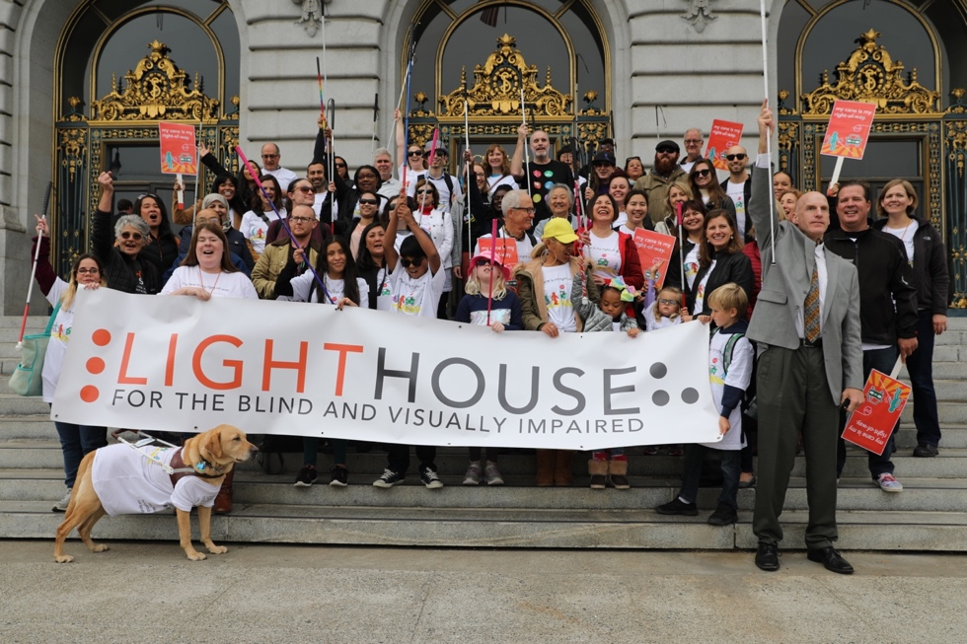
Photo caption: A group of LightHouse staff and supporters gathered outside San Francisco City Hall on White Cane Day, holding their white canes and a LightHouse Banner. Photo by Sarika Dagar
With the strength of kind donors and supporters, we are empowering the blind community, designing innovative programs and expanding our reach across California and beyond. Please consider a donation to support LightHouse for the Blind and Enchanted Hills Camp.

We will rebuild EHC better and stronger!
To contribute directly to rebuilding Enchanted Hills Camp following the destructive fire of 2017, please contact our Director of Development at 415.694.7333 or jsachs@lighthouse-sf.org.

1155 Market Street, Floor 10
San Francisco, CA 94103
Phone: 415-431-1841
VP: 415-255-5906

Learn more about what we do: www.lighthouse-sf.org

EIN 94-1415317

Together we’re better!
8

