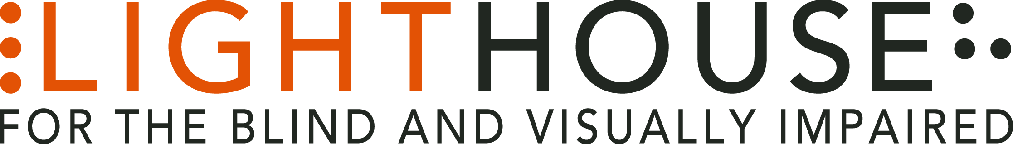

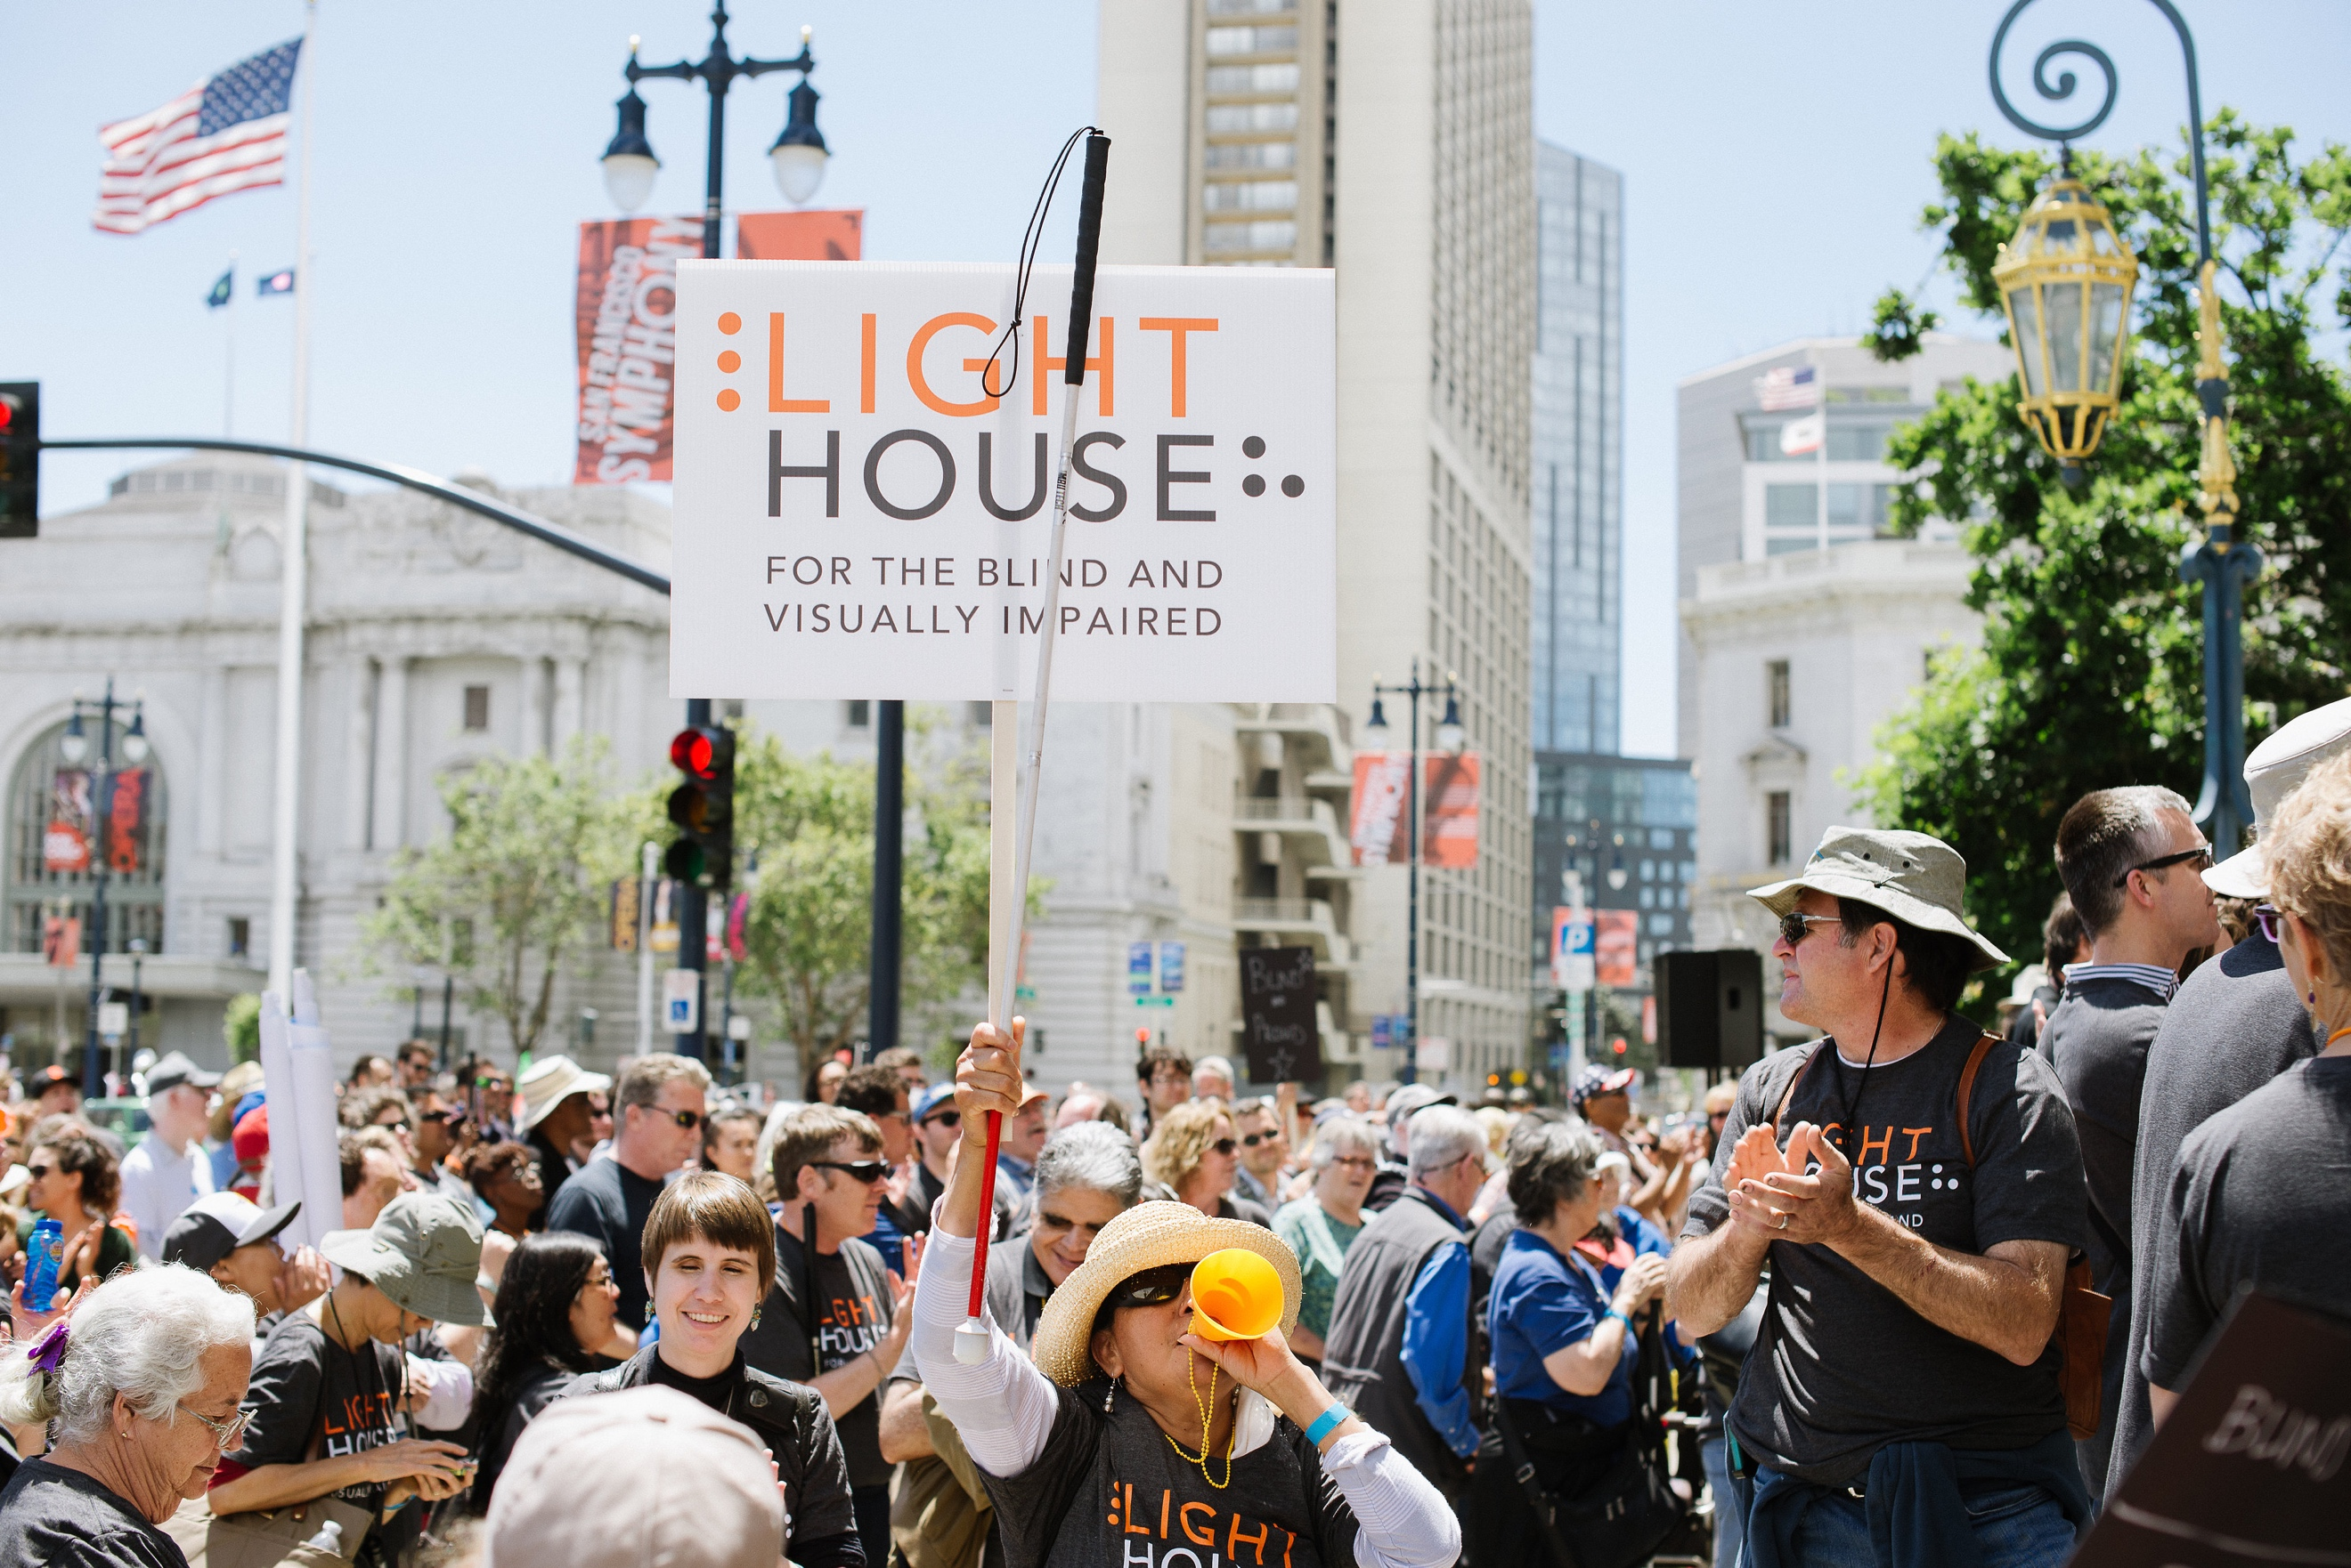

ANNUAL REPORT | 2016

Mission

Founded in 1902, LightHouse for the Blind and Visually Impaired promotes the independence, equality and self-reliance of people who are blind or have low vision.

Vision

We offer blindness skills training and relevant services such as access to employment, education, government, information, recreation, transportation and the environment. We also pursue the development of new technology, encourage innovation, and amplify the voices of blind individuals around the world.

Values

- independence
- innovation
- equality
- collaboration
- literacy
- employment advocacy
- education
- community

Board of Directors

President
Chris Downey, Architect,
Architecture for the Blind

Immediate Past President
Joshua A. Miele, Ph.D., Research Scientist, Smith-Kettlewell Eye Institute

1st Vice President
Lisa Carvalho, Attorney at Law

2nd Vice President
Gena Harper, Sr. Vice President,
Morgan Stanley

Secretary
Geoffrey Murry, Attorney at Law, Ad Astra Law Group, LLP

Treasurer
Dana Hooper, Executive Director, Life Services Alternatives

Jennison Mark Asuncion, LinkedIn, Digital Accessibility Leader

Michael Dellar, CEO, Lark Creek Restaurant Group

Jerry Kuns, Technology Specialist, California School for the Blind (retired)

Michael Nuñez, Attorney at Law, Rosen Bien Galvan & Grunfeld, LLP

Luciana Profaca, Ph.D., Chief Deputy,
California Department of Rehabilitation (retired); Consultant

Dr. Jennifer Ong, O.D., Optometrist

Yue-Ting Siu, TVI, Ph.D., Educator, San Francisco State University

Executive Leadership

CEO
Bryan Bashin

Senior Director, Programs
Scott Blanks

Senior Director, Operations
Brandon Cox

Locations

LightHouse for the Blind and Visually Impaired (Headquarters)
San Francisco, CA

LightHouse of Marin
San Rafael, CA

LightHouse of the East Bay, Ed Roberts Campus
Berkeley, CA

LightHouse North Coast
Eureka, CA

Enchanted Hills Camp
Napa, CA

LightHouse Industries Sirkin Center
San Leandro, CA

A Letter from our CEO

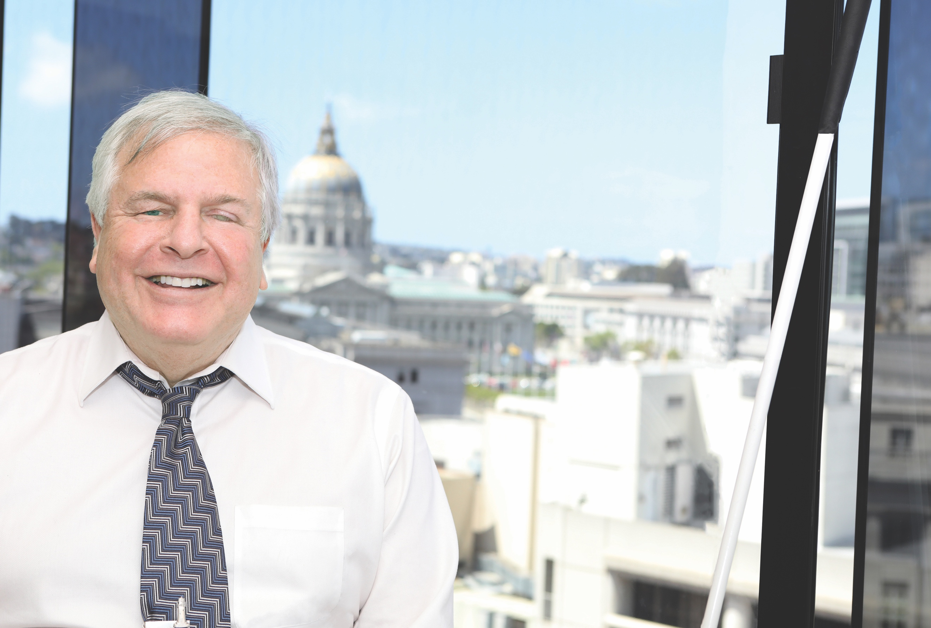

In May 2016, after three years of design, demolition and construction, our staff moved out of our well-loved building at 214 Van Ness Avenue into bright and sparkling new offices three times the size. The $20 million Civic Center construction project, designed by Mark Cavagnero and Associates and built by DPR Construction, triples the number of blind and visually-impaired people we can serve and allows us to house nearly 100 employees.

After 114 years of operation, the LightHouse finally has the space it needs to grow for generations to come.

We’re now at the nexus of San Francisco public transportation atop the Civic Center BART and Muni station, a huge plus for our community. With the purchase of this 11-story building came additional income from eight floors of rental offices, as well as newfound partnerships with the San Francisco city employees who work in them.

So what have we built? There’s a residential wing for 29 students, meeting rooms for gatherings of up to 150 people and massive investment in audio and video connectivity. There are more than a dozen teaching rooms, a dedicated low vision optometry clinic, a volunteer center, the region’s largest blindness technology store and rooms for fitness, crafts, a science lab and video and audio recording studios. We’ve even built a specialized lab for braille and tactile production.

When we opened our doors on June 10, 2016, the San Francisco Mayor proclaimed a city-wide ‘LightHouse Day’. An unprecedented 1,000 celebrants took over downtown San Francisco, parading behind a marching band to enter our new space. The ‘blind pride’ march from City Hall to our headquarters was like nothing ever seen in the blindness community since our predecessors inaugurated their new headquarters a century before.

Today, LightHouse has never had so many friends and supporters. We’ve hosted thousands of collaborators, students and community members eager to see our new center’s accessible and inclusive features for people of all abilities. San Francisco magazine featured an extensive piece about our design process. The deluge of press about how we’ve entered our next century has raised our prominence in California and around the world.

So how will we harness the new headquarters, our five satellite offices and our compassionate staff?

This year our Board of Directors has authorized a strategic planning process which will culminate in 2017 with an ambitious and inventive plan to take the LightHouse through the year 2020 and beyond.

I look forward to the LightHouse making a fuller impact in our new space. This annual report shines a light on this organization’s activity, muscle and the ambition that fairly crackles in the air. Let me assure you that the human capital of creativity and compassion also shines just as brightly in the future emerging around us.

In gratitude,

Bryan Bashin
LightHouse CEO

415.694.7346

Student: Ruth Hartman

When Ruth used a brailler at a Changing Vision Changing Life Immersion retreat at Enchanted Hills Camp in February 2016, she was hooked.

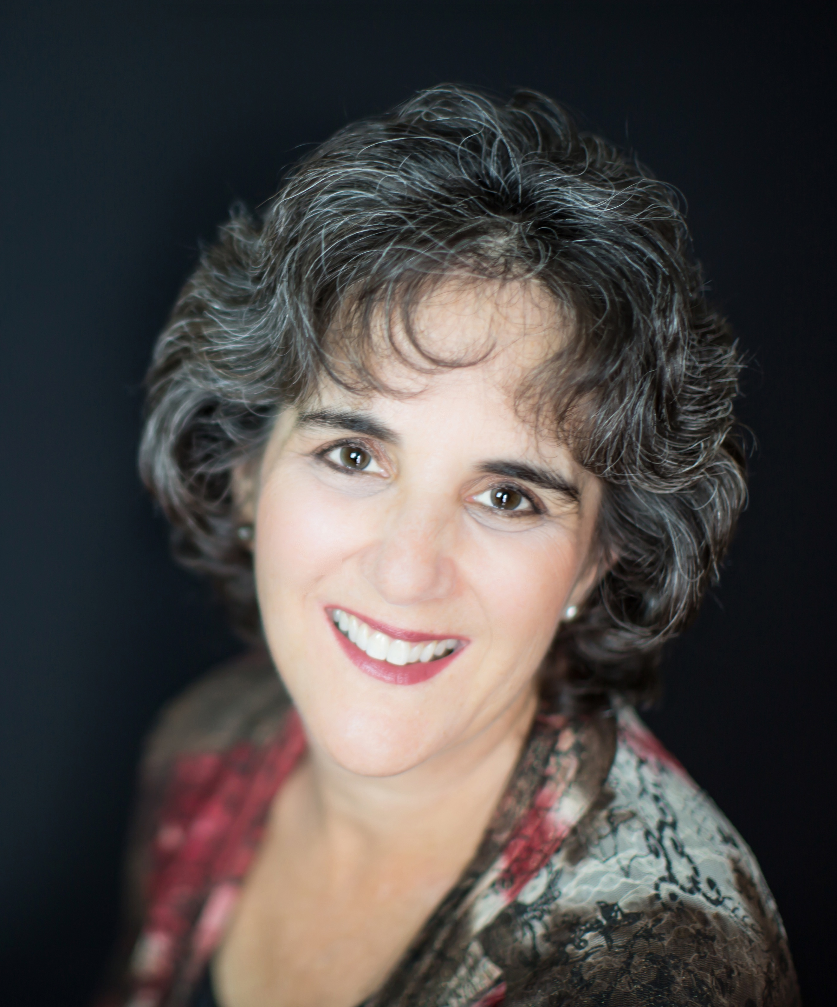

“The loss and grief and fear and feelings of panic were getting more difficult to manage as my central vision was deteriorating more. I needed to make some kind of mental breakthrough—but I didn’t know what it was. There was something about solving the puzzle of braille that I found really enthralling.”

Ruth is a busy person. She runs her own marketing and communications business, called Wordcraft. She’s a leader at her synagogue, teaches peer counseling, and dedicates her time to vegetarian cooking and bread baking. She’s an avid reader, follows politics and baseball, and raised two daughters who are now in their 20s.

She’s done all of this as her vision declined due to a progressive condition over the last 30 years. Changing Vision Changing Lives helped her make the adjustments she needed to keep living a full life.

82%  of our students are say they are successfully using newfound skills and strategies | 83%  of our students say they are motivated to try new things | 82%  of our students say they are better able to maintain their day-to-day activities

By the Numbers

Blind Students: 885

15,222 hours

PROGRAM HOURS

- 3,009 adults & seniors
- 2,802 youth
- 2,660 orientation & mobility
- 2,021 employment immersion
- 1,317 student support (advocacy, family, referrals, transportation)
- 1,156 technology
- 832 deaf-blind
- 292 braille instruction

LH Age Breakdown

- 0-12: 6 people

- 13-18: 39 people

- 19-24: 51 people

- 25-64: 431 people

- 65+: 358 people

Volunteers

660 individual volunteers
17 separate volunteer groups

Charity Navigator Status – 4 Stars

Places We’ve Reached

CA Counties

Alameda
Amador
Butte
Contra Costa
Del Norte
El Dorado
Fresno
Humboldt
Imperial
Kern
King
Lake
Lassen
Los Angeles
Marin
Mendocino
Monterey
Napa
Nassau
Nevada
Orange
Placer
Plumas
Riverside
Sacramento
San Benito
San Bernardino
San Diego
San Francisco
San Joaquin
San Jose
San Luis Obispo
San Mateo
Santa Barbara
Santa Clara
Santa Cruz
Shasta
Solano
Sonoma
Stanislaus
Tulare
Tuolomne
Ventura
Yolo
Yuba

States

Alaska
Arizona
Arkansas
California
Colorado
Florida
Hawaii
Illinois
Indiana
Maryland
Massachusetts
Michigan
Minnesota
Montana
Nevada
New Hampshire
New Jersey
New Mexico
New York
North Carolina
Ohio
Oregon
South Carolina
Tennessee
Texas
Virginia
Washington
Washington, D.C.

Countries

Armenia
Australia
Belgium
Brazil
Canada
China
Croatia
Czech Republic
Denmark
Finland
France
Germany
Hungary
Iceland
India
Islamic Republic of Iran
Israel
Italy
Japan
Mexico
Myanmar
Netherlands
New Zealand
Norway
Poland
Puerto Rico
Russia
Spain
Sweden
Switzerland
Turkey
Ukraine
United Arab Emirates
United Kingdom
United States

Volunteer: Abby Cochran

When Abby Cochran first found the LightHouse three years ago, she came asking for help – but she wasn’t blind.

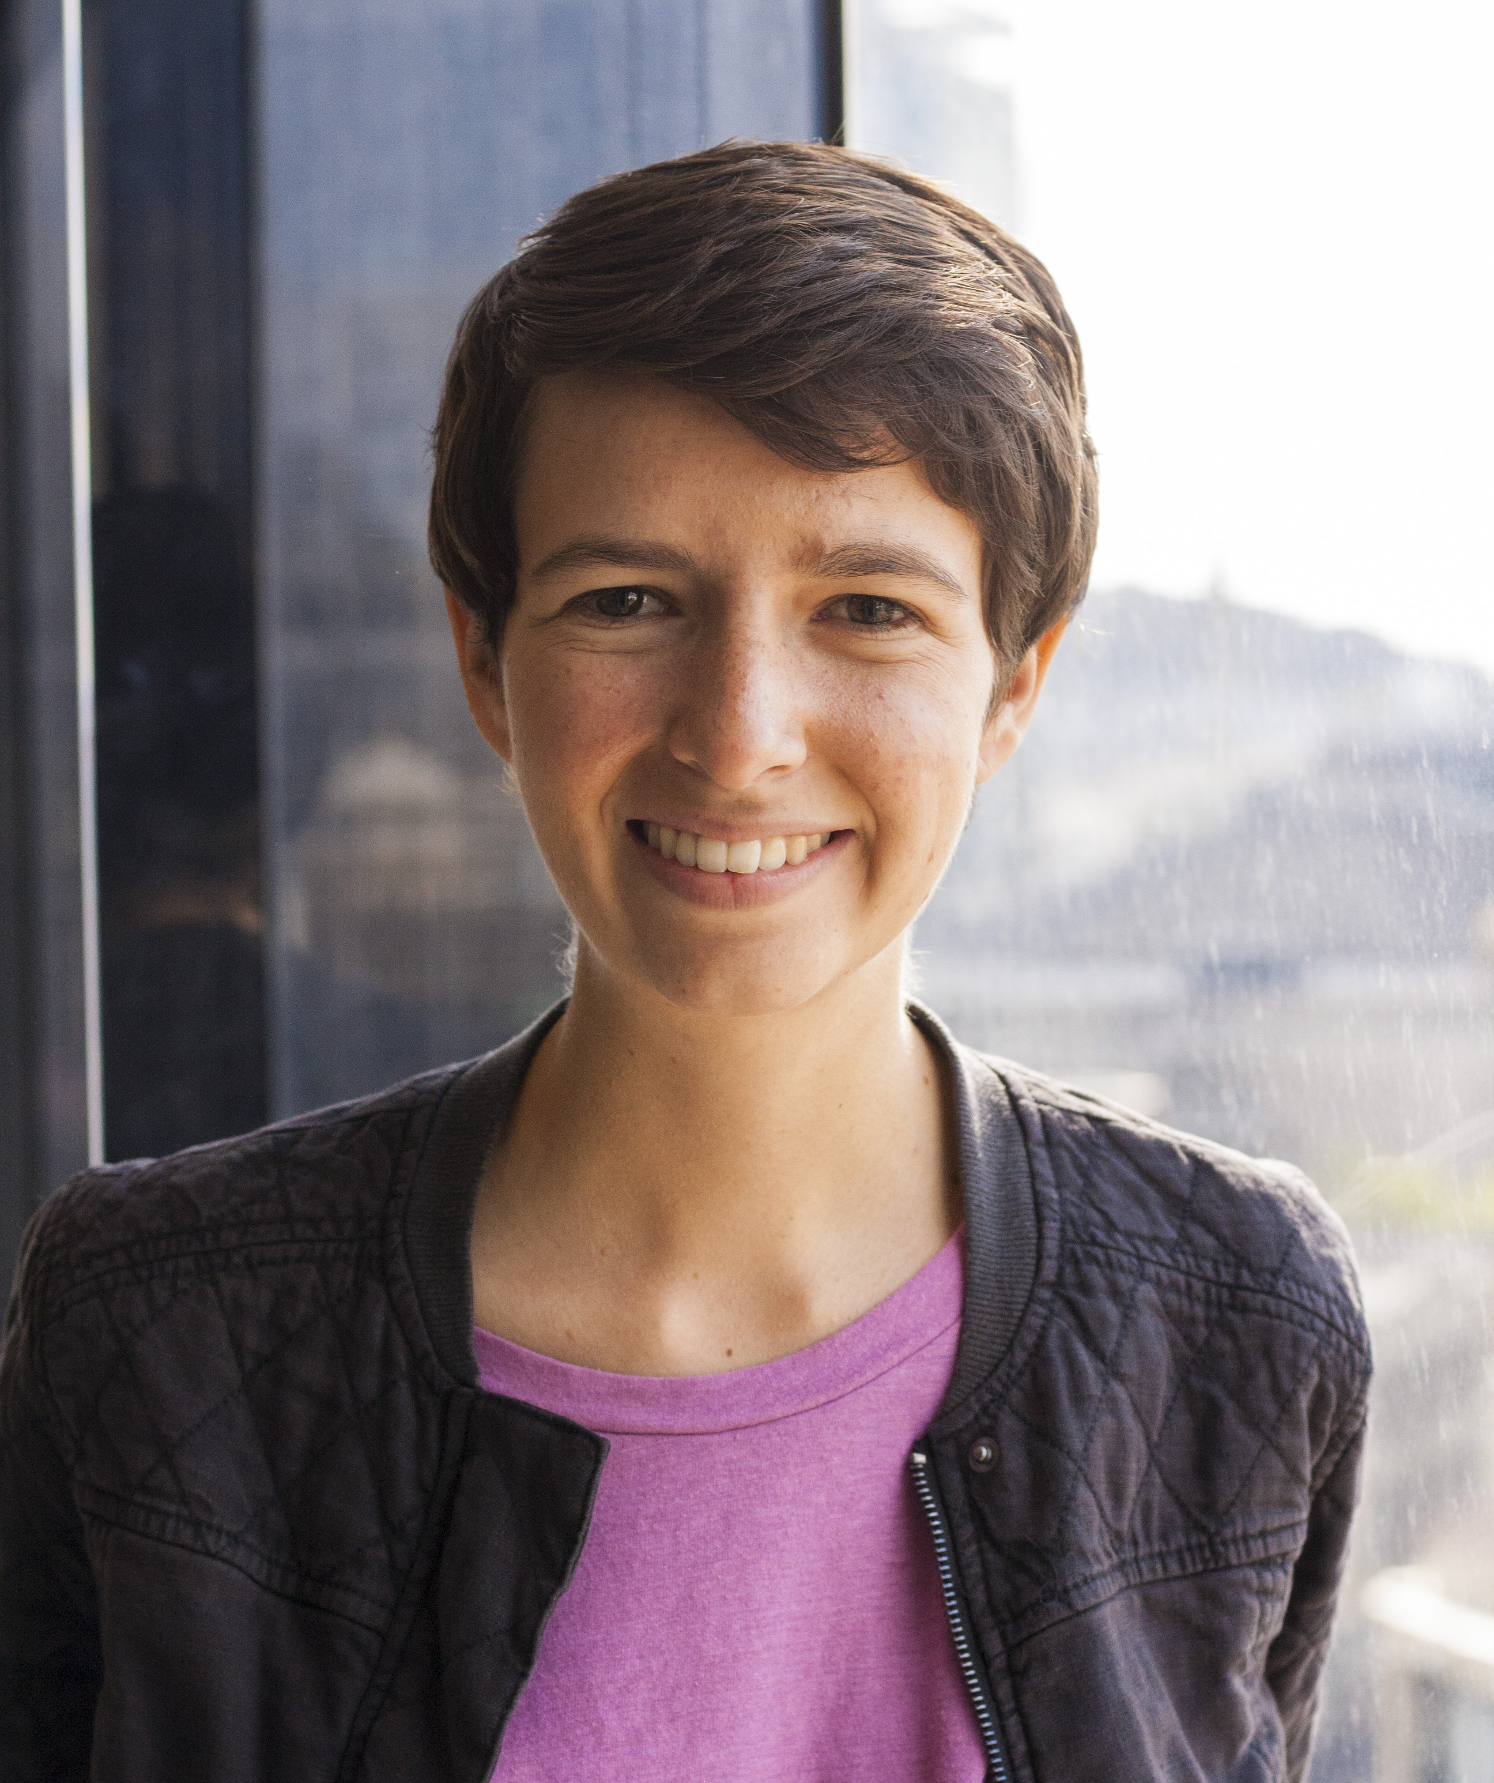

“Within the first few weeks we were exercising together, he invited me to an event,” she says. “We were doing introductions and meeting people, and he said this is Abby. And they were like ‘Oh, how do you two know each other?’ And we hesitated for a second and looked in each other’s direction and said, ‘Well, we’re… friends.’”

Abby, who is fully sighted, had just moved to Berkeley for her Master’s degree and was working at a startup in the city called TransitScreen. The company was using Bluetooth beacons to send transit data to user’s phones – particularly useful for blind users at inaccessible signs. She needed user testers though, and someone told her LightHouse was the obvious choice.

As Abby transitioned into her PhD in Urban Planning at UC Berkeley, LightHouse stuck in the back of her mind. Her social setting was changing, she was on a new schedule and she was looking for new friends and activities to fill her time.

A couple months and a few LightHouse newsletters later, Abby discovered our Volunteer Program. She signed up for a Volunteer Training and connected with her new fitness partner who, like Abby, lived in Berkeley and was excited to spend time every weekend getting out and about. The two quickly fell into a rhythm with hikes all around the Bay Area. They still hike about once a week, usually for half a day.

80%  of our students say they have more confidence because of LightHouse | 77%  of our students say they are more satisfied with their quality of life

Enchanted Hills Camp & Retreat

Founded in 1950 by Rose Resnick, Enchanted Hills is the first camp for the blind west of the Mississippi. We offer programs for blind children, teens, adults and their families as well as deaf-blind campers. Located on 311 acres on Mt. Veeder in Napa, Enchanted Hills is a place for blind campers to explore, grow confidence and build a community.
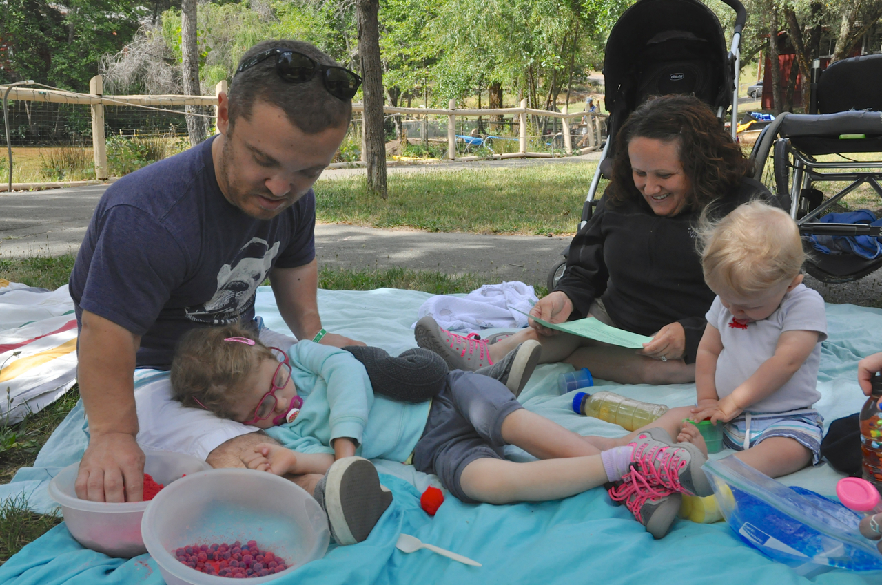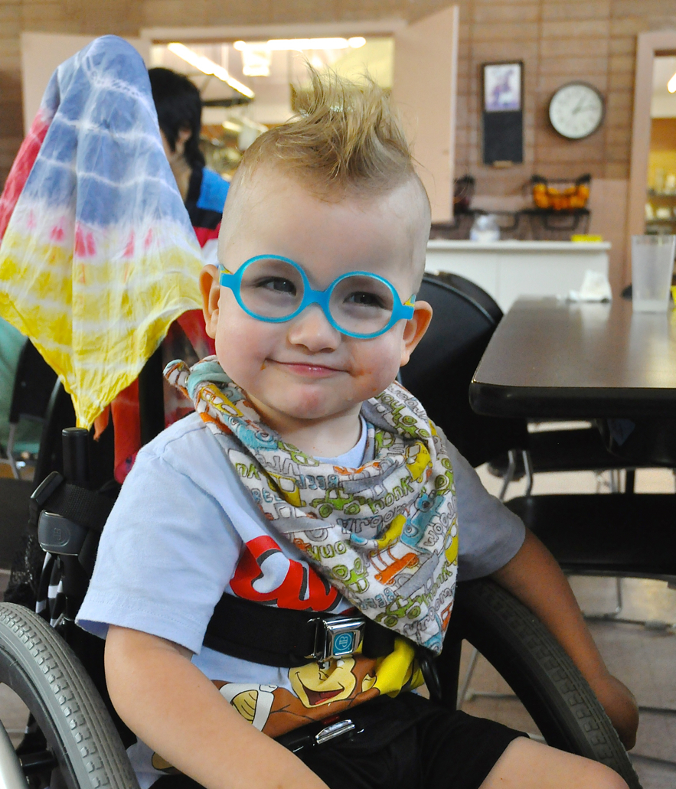

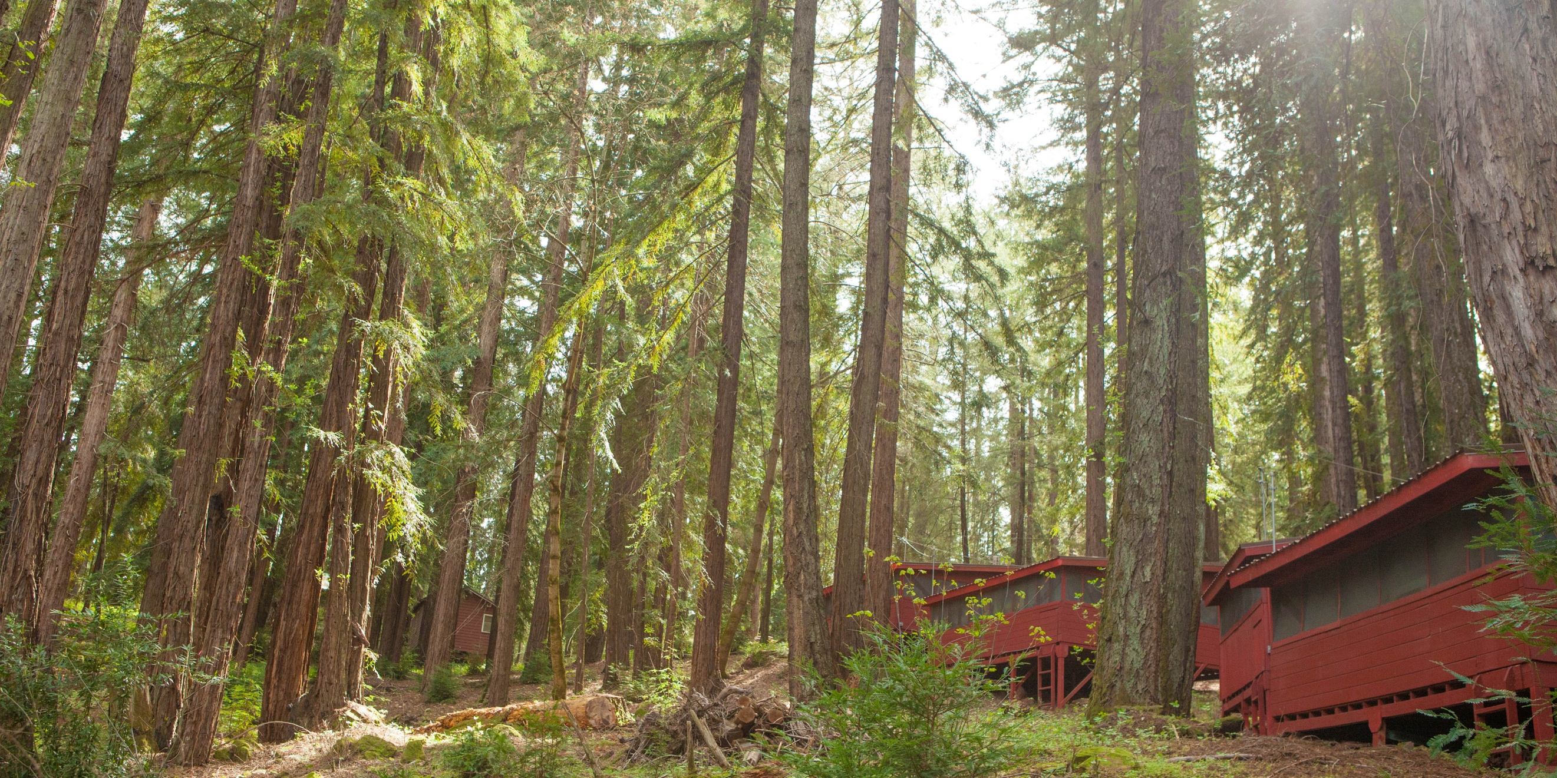

EHC By the Numbers

Blind Campers: 351

Total EHC service hours: 22,758.5

EHC age breakdown
- 0-12: 79
- 13-18: 80
- 19-24: 30
- 25-64: 140
- 65+: 22

Meals served = 25,000
EHC Guests Hosted =12,000

2016 ANNUAL EHC PROGRAMS:

- Changing Vision, Changing Life programs
- Deaf/Blind Session
- Blindness Professionals Weekend
- National Blind Woodworkers Conference
- Chemistry Camp
- Cycle for Sight
- Blind Babies Family Camp
- Music Academy
- Horse Camp
- STEM Camp
- 30 community groups used EHC including one wedding and one retirement party

Student: Toby Clark

Toby works around the corner as an attorney at the federal courts and regularly attends our 30% and Growing blind professionals meet-up.

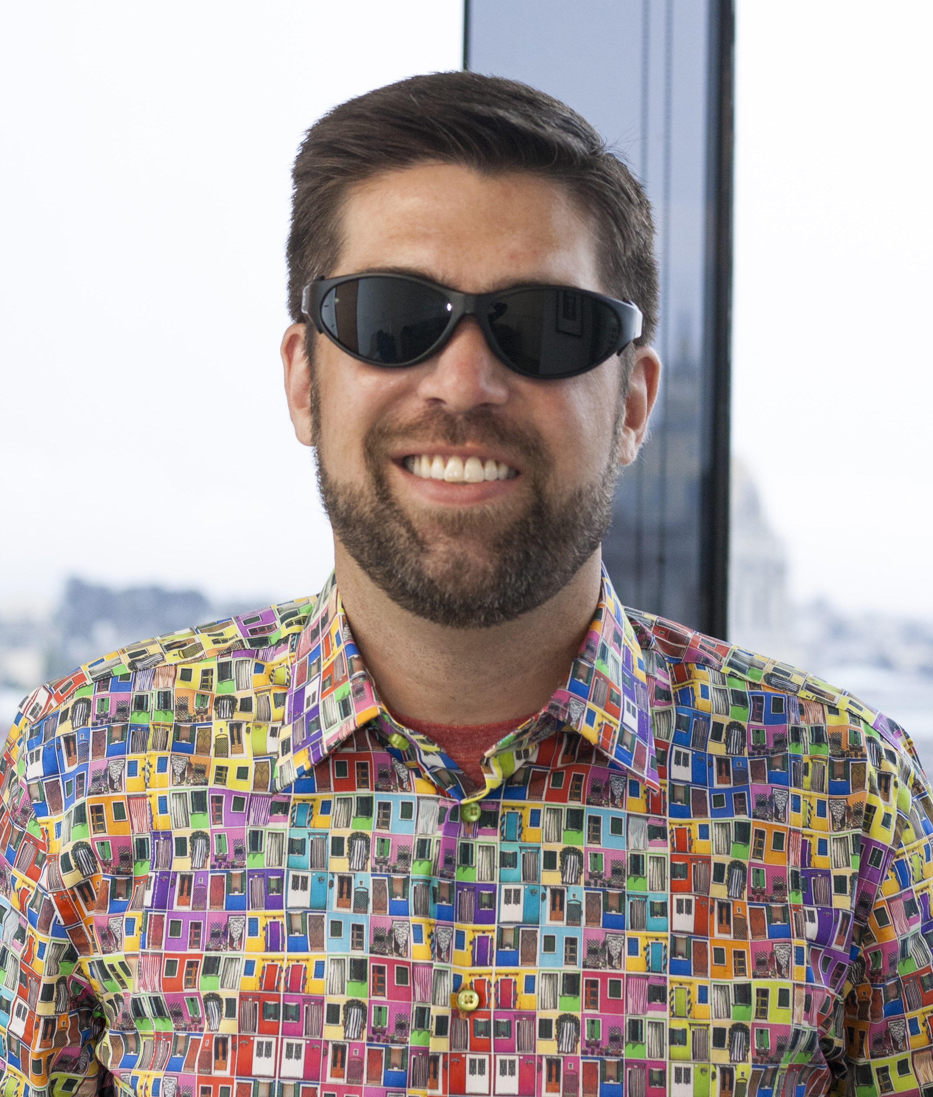

“LightHouse changed my life. I was homebound in a little bubble and they brought me out. I now have activities and new challenges that I can meet thanks to the LightHouse.”

Long before Toby was networking with fellow blind professionals, he was struggling with the uncertainty of a rare retinal disorder and worrying about continuing with his job. As his eyesight changed, his mood began to decline. But everything shifted when a friend asked Toby, “Have you heard of LightHouse?” He connected with LightHouse psychological services counselor Connie Conley-Jung for an initial session.

She laid out a path for him, showed him the available resources and told him how to get connected with Department of Rehabilitation.

“It helped to talk with someone who gets it,” he said. “It was the first time in all that floundering and trying to figure out how to do things on my own that I felt like there was a map forward, both personally and professionally.”

And that was just the start for Toby. He completed more counseling sessions with Connie, a Changing Vision Changing Life Immersion at Enchanted Hills Camp, orientation and mobility with specialist Katt Jones, technology training and braille lessons with instructor Divina Carlson. These days, Toby uses ZoomText, Jaws and NVDA to access his scripts and legal documents.

93%  of our students would refer someone who is blind to LightHouse | 91%  of our students say LightHouse met their interests and needs | 94%  of our students say staff are professional and knowledgeable

2016 Financials

Assets
 | $
Current Assets
Cash and cash equivalents | 5,245,888
Receivables | 1,201,456
Prepaids and deposits | 65,679
Inventory | 194,675
Total Current Assets | 6,707,698
Non-Current Assets
Investments | 148,981,892
Loan receivable | 11,630,500
Construction in progress | 226,761
Property & equipment- net of accumulated depreciation | 6,607,552
Total Non-Current Assets | 167,446,705
Total Assets | 174,154,403

Liabilities and Fund Balance
Current Liabilities
Accounts payable and other accrued expenses | 810,983
Loan payable - current portion | 939,000
Line of credit | 7,757,387
Total Current Liabilities | 9,507,370
Non-Current Liabilities
Loan payable | 34,378,000
Total Non-Current Liabilities | 34,378,000
Total Liabilities | 43,885,370
Fund Balances
Unrestricted, Temporarily Restricted, Restricted | 130,269,033
Total Liabilities and Fund Balances | 174,154,403

Revenue
 | $
Revenue
Sales, net of fees of $46,253 | 1,423,933
Fees for service | 926,656
Realized & unrealized gains on investments | 8,377,449
Interest & dividend income | 2,335,374
Miscellaneous and other | 169,733
Total Revenue | 13,233,145
Support
Government contracts & other grants | 2,048,022
Donations and bequests | 1,673,977
Total Support | 3,721,999
Total Support & Revenue | 16,955,144

Expenses
Program Services
Community and Information | 16,747,903
Rehabilitation Services | 11,857,462
Lighthouse Enterprises | 1,832,267
Total Program Services Expenses | 30,437,632
Supporting Services
General and administration | 6,329,354
Fundraising | 1,150,515
Total Supporting Services | 7,479,869
Total Expenses | 37,917,501
Public Support & Revenue Over Expenses | (20,962,357)
Fund Balances, Beginning of year | 151,231,390
Fund Balances, End of year | 130,269,033

Donors

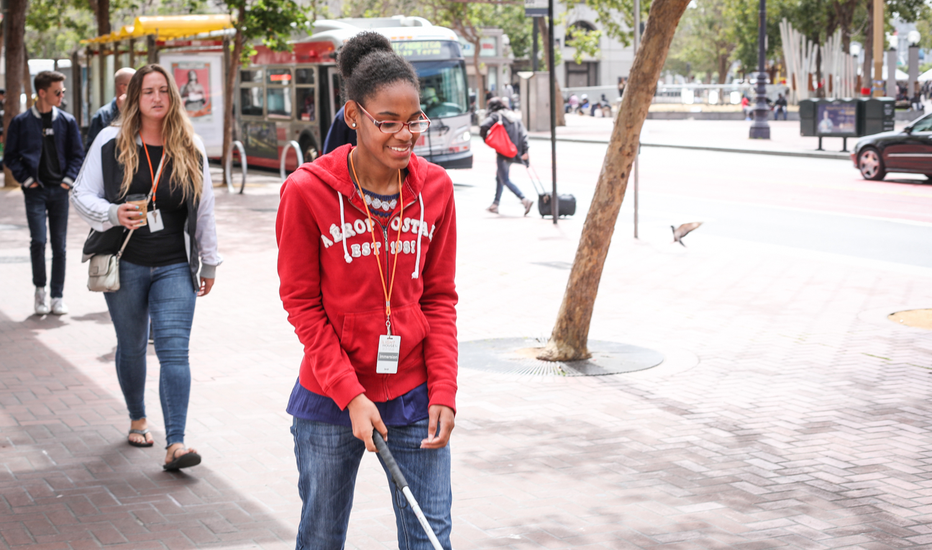

How many donors gave in 2016?

$1 - $99 = 434
$100 - $499 = 350
$500 - $999 = 50
$1,000 - $2,499 = 56
$2,500 - $4,999 = 20
$5,000 - $9,999 = 9
$10,000 - $14,999 = 7
$15,000 - $24,999 = 9
$25,000 - $49,999 = 4
$50, 000 - $99,999 = 3
$100,000+ = 8

LightHouse Estate Donors

Agnes Cole Trust
Estate of Irene A. Crescio
Estate of Margaret Bolger Creech
Josephine K. Knowles Trust
Thomas Dutra Trust
Estate of John I. Lee
Rolph-Nicol Fund TA I Charitable Trust
Elsie M. Stevens Revocable Living Trust
Clyde Margaret Stone
Revocable Trust
Emma G. Trebilcot Trust
Storrow Twelve Charities
Lillie Wissman Trust
William W. Witney Trust

LightHouse Legacy Society

The LightHouse Legacy Society is a group of people who have decided to support LightHouse by including us in their estate plans.

Hank Boerenko
Joseph Chan
Margie Donovan
Joan M. Dove
Lewis J. Feldman
Robert Ray Foster
Gena Harper and Michael May
Dolores Ippolito
Roger Kallen
Justin Kim
Judith Kuhnle
Jerry Kuns and Theresa Postello
Inez E. Martini
Ann Noble and Goran Muhlert
Robert E. O’Donnell
Alicia Jean Rose
Frederic and Kristine Silva
Richard Stevens and Virginia Behm
Dorothy M. Walker
David and Regula Weill
Martin and Rosan Weissman
Jennifer Westbrook
Susan Lapin

Who We Reach

561 media sources published articles about LightHouse and our programs in 2016, including The New York Times, San Francisco Magazine, NBC Evening News, CBS Radio, Re/Code, Napa Register, Bloomberg News, Inside Bay Area and many more.

http://modernluxury.com/san-francisco/story/blind-people-dont-need-your-help-they-need-better-design

http://napavalleyregister.com/news/local/visually-impaired-musicians-overcome-obstacles-with-technology-at-napa-camp/article_b8819fbb-d529-5cb2-b813-67a63833d6e5.html

https://well.blogs.nytimes.com/2016/01/25/blind-low-vision-rehabilitation-services/

https://www.recode.net/2016/3/16/11587034/the-best-party-at-sxsw-was-in-a-rented-house-full-of-blind-people

In 2016, we hosted advocacy groups and organizations from across the nation.

2016 Hillary Clinton Campaign for President
Actiview
Be My Eyes
California Council of the Blind
California Foundation for Independent Living Centers
Central Market Community Benefit District
City and County of San Francisco
Development Executives Roundtable
Frances Neer Forum
Mayor’s Office on Disability
National Federation of the Blind
Paul K. Longmore Institute on Disability at San Francisco State University
Saatchi & Saatchi
San Francisco Municipal Transportation Agency (SFMTA)
Senior and Disability Action
Sierra Club
Walk SF

We also presented about blind innovation and services to partners all over the world, including:

BART Developer Summit
Bay Area Arts Access Collective (BAAAC)
Calgary Transit
California Transcribers and Educators for the Blind and Visually Impaired (CTEBVI)
Federal Reserve Bank
General Assembly
PG&E
Provider's Weekend
San Francisco Department of Public Works
San Francisco State University
SFMTA
SXSW (South by Southwest)
World Blind Union (WBU)
CSUN Assistive Technology Conference
SF Taxi Drivers Groups
American Foundation for the Blind Training Conference
Bank of America College Success Program
Blind Advisory Council
National Federation of the Blind
Sacramento Society for the Blind
San Francisco Exploratorium
Seattle LightHouse
Toyota Robotics
Uber
Development Executives Roundtable (DER)

Commercial Services

Media and Accessible Design Lab (MAD Lab)

From printed information to physical space, our MAD Lab specializes in making the visual tactile and turning inaccessible experiences into inclusive ones. Our team of designers and consultants specialize in braille, tactile maps, accessible venues and alternative media.

Design: Tactile Maps, Graphics, 3D | 9529 items
Consulting: Design and Accessibility | 9 projects
Consulting: ADA/CBC Sign Review | 36 projects, 3636 signs
Braille | 232 projects, 57177 pages
Braille Business Cards | 30200 business cards
Audio Recordings | 50 Recordings
Trainings, Presentations, Conferences | 26 venues

Adaptations Store

Adaptations is the only place in Northern California with a comprehensive offering of tools, technology and other solutions for people who are blind or have low vision.

Total number of items sold | 5,551
Total number of transactions | 2,314
Total number of customers | 2,284
Number of unique customers | 1,327
Number of items carried | 143

LightHouse Industries Sirkin Center

The Sirkin Center provides employment to blind employees and empowers them in customer service, shipping and receiving, inventory management and light manufacturing. The Sirkin Center manufactures tissue packets included in MREs (Meals Ready to Eat) for soldiers and fire fighters in the field.

Number of Packets of Toilet tissue produced | 35,149,000

Support Our Work

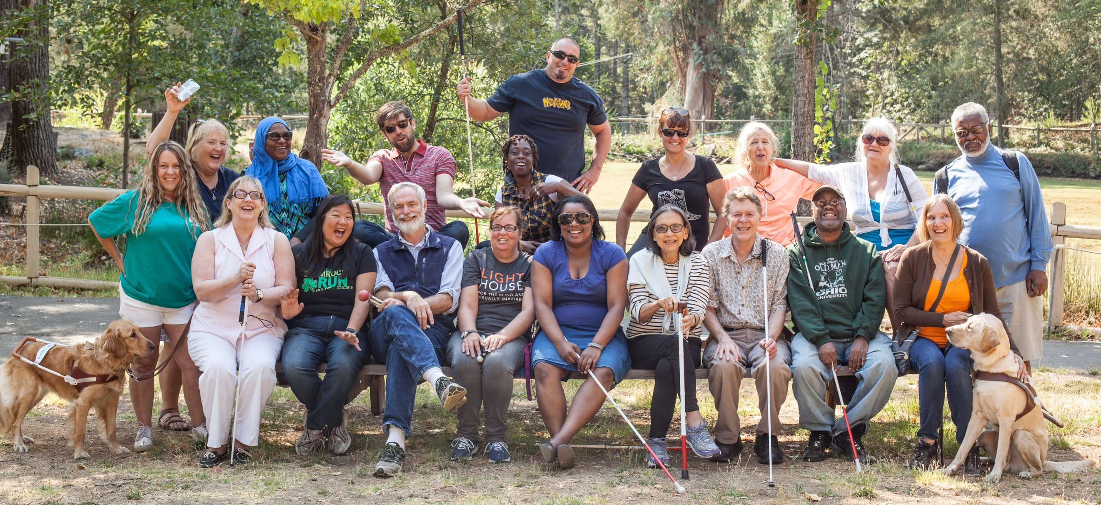

Together we can map out strategies to help you support our empowering programs for people who are blind or have low vision while maximizing your tax and financial benefits. To contribute, please contact our Director of Development at 415.694.7333 or jsachs@lighthouse-sf.org.

1155 Market Street, 10th Floor

San Francisco, CA 94103

P: 415. 431.1481 VP: 415. 255. 5906

www.lighthouse-sf.org

